Installing and licensing SPSS 24 for Windows
Installation | Licensing | Fix packs | Licensing failure
Installation
To successfully install SPSS, you must have administrative privileges on your computer.
1. Once the file has downloaded, right­click on the file and select Run as administrator to open IBM SPSS Statistics ­ InstallShield Wizard. Wait as the file is extracted and prepared for installation.
2. Proceed through the screens until you reach the Software License Agreement screen. Read the agreement carefully. You must accept the terms** to install and use SPSS. If you agree, select “I accept…”
** To use SPSS as licensed through VCU, you must also abide by VCU’s SPSS License Terms.
3. Continue to the screen for Python Essentials. If you will be using Python with SPSS, select
“yes” to install the Essentials for Python pack with SPSS. You must also:
a. Read the License Agreement for Python carefully and select “I agree…” if you accept the terms of the agreement.
b. Read the Software License Agreement carefully and select “I agree…” if you accept the terms of the agreement.
4. Continue to Destination Folder. Select the drive and folder on your computer where you would like to install SPSS Statistics 24. (Multiple SPSS versions may be on the same computer if they are installed in separate folders.)
5. Proceed to Ready to Install the Program. Select “Install” and a progress screen will display during installation.
6. When installation completes, this “successful installation” screen will appear. Select the checkbox to “Start IBM SPSS now” (as below). Then click Finish.
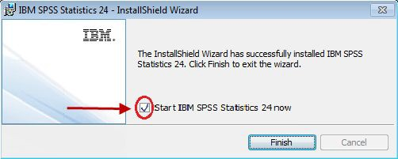

7. SPSS 24 will begin to launch, and then the screen below (or similar) will display. Click the License Product button.
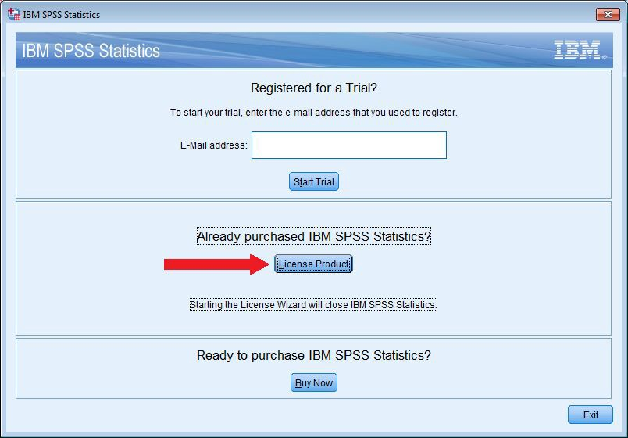
8. The SPSS License Authorization Wizard will launch for licensing SPSS, as described below. (If the license wizard does not start, then launch the SPSS program. An initial screen will display, containing a License Product button. Click that button to launch the license wizard. Then continue below.)
Licensing SPSS
In order to use SPSS, licensing must be completed after the installation of SPSS software and again each June and December for renewal or re-licensing. During the installation, you read and agreed to the terms of the license. To use SPSS as licensed through VCU, you must also abide by VCU’s SPSS License Conditions.
Follow these steps to license SPSS:
1. Ensure that your PC has a wired Internet connection (one that uses an Ethernet cable). If it does not have a wired connection, licensing may fail — if so, proceed to Licensing Failure below to obtain assistance from the VCU IT Support Center.
2. Launch the License Authorization Wizard by one of these methods:
- If installing SPSS, the license wizard should launch automatically following SPSS installation. (If it does not, then launch the SPSS program. An initial screen will display, containing a "License Product" button. Click the button to launch the license wizard.)

- If re-licensing SPSS, launch the license wizard manually as follows:
  - If you have a Windows Start menu, then select
    - Start
    - Programs
    - IBM SPSS Statistics
    - IBM SPSS Statistics 24 License Authorization Wizard
  - If you do not have a Windows Start menu, then type "SPSS 24 Licnese Wizard" on your Desktop screen (or in the Windows Search box) and then select "IBM SPSS Statistics 24 License Authorization Wizard."
3. Proceed through the License Status screen.
4. Continue to Product Authorization and select “Authorized user license.”
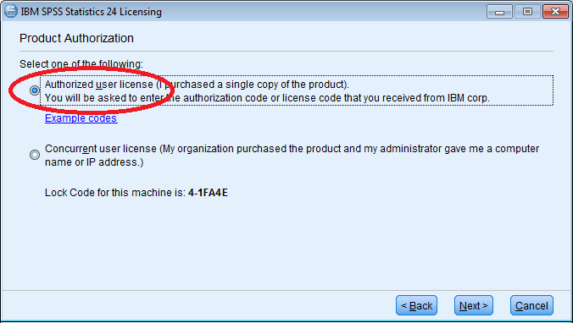
5. Proceed to Enter Codes. Input the authorization code from the SPSS installation email sent to your VCU account.
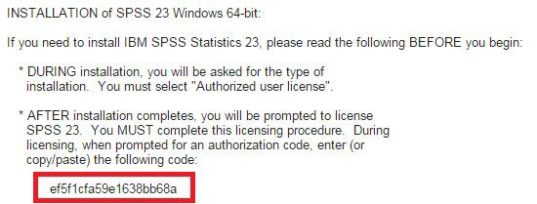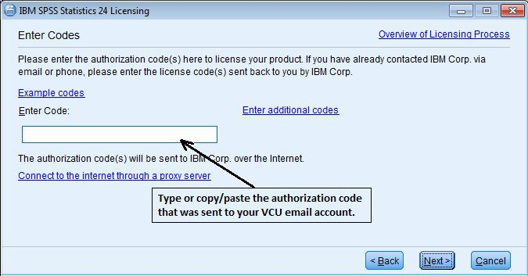
6. Continue to Internet Authorization Status and wait for the “Authorization succeeded” message.
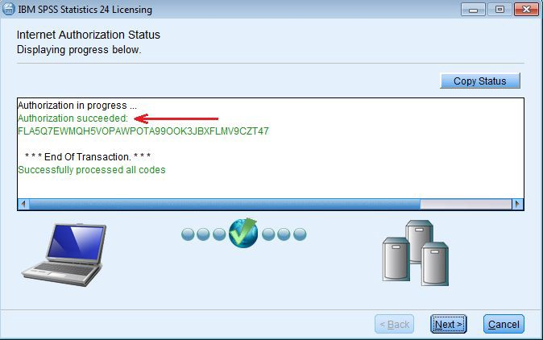
a. If you instead receive an “Authorization failed” message, double­check that your authorization code is entered correctly and that you are using a wired internet connection. If unable to resolve, proceed to the steps below for Licensing Failure to obtain assistance from the VCU IT Support Center.
7. Continue to display the Licensing Completed message and select “Finish” to exit the license wizard.
After successul installation and licnesing, you should install any fix packs that are available for SPSS 24 (see next section below).
Fix packs
As with all software, SPSS usually contains a few "bugs" (problems) that were unknown when the software was first released. As IBM, Inc., becomes aware of these problems (via user interaction, etc.), it periodically provides free updates, called fix packs, that you can install to correct many of the problems.
You should regularly check (every few weeks or months) for newly released fix packs at Windows Fix Packs. When fix packs do become available, instructions will be provided there for downloading and installing them. You are strongly encouraged to install them.
(see Licensing failure below)

Licensing failure
If you have re­attempted to license and repeatedly received an “Authorization failed” message, or if your PC does not have a wired Internet connection, then please follow these steps to obtain licensing assistance from the VCU IT Support Center.
1. If your PC does have a wired Internet connection, make sure you have attempted to license according to the licensing instructions above and, during that procedure, that you have correctly inputed your SPSS authorization code on the Enter codes licensing screen.
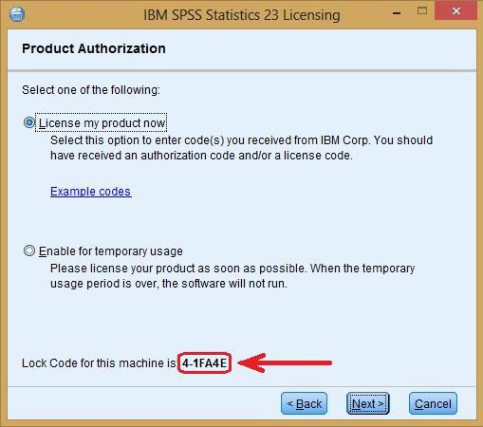2. If those steps fail, launch the License Authorization Wizard again and proceed to the Product Authorization screen.

3. Do not proceed beyond this screen.
Note the lock code, displayed at the bottom of the window. For example, 4­1FA4E. Copy or write down this code.
4. Send an email to the VCU IT Support Center (itsc@vcu.edu) describing your problems licensing. Include the exact lock code in the body of your message. Make the subject of your email “Problem licensing Windows SPSS 24.”
5. Close out of the License Authorization Wizard.
The VCU IT Support Center will work to obtain a special license code for you that does not require an Internet connection. They will email this code to you in response. Please note this process may take one or more days to complete. When you receive the special license code via e­mail from the IT Support Center, follow the directions in the e­mail to license your SPSS software. If you continue to have licensing problems, please contact the IT Support Center (828­2227 or itsc@vcu.edu) for further assistance.

