Installing and licensing SPSS 25 for Linux
Install | License | License Failure | Fixes & Updates | Uninstalling

Installation
You must be operating as the root user to install this software.
- Launch a terminal application (xterm, konsole, gnome-terminal, etc.) to open a window in which you can issues commands at a shell prompt.
- Locate the install file that you downloaded previously. At the shell prompt, issue a ‘cd’ command to change directory to the directory containing the install file.

- Issue the following command to launch the installation:
sh SPSS_Statistics_25_lin.bin

- Wait while your computer prepares to install. The following messages may be displayed:
Preparing to install…
Extracting the JRE from the installer archive…
Unpacking the JRE…
Configuring the installer for this system’s environment…
Launching installer…

- Proceed through the screens to the Software License Agreement screen and read the terms of license. To install and use SPSS, you must accept these terms.** To continue, select “I accept…”
** To use SPSS as licensed through VCU, you must also abide by VCU’s SPSS License Terms.
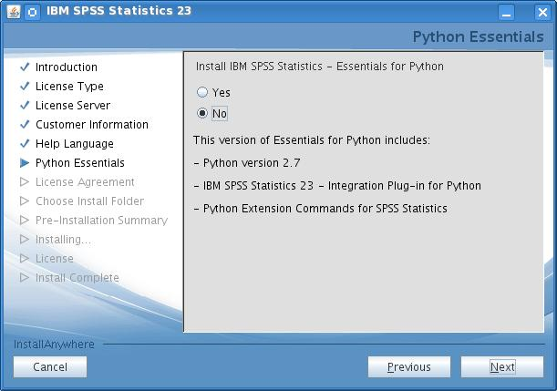
- Continue to Python Essentials. If you will be using Python with SPSS, select Yes and continue to the Python License Agreements. You must also accept the terms of those agreements to use Python with SPSS.

- Continue to the Choose Install Folder. Select the location where you would like to install and launch SPSS. (Multiple SPSS versions may be on the same computer if they are installed in separate folders.)

- Continue to the Pre-Installation Summary and select Install. A progress screen will display during installation.

- When installation completes, this “successful installation” screen will appear. Select the checkbox to “Start License Authorization Wizard now”, as shown below, and then click Done.
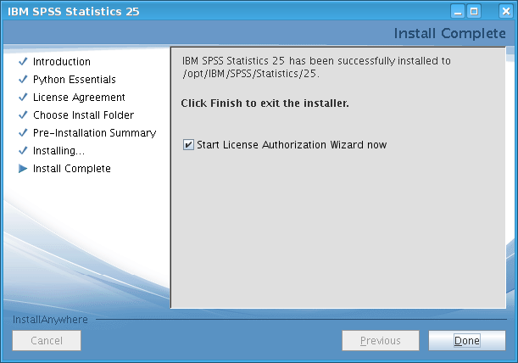
- The SPSS License Authorization Wizard will launch for licensing SPSS, as described below. (If the license wizard does not start, then launch it manually, as described in Step 2 below.)
Continue to the Licensing SPSS section below to license your software. Licensing is required in order to use the software.

Licensing SPSS
In order to use SPSS, licensing must be completed after the installation of SPSS software and again in June and December for renewal or re-licensing. During the installation, you read and agreed to the terms of the license. To use SPSS as licensed through VCU, you must also abide by VCU’s SPSS License Conditions.
To license SPSS software, a 20-character authorization code must be applied using the SPSS License Authorization Wizard, as described below.
To obtain an authorization code for licensing:
- For academic use (academic research and teaching): When you visit Download SPSS or License SPSS and follow the steps to download or license SPSS, an authorization code is emailed to your VCU address. This authorization code cannot be used for administrative purposes.
- For administrative use: You must obtain a special authorization code for administrative use of SPSS Please contact the IT Support Center.
Follow these steps to license SPSS:

- Ensure that you have a wired Internet connection (one that uses an Ethernet cable).

- If the SPSS License Authorization Wizard did not launch automatically after SPSS installation, or if you are re-licensing SPSS, then launch the wizard manually by, as the root user, going to the bin subfolder of the SPSS installation folder and running the program named licensewizard.

- Proceed through the License Status screen, if it is displayed.

- Continue to Product Authorization and select “Authorized user license.”
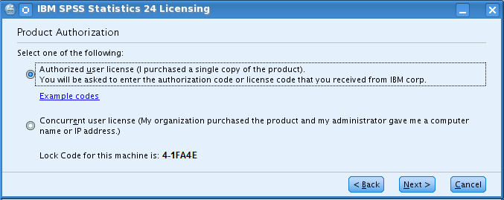

- Continue to Enter Codes.

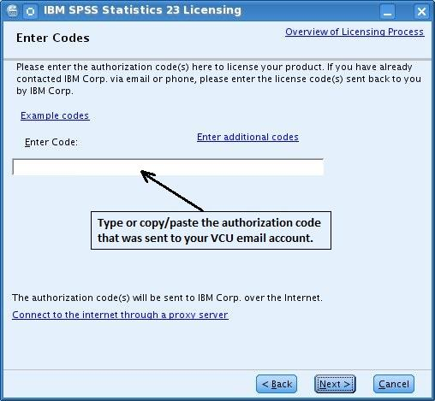
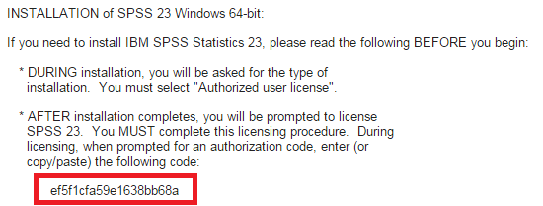
- Input the unique SPSS authorization code from the installation email sent to your VCU account.

- Continue to Internet Authorization Status and wait for the “Authorization succeeded” message.
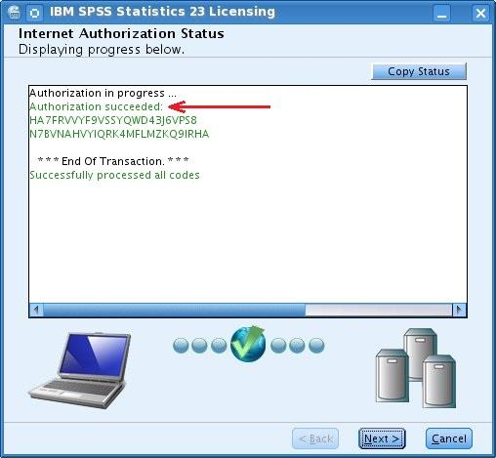
  - If you instead receive an “Authorization failed” message:
  - Double-check that your authorization code is entered correctly and that you are using a wired internet connection.
  - If unable to resolve, proceed to the steps in Licensing Failure below to obtain assistance from the IT Support Center.

- Continue to display the Licensing Completed message and select “Finish”

After successful installation and licensing, you should install any fix packs (updates) that are available for SPSS 25 (see next section below).

Fix packs
As with all software, SPSS usually contains a few "bugs" (problems) that were unknown when the software was first released. IBM periodically provides free updates, called fix packs, that you can install to correct these problems.
There currently are no fix packs available for SPSS 25. However, you should regularly check for them at Linux Fix Packs. When fix packs do become available, instructions will be made available there for obtaining and installing them.
Note: At this writing (May 2018), Fix Pack 25.0.0.1 is available. To obtain it, please visit Linux Fix Packs.

Licensing failure
If you have re-attempted to license and repeatedly received an “Authorization failed” message, follow these steps:
- Make sure you have attempted to license using a wired Internet connection using an Ethernet cable.
- Make sure you have correctly entered your SPSS authorization code on the Enter codes page.
- If the authorization process fails even though the above two conditions are satisfied, then you must obtain assistance from the VCU IT Support Center (828-2227 or itsc@vcu.edu) in licensing your software. Please inform them that you have a "problem licensing Linux SPSS 25".

Launching IBM SPSS Statistics 25
Note: You should not need to be the root user to launch and run IBM SPSS Statistics 25.
To launch/run IBM SPSS Statistics 25:
- Browse to the bin subdirectory of the IBM SPSS Statistics 25 installation directory.
- Run the stats file.

Un-installing SPSS 25
For instructions on un-installing SPSS 25, please refer to the Uninstalling section of the SPSS 25 Linux Installation Instructions PDF document.

