Installing and licensing SPSS 25 for Mac
Install | License | Fix packs | License failure

Installation
To successfully install SPSS, you must have access to an administrative account for your computer.
- Once you have downloaded the SPSS installation file, locate and open it (double­click) in Finder.
- Follow the installation steps as prompted until you reach ​Software License Agreement. You must​ accept the terms** of license in order to install and use SPSS. If you agree, select “​I accept…​”
** To use SPSS as licensed through VCU, you must also abide by VCU’s SPSS License Terms.
- Continue to the screen for ​Python Essentials. If you will be using Python with SPSS, select “Yes” to​ install the Essentials for Python pack with SPSS. You must also:
  - Read the License Agreement for Python carefully and select “​I accept…​” if you accept the terms of the agreement.
  - Read the next License Agreement carefully and select “​I accept…” if you accept the terms of the​ agreement.
- Continue to ​Choose Install Folder​. Select the location on your computer where you would like to install SPSS Statistics 25. (Multiple SPSS versions may be on the same computer if they are installed in separate folders.)
- Continue to the ​Pre­Installation Summary​ screen and click Install​ . A progress screen will display​ during installation.
- When installation completes, this “successful installation” screen will appear. ​Select the checkbox for “Start SPSS Statistics 25 License Authorization Wizard now​” (as below). Then click Done​ .​
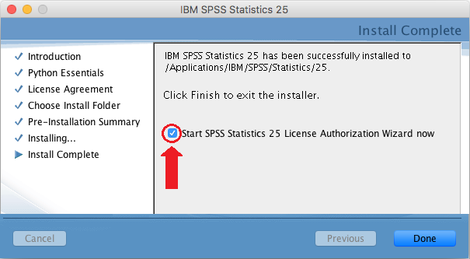

- The SPSS License Authorization Wizard​ will launch for licensing SPSS, as described in the Licensing SPSS section below. Licensing is required in order to use the software.
If the license wizard ​does not start, then launch it from your Mac Applications folder. The default location is:
Applications→ IBM→ SPSS→ Statistics→ 25→SPSS Statistics License Authorization Wizard
** Note:​ To use SPSS as licensed through VCU, you must also abide by VCU’s SPSS License Terms.

Licensing SPSS
In order to use SPSS, licensing must be completed after the installation of SPSS software and again each June and December for renewal or re-licensing. During the installation, you read and agreed to the terms of the license. To use SPSS as licensed through VCU, you must also abide by VCU’s SPSS License Terms.
To license SPSS software, a 20-character authorization code must be applied using the SPSS License Authorization Wizard, as described below.
To obtain an authorization code for licensing:
- For academic use (academic research and teaching): When you visit Download SPSS or License SPSS and follow the steps to download or license SPSS, an authorization code is emailed to your VCU address. This authorization code cannot be used for administrative purposes.
- For administrative use: You must obtain a special authorization code for administrative use of SPSS. Please contact the IT Support Center.
Follow these steps to license SPSS:
- Ensure that your PC has a wired Internet connection (one that uses an Ethernet cable). If it does not have a wired connection, licensing may fail — if so, proceed to Licensing Failure below to obtain assistance from the VCU IT Support Center..
- Launch the License Authorization Wizard:
  - If you have just finished installing SPSS, the license wizard should launch automatically following SPSS installation. (If it does not, then launch it manually, as described immediately below.)
  - You may launch the license wizard manually from your Mac Applications folder (for example, if you are re-licensing SPSS). The default location is:
Applications → IBM → SPSS → Statistics → 25 → SPSS Statistics License Authorization Wizard
- Proceed through the License Status screen, if it is displayed.

- Continue to Product Authorization and select “Authorized user license.”
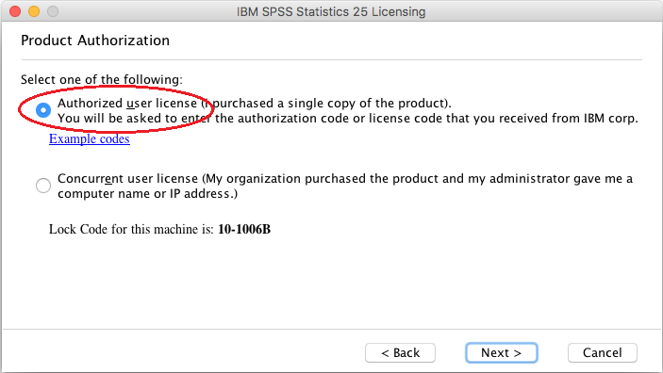
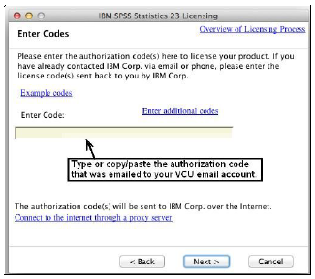
- Proceed to Enter Codes. Input the SPSS authorization code found in the installation email which was sent to your VCU account.

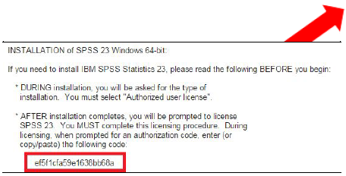
- Continue to Internet Authorization Status and wait for the “Authorization succeeded” message
If you instead receive an “Authorization failed” message:.
  - Double­check that your authorization code is entered correctly and that you are using a wired internet connection.
  - If unable to resolve, proceed to the steps for Licensing Failure to obtain assistance from the VCU IT Support Center
- Continue to display the ​Licensing Completed screen and select “​ Finish.​ ​”
After successful installation and licensing, you should install any fix packs (updates) that are available for SPSS 25 (see next section below).

Fix packs
As with all software, SPSS usually contains a few "bugs" (problems) that were unknown when the software was first released. As IBM, Inc., becomes aware of these problems (via user interaction, etc.), it periodically provides free updates, called fix packs, that you can install to correct many of the problems.
You should regularly check (every few weeks or months) for newly released fix packs at Macintosh Fix Packs. When fix packs do become available, instructions will be provided there for downloading and installing them. You are strongly encouraged to install them.
Note: At this writing (May 2018), Fix Pack 25.0.0.1 is available. To obtain it, please visit Macintosh Fix Packs.

Licensing failure
If you have re­attempted to license and repeatedly received an “Authorization failed”​ message, or if your Mac does not have a wired Internet connection, then please follow these steps to obtain licensing assistance from the VCU IT Support Center.
- If your Mac does have a wired Internet connection, make sure you have attempted to license according to the licensing instructions above and, during that procedure, that you have correctly entered your SPSS authorization code on the Enter codes licensing screen.

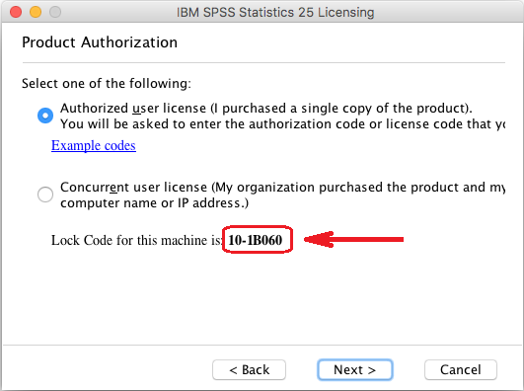
- If these steps fail, launch the License Authorization Wizard again and proceed to Product Authorization ​screen.
- Do not proceed beyond this screen. Note the ​lock code that is displayed in this window. For example, 10­1B060. Copy or write down this code.
- Send an email to the VCU IT Support Center (itsc@vcu.edu) describing your problems licensing. Include the exact lock code in the body of your message. Make the subject of your email “Problem licensing Mac SPSS 25.”
- Close out of the License Authorization Wizard.
The VCU IT Support Center​ will work to obtain a special license code for you that does not require an Internet connection. They will email this code to you in response. Please note this process may take one or more days to complete. When you receive the special license code via e­mail from the IT Support Center, follow the directions in the e­mail to license your SPSS software. If you continue to have licensing problems, please contact the IT Support Center (828­2227 or itsc@vcu.edu)​ for further assistance.

