Installing and licensing SPSS 24 for Linux
Install | License | License Failure | Fixes and Updates

Installation
You must be operating as the root user to install this software.
- Launch a terminal application (xterm, konsole, gnome-terminal, etc.) to open a window in which you can issues commands at a shell prompt.
- Identify the install file you downloaded previously. At the shell prompt, issue a ‘cd’ command to change directory to the directory containing the install file.

- Issue the following command to launch the installation:
sh SPSS_Statistics_24_lin.bin

- Wait while your computer prepares to install. The following messages may be displayed:
Preparing to install…
Extracting the JRE from the installer archive…
Unpacking the JRE…
Configuring the installer for this system’s environment…
Launching installer…

- Proceed through the screens to the Software License Agreement screen and read the terms of license. To install and use SPSS, you must accept these terms.** To continue, select “I accept…”
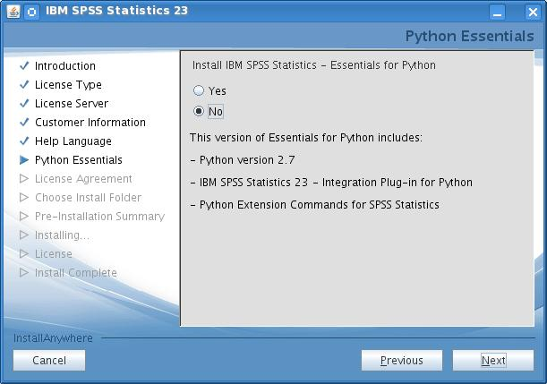
- Continue to Python Essentials. If you will be using Python with SPSS, select Yes and continue to the Python License Agreements. You must also accept the terms of those agreements to use Python with SPSS.

- Continue to the Choose Install Folder. Select the location where you would like to install and launch SPSS. (Multiple SPSS versions may be on the same computer if they are installed in separate folders.)

- Continue to the Pre-Installation Summary and select Install. A progress screen will display during installation.

- When installation completes, this “successful installation” screen will appear. DE-select the checkbox to “Start IBM SPSS 24 now” (as below). Then click Done to exit the license wizard.
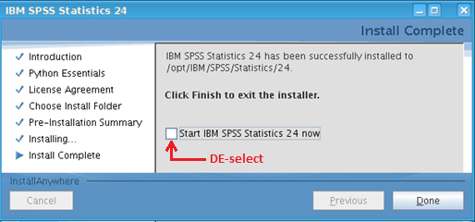
Continue to the Licensing SPSS section below to license your software.
** Note: To use SPSS as licensed through VCU, you must also abide by VCU’s SPSS License Terms.

Licensing SPSS
In order to use SPSS, licensing must be completed after the installation of SPSS software and again in June and December for renewal or re-licensing. During the installation, you read and agreed to the terms of the license. To use SPSS as licensed through VCU, you must also abide by VCU’s SPSS License Conditions.
Follow these steps to license SPSS:

- Ensure that you have a wired Internet connection (one that uses an Ethernet cable).

- Launch the SPSS License Authorization Wizard --- as the root user, go to the bin subfolder of the SPSS installation folder and run the program named licensewizard.

- Proceed through the License Status display.
(continued below)

- Continue to Product Authorization and select “Authorized user license.”
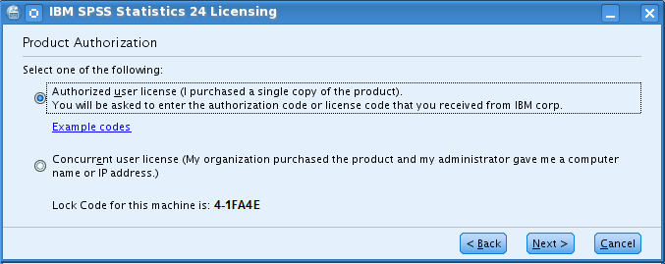

- Continue to Enter Codes.

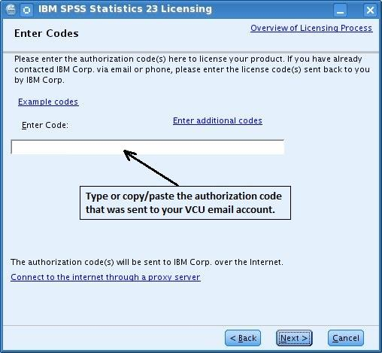
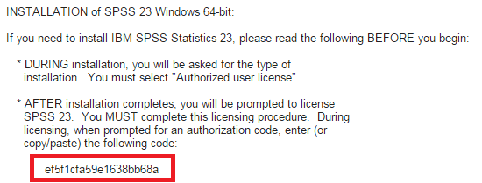
- Input the unique SPSS authorization code from the installation email sent to your VCU account.

\

- Continue to Internet Authorization Status and wait for the “Authorization succeeded” message.
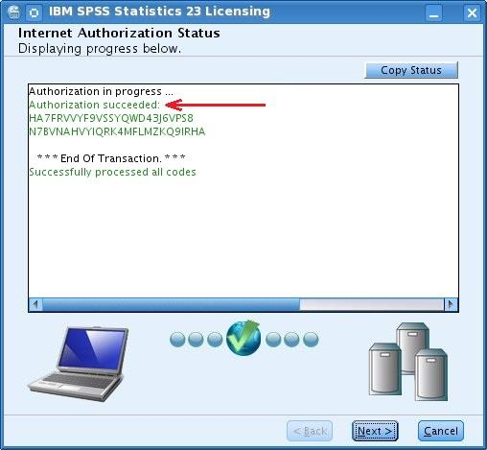
  - If you receive an “Authorization failed” message:
  - Double-check that your authorization code is entered correctly and that you are using a wired internet connection.
  - If unable to resolve, proceed to the steps for Licensing Failure below to obtain assistance from the IT Support Center.

- Continue to display the Licensing Completed message and select “Finish”

Licensing failure
If you have re-attempted to license and repeatedly received an “Authorization failed” message, follow these steps:
- Make sure you have attempted to license using a wired Internet connection using an Ethernet cable.
- Make sure you have correctly inputed your SPSS authorization code on the Enter codes page.
- If the authorization process fails even though the above two conditions are satisfied, then you must obtain assistance from the VCU IT Support Center (828-2227 or itsc@vcu.edu) in licensing your software. Please inform them that you have a problem licensing Linux SPSS 24.

Launching IBM SPSS Statistics 24
Note: You do not need to be the root user to launch and run IBM SPSS Statistics 24.
To launch/run IBM SPSS Statistics 24:
- Browse to the bin subdirectory of the IBM SPSS Statistics 24 installation directory.
- Run the stats file.

Fix packs & updates
As with all software, SPSS usually contains a few "bugs" (problems) that were unknown when the software was first released. IBM periodically provides free updates, called fix packs, that you can install to correct these problems.
There currently are no fix packs available for SPSS 24. However, you should regularly check for them at Linux Fix Packs. When fix packs do become available, instructions will be made available there for obtaining and installing them.

