The Basics: SPSS for Windows 10.0
SPSS Inc.
233 S Wacker Drive, 11th Floor
Chicago, Illinois 60606 312.651.3300
Training Department
800.543.6607
v10.0 Revised 9/ 30/ 99 ss
SPSS Neural Connection, SPSS QI Analyst, SPSS for Windows, SPSS Data
Entry II, SPSS-X, SCSS, SPSS/PC, SPSS/PC+, SPSS Categories, SPSS Graphics,
SPSS Professional Statistics, SPSS Advanced Statistics, SPSS Tables, SPSS Trends and SPSS Exact Tests are the trademarks of SPSS Inc. for its proprietary computer software. CHAID for Windows is the trademark of SPSS Inc. and Statistical Innovations Inc. for its proprietary computer software. Excel for Windows and Word for Windows are trademarks of Microsoft; dBase is a trademark of Borland; Lotus 1-2-3 is a trademark of Lotus Development Corp. No material describing such software may be produced or distributed without the written permission of the owners of the trademark and license rights in the software and the copyrights in the published materials.
General notice: Other product names mentioned herein are used for identification purposes only and may be trademarks of their respective companies.
Copyright(c) 1999 by SPSS Inc.
All rights reserved.
Printed in the United States of America.
No part of this publication may be reproduced or distributed in any form or by any means, or stored on a database or retrieval system, without the prior written permission of the publisher, except as permitted under the United States Copyright Act of 1976.

THE BASICS: SPSS FOR WINDOWS 10.0
TABLE OF CONTENTS
Chapter 1 Introducing SPSS
Starting SPSS for Windows 1-2
Opening an SPSS Data File 1-3
Running an Analysis 1-6
Building a Chart 1-10
Leaving SPSS 1-12
Summary 1-13
Chapter 2 Help and Output Navigation
Major Windows within SPSS 2-2
Using the Standard Toolbar 2-3
The Help System 2-4
How to Choose a Chart Type 2-6
Statistics Coach 2-9
Navigating Output 2-12
Showing and Hiding Output 2-13
Collapsing and Deleting SPSS Viewer Items 2-14
Summary 2-18
Chapter 3 Sources and Organization of Data
Sources of Data 3-2
Data Organization in SPSS 3-3
Survey Design 3-3
Sample Survey 3-4
Designing a Coding Scheme 3-5
Choices in Entering Data 3-5
SPSS Data Entry 3-6
Survey References 3-6
Summary 3-6
Appendix: Sample Data from an Engineering Application 3-7
Chapter 4 Entering and Reading Data
Data Fields 4-2
Entering Data Using the Data Editor 4-3
Reading Spreadsheets 4-5
Reading Databases Using the Database Wizard 4-8
Reading Text Data 4-17
Saving Data 4-33
Summary 4-35
Appendix: Saving Instructions 4-35
Table of Contents - 1
Chapter 5  Chapter 6  Chapter 7 | Variable View Sheet: Labels and Missing Values  What are Labels and Why are They Important?  Reading an SPSS Data File  The Variable View Sheet  Adding Variable Labels, Changing Type and Format  Entering Value Labels for a Numeric Variable  Adding Value Labels for a String Variable  Treating Data Values as Missing Information  Missing Values for a Numeric Variable  Missing Values for a String Variable  Using Labeled Variables in a Procedure  Saving the Modified Data File  Exiting SPSS for Windows  Note About the Data  Summary  Appendix: Entering Labels into Earlier Versions of SPSS  Examining Summary Data for Individual Variables  What Type of Summary Information Is Useful  Levels of Measurement  Appropriate Statistics  Producing Summaries for Nominal Variables  Bar Charts Displaying Frequency Tables  Producing Summaries for Ordinal Variables  Producing Summaries for Interval or Ratio Variables with Frequencies  Producing Summaries with the Descriptives Procedure  Statistical Definitions  Summary  Modifying Data Values  Displaying Values in SPSS Output  Recoding Values into the Same Variable  Recoding Values into a New Variable  Computing New Values  Listing Data Values  Saving an Updated Copy of the Data  Summary | 5-2  5-4  5-5  5-7  5-9  5-14  5-15  5-15  5-18  5-19  5-22  5-25  5-27  5-27  5-27  6-1  6-1  6-2  6-2  6-9  6-12  6-14  6-17  6-18 6-20  7-2  7-3  7-9  7-14 7-17  7-20  7-20

2 - Table of Contents
Chapter 8  Chapter 9  Chapter 10 | Crosstabulation Tables  A Simple Crosstabulation  Adding Cell Percents  Obtaining the Chi-Square Statistic  Adding a Control Variable  Result's Coach  Additional Features of Crosstabs Summary  Pivot Tables  Editing a Pivot Table  Changing the Display Order in a Dimension  Transposing Rows and Columns  Changing Column Widths  Removing or Adding Labels  Editing Text  TableLooks  Reorder Pivot Table Categories  Creating Graphs from Pivot Tables Summary  Creating Charts  Creating a Pie Chart (Standard Graph)  Editing a Standard Graph-Adding a Title  Editing a Standard Graph-Suppressing Data  Editing a Standard Graph-Changing Label Formats  Saving a Chart  Interactive Graphs: Creating a Stacked Bar Chart  Editing the Interactive Graph  Adding a New Variable to an Interactive Graph  The Chart Manager  Adding an Element to an Interactive Graph  Creating a Scatterplot (Interactive Graph)  Exporting Charts  Saving Charts Summary | 8-2  8-7  8-10  8-12  8-14  8-16 8-16  9-2  9-5  9-6  9-7 9-10  9-13  9-14  9-17  9-18  9-20  10-2  10-4  10-6  10-7  10-9  10-10  10-14  10-17 10-19  10-20 10-22 10-26 10-27  10-27
Table of Contents - 3
Chapter 11  Appendix A  Appendix B  Appendix C  Appendix D | Useful Features  SPSS Syntax  SPSS Journal File  Copy and Paste Variable View Properties  Applying Dictionary Information  Dialog Box Recall  Data Codebook  Summary  Appendix: SPSS Options  Multiple Response Variables  What are Multiple Response Variables?  Defining a Multiple Response Set  Defining a Multiple Response Set: Dichotomous Items  Frequency Tables Using Multiple Response Variables  Crosstab Tables with Multiple Response Variables  Handling Nonresponses Summary  Coding of General Social Survey 1991 Questions  Sample Questions  Adding Labels and Missing Value Codes in SPSS 9.0  Hands-On Exercises | 11-2  11-5  11-7  11-10  11-12  11-13  11-14  11-15  A-2  A-4  A-7  A-9  A-13  A-16 A-16

4 - Table of Contents

Chapter 1  Topics | Introducing SPSS  Starting SPSS  Opening an SPSS data file  Requesting an Analysis  Building a Chart  Leaving SPSS
INTRODUCTIONhe goal of this course is to enable you to perform useful analyses
T
on your data with SPSS for Windows. Keeping this in mind, the following chapters include such topics as reading data, adding
labels, performing basic statistical analyses, modifying data, and creating charts. This course guide will focus on the key elements necessary for you to answer basic questions from your data. As such it will not cover all topics in the SPSS Base 10.0 User’s Guide, which provides a more complete and detailed description of SPSS.
This chapter will introduce you to the basic environment of SPSS and demonstrate a typical session. We will run SPSS, retrieve a previously defined SPSS data file, and then produce a simple statistical summary and a chart. In the process you will learn the roles of the primary windows within SPSS and see a few features that smooth the way when running analyses. More detailed instruction about many of the topics touched upon in this chapter will follow in later chapters. Here we hope to give you a basic framework for understanding and using SPSS.
The data in this chapter are taken from the 1991 General Social
Survey by the National Opinion Research Center (NORC) at the University of Chicago, a survey collecting attitudinal, behavioral and demographic information from a representative sample of approximately 1,500 U.S. adults. Additional description about the General Social Survey data appears in Chapter 3.
Once you are at the Windows desktop, you start SPSS by doubleclicking on the short-cut labeled SPSS for Windows (if present), or by running it from the Start Button.
STARTING SPSS 1) Click Start..Programs..SPSS for Windows..SPSS 10.0 for

FOR WINDOWS ^{Windows}
- Click the Cancel pushbutton to close the Startup dialog box
- Click File..Switch Server

Figure 1.1 SPSS Server Login Dialog
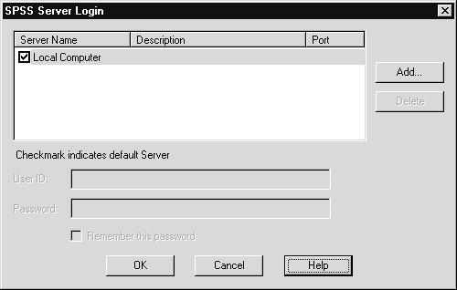

Note about Data
File Access

When Running
SPSS 10 from a Remote Server
SPSS for Windows 10.0 can run entirely on your desktop machine. Alternatively, an SPSS Client, through which you request analyses and view results, can run on your desktop, while the analyses are run by the SPSS Server, possibly located on a different machine. In this course, except for the directory you use to access the training data files, it makes no difference whether the SPSS Server is located on your desktop or a different computer. The SPSS Server Login dialog (click File..Switch Server) allows you to connect to a remote SPSS Server (if installed on your network).
If you are running SPSS from a Remote (not Local) server, then to use the data files accompanying this course, they must be copied either to the server running SPSS or to a directory that can be accessed by the server. The directory references in this guide assume you are running SPSS as a local server and can thus directly access files stored on your hard drive.
4) Click Cancel pushbutton to close the SPSS Server Login dialog box
When SPSS begins a Startup-Wizard dialog box opens, prompting you to access data or run a tutorial. One window (the Data Editor window) is open. Other SPSS windows will open as we create and edit tables and charts, or create SPSS syntax commands. We will view some of these windows in the course of this chapter; others will be explored later in the course. The tool bar contains useful shortcuts and helpful features when running SPSS for Windows.
Figure 1.2 SPSS Data Editor Window (Data View Tab Sheet)
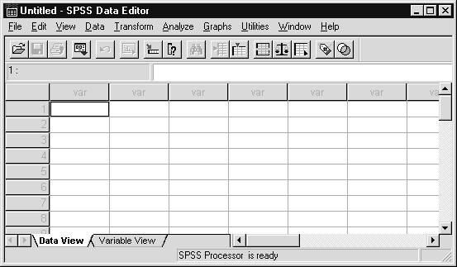

How Variables Display in Dialog Box

OPENING AN SPSS DATA FILE
Either variable names or longer variable labels (see Chapter 5 for details on how to build variable labels) will appear in list boxes within SPSS dialogs. Additionally, variables within list boxes can be ordered alphabetically or by their position in the file. In this course, we will display variable labels in alphabetic order within list boxes. For a new user of SPSS, this provides a more complete description of variables in an easy-to-follow order. In more advanced courses, we typically display variable names in alphabetic order.
Since the default setting within SPSS is to display variable labels in file order, we will change this before accessing data. A brief introduction to environment settings within SPSS can be found in Chapter 11.
- Click Edit..Options
- Click Display labels option button in the Variable Lists area of the General tab
- Click Alphabetical option button in the Variable Lists area of the General tab
- Click OK and then click OK to confirm the change
In order to analyze data, you must first have data present in the Data
Editor window. You can use the main menu File choice to open an

existing SPSS data file (or click on the Open File tool on the tool bar).
- Click File..Open..Data on the main menu
(or click the Open File tool button )
SPSS displays the Open File dialog box that lets you specify the name, directory and type of file you wish to read. By default, SPSS data files (those with extension .SAV) in the SPSS folder (usually the Program Files\ Spss subdirectory, which contains SPSS) are displayed. You can change these specifications to read other SPSS files (output, syntax) or different types of data files (see Chapter 4) from different folders. To read the General Social Survey file, change the folder to Basewin10 (located within the Train folder, this folder/directory contains all files used in the course) and pick the name Gss91Small (Gss91Small.sav) using the steps listed below. The completed Open File dialog box is shown in Figure 1.3.
- Click on the up one level folder tool until you reach the top level of the C: hard drive
- Double-click on the Train folder from the list of folders
- Double-click on the Basewin10 folder
- Click Gss91Small in the Files list box (following Windows convention, the .sav extension does not display)

Figure 1.3 Open File Dialog Box
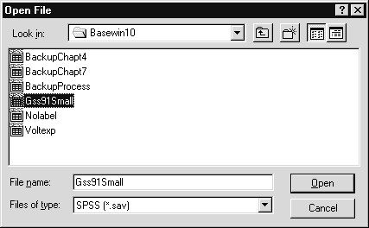
After identifying the data file:
- Click Open to open the SPSS data file
SPSS places the data into the Data Editor window, shown in Figure 1.4. You can make changes to individual entries in the file by highlighting a cell and typing the new data value. You can also add new data to the file via the Data View tab sheet of the Data Editor window. Either the mouse or the keyboard can be used to move within the Data Editor window in the usual Windows way.
- Place the cursor over marital at the top of the second data column in the Data View tab sheet

Figure 1.4 SPSS Data File Displayed in Data Editor Window
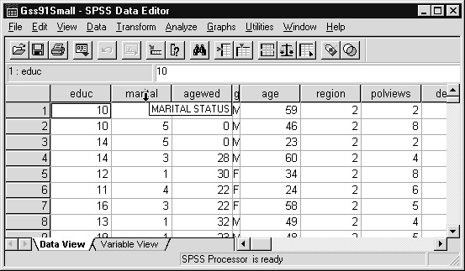
Variable labels (if supplied—see Chapter 5) pop up when the cursor is placed on a variable name in the Data View sheet of the Data Editor window. If labels have been supplied for data values (see Chapter 5), then you can choose whether to display the actual data values or the value labels in the Data View sheet of the Data Editor window. Currently the data values from the survey appear. You can use the View menu or the Label tool to instruct SPSS to display value labels.
8) Click View..Value Labels (so that Value Labels is checked)
Alternatively, click the Label tool on the tool bar
As shown in Figure 1.5, SPSS now displays any labels that have been assigned to the data. This makes it easier to interpret an individual’s responses.

Figure 1.5 Data Editor Window with Labels Displayed
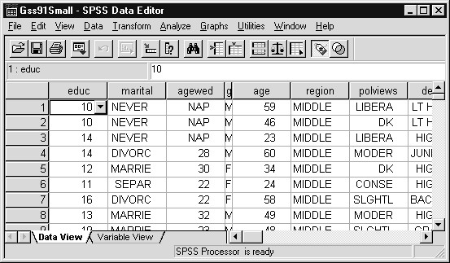
Once you choose to display value labels, SPSS retains this specification and applies it to future data files in the Data Editor. To reset the Data Editor so it again displays actual data values:
9) Click View..Value Labels in the main menu (so that the check is removed from Value Labels)
Or, click the Label tool (which is currently depressed)
RUNNING AN  ANALYSIS | The Analyze menu contains a list of general reporting and statistical analysis categories. Most of the categories are followed by an arrow (>), which indicates that there are several analysis procedures available within the category; they will appear on a submenu when the category is picked.
1) Click Analyze on the main menu

Figure 1.6 Analyze Menu
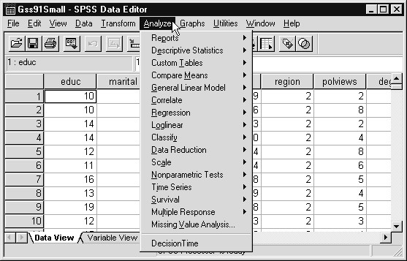
The list in Figure 1.6 is based on a complete SPSS system (optional modules included). Many statistical procedures are available, from basic frequency and crosstab tables (Descriptive Statistics) to such advanced statistical techniques as regression, factor analysis, and time series modeling. In this course we focus on a few basic statistical procedures. However, the more complex statistical analyses are set up using dialog boxes in the same way as we will do for simpler analyses. Let’s produce some frequency tables.
- Click Descriptive Statistics..Frequencies on the Analyze menu
- Scroll down the Variables list and place the cursor over theSubjective Class… variable

Figure 1.7 Variable Names and Labels in Frequencies Dialog Box
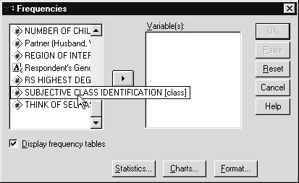
Notice that a more complete description of the variable pops up when the cursor touches it, similar to what we saw in the Data Editor window. The variable name is “class” and it has the variable label “Subjective Class Identification.” Note the variable name appears in square brackets. If there were no variable label, only the variable name would appear in the list box (see prob1).
In the Frequencies dialog box we must indicate which variables we wish to analyze. Notice that the OK button, which runs the analysis, is gray, or inactive, until at least one variable is placed in the Variable(s) list box. Additional labeling information can be easily obtained for any variable on the list by clicking on the variable name with the right mouse button.
- Click the right mouse button on Subjective Class...[class]
- Click (left mouse button) Variable Information
- Click the drop-down arrow to the right of the Value
Labels list (in the information window)

Figure 1.8 Information About Subjective Class Variable
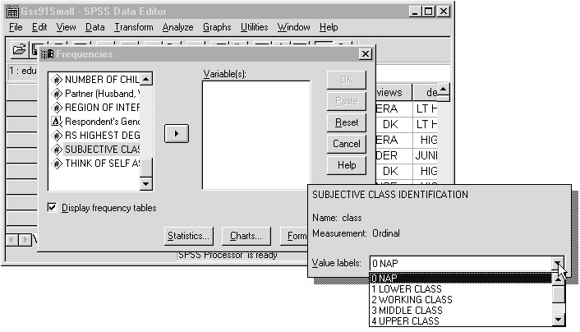
Thus when labeling information is provided, you have quick, direct access to it when running analyses. We will request frequency analyses on social class (class) and education (highest year of school completed educ).
- Click Subjective Class..[class], then click the right-arrow button (to place class on the Variable(s) list)
- Click Highest Year of School Completed [educ], and then click the right-arrow button

Figure 1.9 Completed Frequencies Dialog Box
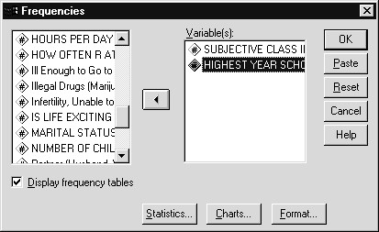
The pushbuttons at the bottom of the dialog box can be used to request descriptive statistics (Statistics), pie charts, bar charts or histograms (Charts) for the selected variables, and to select formatting options (Format). We will explore these features in later chapters. Notice most variables have a pound sign beside them. The pound sign
indicates the variable is numeric. The letter A identifies a string variable (which can contain text), for example, Respondent’s Gender [gender]. The "less than" sign (<) beside the A identifies gender as a short string (eight characters maximum) variable.
- Click OK to run the frequencies analysis
- Click the item labeled “Subjective Class..” in the Outline
(left side) pane of the now-open Viewer window

Figure 1.10 SPSS Viewer Window
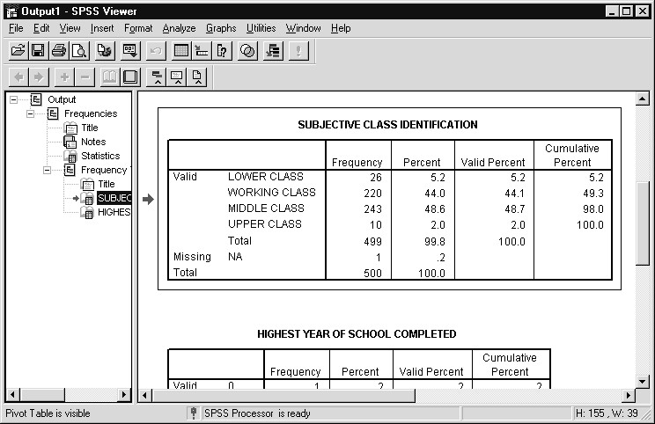
An outline of the output content appears in the Outline pane (left pane) of the Output Viewer window. The right pane, or Contents pane, contains the statistical tables (or charts, or text output) themselves. The Contents pane displays the details of the item highlighted in the Outline pane. You can navigate using the scroll bars in the Contents pane, or simply click on an item in the Outline pane to go directly to the corresponding table or chart. We see from Figure 1.10 that most adults described themselves as belonging to the working or middle class. By scrolling down in the Contents pane (or clicking the Highest Year of School Completed Frequencies item in the Outline pane) we would reach the frequency table based on education.
BUILDING A CHART | Although some of the statistical procedures in SPSS for Windows contain an option to produce high-resolution charts (we saw this in the  Frequencies dialog box), we will request a chart directly from the Graphs menu. Suppose we wish to view the relationship between age when first married and education. A line chart would provide a reasonable representation of this information. We can create charts or run additional statistical summaries from either the Data Editor or Output Viewer windows. We will produce an Interactive Graph which allows greater customization and editing flexibility than standard charts.
- Click Graphs..Interactive..Line from the main menu
- Drag and drop Age When First Married [agewed] to the vertical-axis list box
- Drag and drop Highest Year of School Completed [educ] to the horizontal-axis list box

Figure 1.11 Create Lines Dialog Box
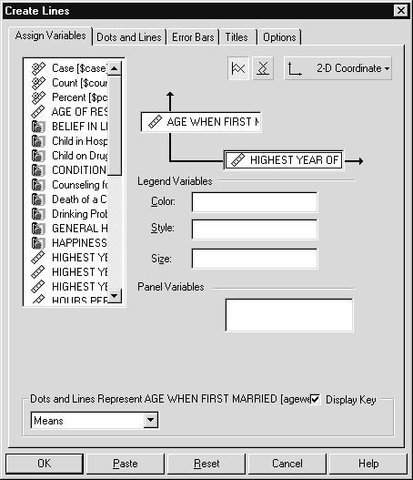
We have provided all necessary information for our line chart. Many aspects of the chart are controlled through the remaining tab sheets. For example, the Options tab is used to control such chart features as chart size, category order, and the display of missing values. Titles can be added using the Titles tab (Chapter 10 is devoted to charts).
- Click OK to produce the chart
- Click the item labeled “Line Chart” in the Outline (left) pane of the Output Viewer window

Figure 1.12 Line Chart in the Output Viewer Window
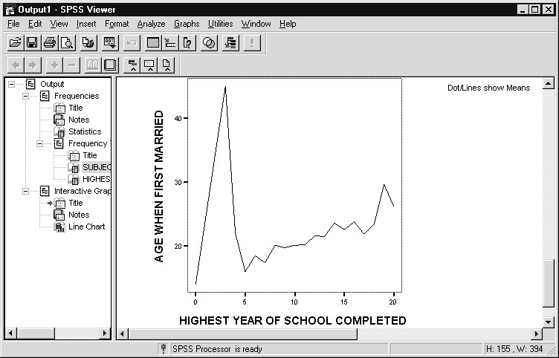
The chart is added to the Output Viewer window; an Interactive Graph item appears at the bottom of the Outline pane and the chart itself is appended to the Contents pane. We see that for those with 5th grade or higher education there is a fairly steady increase in age first married as education increases. There is also a pronounced peak at 3rd grade, which is probably due to having very few respondents (perhaps only one) with 3rd grade education. Moving up in the Contents pane and reviewing the frequency table of education could check this. The graph can be edited by double-clicking on it (which opens an Interactive Graph Editor window) and, if you wish, it can be copied to the clipboard and pasted into other applications, or saved to disk in several formats.
At this point we could create additional reports, statistical tables or charts, or edit those we have already created; instead we will end the SPSS session.
LEAVING SPSS To complete this session, we will leave SPSS and return to the desktop.
1) Click File..Exit
When you leave SPSS, you will see messages asking whether you want to save the contents of any windows that have changed during the session. In this session we produced some frequency tables and a line chart in the Output Viewer window. Figure 1.13 shows the message concerning the contents of the Output Viewer window.

Figure 1.13 Alert Box Asking to Save Output Viewer Contents
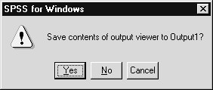
Since we have made no changes to the Data Editor window, there is no request to save the contents of that window. Also, since we can easily recreate the frequency tables and chart later, we will not save the contents of the Output Viewer window. Note: the contents of this Output Viewer window were saved during a previous session and will be examined in more detail in Chapter 2.
2) Click the No button in the Save Contents alert box
SPSS now closes and you are returned to the Windows desktop.
SUMMARY In this chapter you have seen a typical SPSS session, been introduced to the primary windows within SPSS, and used dialog boxes to produce frequency tables and a chart.

Chapter 2 | Help and Output Navigation
TOPICS | Major Windows within SPSS for Windows  Using the Standard Tool Bar  The Help System  How to Choose a Chart Type  Statistics Coach  Navigating Output  Showing and Hiding Output  Collapsing and Deleting Output Viewer Items
INTRODUCTIONPSS for Windows uses the standard Windows interface and
S
Help system. For this reason, if you have used other Windows software, the transition to SPSS for Windows is easy. The purpose
of this chapter is to introduce you to the major windows within SPSS for Windows and explore some very useful features of the Help system and the Output Viewer.
MAJOR When you first run SPSS you reach the screen below.

WINDOWS
_{WITHIN SPSS} 1) Click Start..Program Files..SPSS for Windows..SPSS 10.0 for Windows
2) Click Cancel to close the Startup wizard dialog

Figure 2.1 Data Editor Window within SPSS
By default, SPSS opens one window: the Data Editor window (displaying the Data View tab sheet). The Data Editor window stores the data to be analyzed and must remain open (cannot be closed) because without data, analyses cannot be performed. After running the first analysis, the Output Viewer window opens, displaying the charts, pivot tables and text output created by SPSS procedures.
In addition to these windows, six editor windows exist in order to edit charts (Chart Editor and Interactive Graphs Editor windows), text output (Text Editor window), pivot tables (Pivot Table Editor window), SPSS syntax commands (Syntax window), and SPSS Scripts (Script Editor window). In this course we will introduce you to these windows, devoting most attention to those commonly used.
USING THE  STANDARD TOOLBAR | SPSS for Windows contains a standard toolbar that provides quick access to commonly used functions within the system. In addition to the standard toolbar, there are toolbars providing specific functionality in the Output Viewer window. The Outlining toolbar enables you to rearrange and reorganize the contents of the Output Viewer window. Editing toolbars are available to edit charts, pivot tables, and text output. Below we describe some helpful buttons on the standard toolbar. In this section we will introduce only a few of the tool functions; others will be discussed later in the course. If you are curious about the use of a tool, merely place the cursor over the button and a brief description of its function (ToolTip) will appear beside the tool.  Note that the View menu controls which toolbars are visible and you can customize toolbars (click View..Toolbars).
The first set of tools is probably recognizable from other Windows applications you have used.
The open file tool invokes the File..Open menu choice, the floppy disk (Save File) tool will run the File..Save menu choice, and the printer tool calls the File..Print menu choice.
SPSS maintains a list of recently accessed dialog boxes. Clicking on the Recall Dialog Box tool shown below will invoke the list. You then click on the name of the dialog box to which you wish to return.
There are other useful tools that we will explain later in the course. Both the Help system and the SPSS Base 10.0 User’s Guide contain additional information about the tools on the toolbars.
THE HELP SYSTEM | The SPSS Help system is similar to those of other Windows applications. You can invoke help by clicking on the Help menu choice located on the main menu. In addition, most dialog boxes contain a Help button that leads to context-sensitive help.
1) Click Help..Topics on the main menu

Figure 2.2 Topics within the Help System
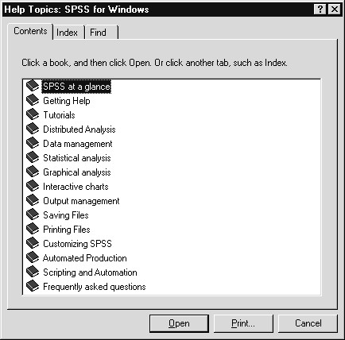
The first tab sheet, Contents, contains a table of contents of the help system. This is probably the most effective approach to the help system if you do not have a specific topic or keyword in mind. The Index sheet searches for help topics whose categories match the keyword you specify. The Find sheet allows you to search for specific words or phrases anywhere within the Help system. If we had earlier chosen Help..Tutorial we would reach a tutorial system, useful when first approaching SPSS for Windows.
On the Contents sheet, the topics “SPSS at a glance” and “Frequently asked questions” are useful to new users, as are the tutorials mentioned above. The other items cover broad areas of SPSS likely to be of interest. To obtain information about any topic, double click on the book icon to the left of the topic, or click on the book icon once to select it, then click the Open pushbutton.
- Double click the book icon beside Frequently asked questions
- Double click the book icon beside Opening Data Files

Figure 2.3 Frequently Asked Questions About Opening Data Files
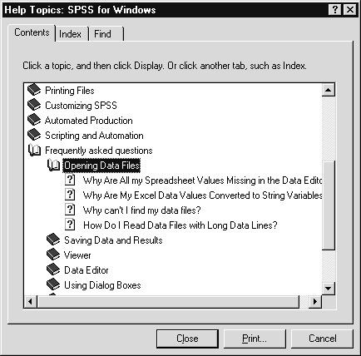
Our Technical Support staff is often asked about these topics. There are several questions under “Opening Data Files.” Double clicking on the question mark icon preceding a question (or click on the question mark icon , then click the Display pushbutton) will lead to detailed information about the topic. After reviewing help on a specific topic you can return to the Content or Index sheets, print the help window, branch to a related topic (if available), or exit the Help system by clicking the Close box .
HOW TO  CHOOSE A CHART TYPE | The Graphical Analysis section of the Help Contents sheet covers a number of topics concerning chart production, editing, and transfer. Since SPSS is capable of constructing many chart types based on different characteristics or views of the data, the help section on “Finding the chart type you want” is a valuable aid in making the best chart choice. We will proceed to investigate the Graphical Analysis help subsystem.
- Double click the book icon beside Graphical Analysis
- Double click the book icon beside Finding the chart type you want

Figure 2.4 Help for Graphical Analysis
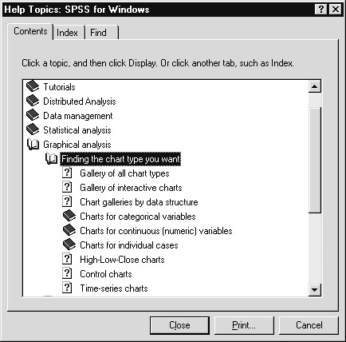
We can obtain a gallery of all chart types, view chart galleries grouped by the structure of the data, or obtain more detailed help about specific graphs.
3) Double click the question mark icon beside Chart galleries by data structure

Figure 2.5 Chart Galleries by Data Structure Help Window
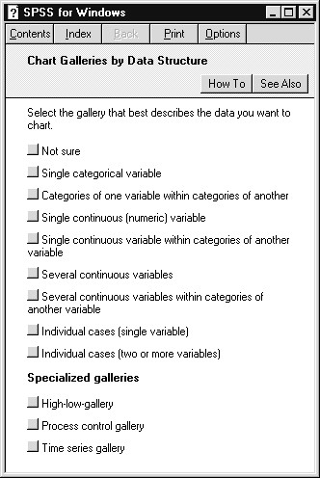
Simple scenarios describe different sorts of data situations. Choosing
one (by clicking the shaded box
) will lead to a help window listing
charts that represent such data. To demonstrate, we will choose Categories of one variable within categories of another.
4) Click the shaded box icon beside Categories of one variable within categories of another

Figure 2.6 Charts Representing Two Categorical Variables
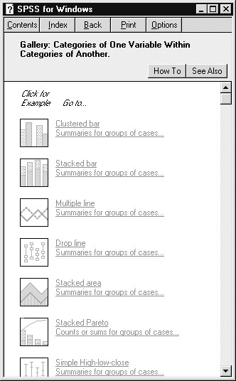
We see a set of chart types that can represent the specified relation between two variables. You can click on the sample chart icons for a more detailed example. Click on the underlined text and you will go to the full detail help screen describing the chart’s dialog box. The How To pushbutton leads to a window describing the menu choices that take you to the menu or dialog box of interest. The See Also pushbutton will list related topics that you can access. In this way you can explore possible ways of presenting data given the nature and relations of the variables.
5) Click the close box in the Gallery: Categories of One Variable Within Categories of Another help window to exit the Help system.
We have examined the Help system in several specific areas and demonstrated its usefulness as a quick guide and information source when you are running SPSS for Windows. Although the SPSS Base 10.0 User’s Guide and SPSS Base 10.0 Applications Guide present a wealth of information about SPSS, the Help system contains much that is of direct, immediate and practical use. We suggest you explore this system during your first hands-on session.
STATISTICS  COACH  Note | SPSS contains a help facility that suggests the appropriate statistical analysis within the SPSS Base system given the questions you want to ask about your data and the type of measurements made. It is important to note that since the Coach is limited to procedures within the SPSS  Base system, it will not suggest analyses contained in optional modules (for example, SPSS Advanced Models), nor will it suggest analyses unavailable in SPSS. Thus it is not a complete statistical advisor system, but an aid within the SPSS Base system. After invoking the Statistics Coach (Help..Statistics Coach), you first provide broad, then more specific information about what you want to do, until the search narrows to a particular statistical analysis. We demonstrate the Statistics Coach by asking about group comparisons.  The Statistics Coach is an optional component listed when installing SPSS for Windows. For this reason, it may not have been placed on on your machine. If not, it can be added by rerunning the SPSS installation setup and checking the Statistics Coarch as a component for installation.
Since the Data Editor window is empty, we must first access data. We will use the 1991 General Social Survey data we saw in Chapter 1.
- Click File..Open..Data on the main menu (or click the Open
File tool )
- Click on the up-one-level folder tool until you reach the top level of the C: hard drive
- Double click on the Train folder from the list of folders
- Double click on the Basewin10 folder
- Click Gss91Small in the Files list box

Figure 2.7 Open File Dialog Box
After identifying the data file:
- Click the Open pushbutton to open the SPSS data file
With data in the Data Editor window we can now invoke the Statistics Coach.
- Click Help..Statistics Coach
- Click the Compare groups for significant differences option button

Figure 2.8 Statistics Coach Main Dialog Box
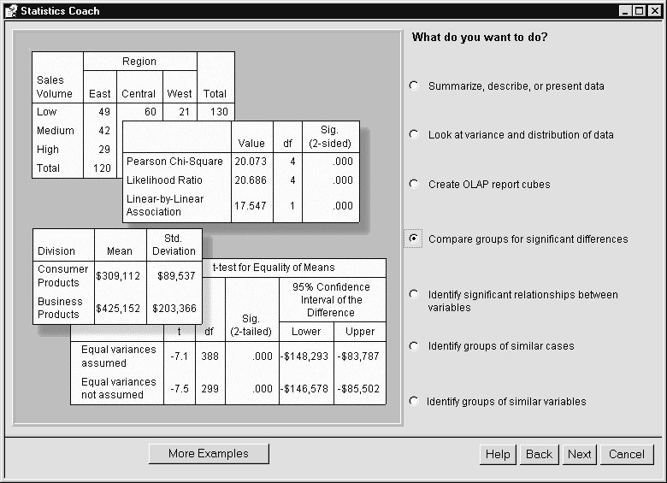
The first Statistics Coach dialog box describes broad types of analyses. After selecting one (here "Compare groups..."), click the Next pushbutton to pursue the topic.
9) Click the Next pushbutton

Figure 2.9 Comparing Groups Help Dialog Box
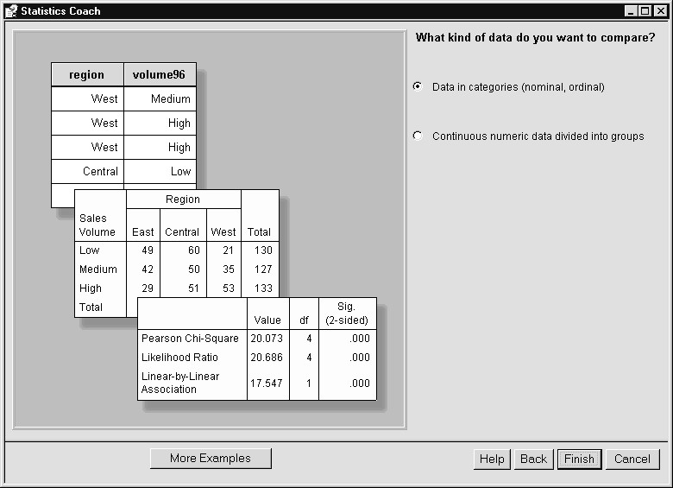
If the data are categorical, crosstabulation analysis and the chisquare test are suggested. If we indicate the data are continuous, then a Next button will replace the Finish button, and additional questions will be asked (concerning number of groups and how they are organized) when Next is clicked.
To learn how to reach the dialog box for the suggested analysis (here crosstabulation), simply click on the Help pushbutton. This leads to a "How-to" dialog box describing the menu choices required to open the analysis dialog box and instructions about the information you must provide. Clicking the Finish pushbutton will take you to the main dialog box of the identified analysis procedure.
Thus the Statistics Coach can be very useful in suggesting which SPSS Base procedure is most appropriate to address a specific research or analysis question.
4) Click the Cancel pushbutton to close the Statistics Coach
Hint SPSS provides definitions of statistical terms appearing in pivot tables through the Help..What's this? menu choice made after selecting the term within the Pivot Table editor. Also, the Result's Coach, which applies to pivot tables, provides information that can help you interpret results (see Chapter 8).
NAVIGATING OUTPUT | You can run many analyses during a single SPSS for Windows session and quick navigation through the output is helpful. We now discuss how to maneuver within the Output Viewer window. We will work with a previously (prior to this class) saved SPSS Viewer document that contains the results generated from the same analyses we ran in Chapter 1.
- Click File..Open..Output (if you are still in the Basewin10 folder, then skip steps 2-4)
- Click the up one level icon until you reach the top level of the hard drive
- Double click on the Train folder
- Double click on the Basewin10 folder (within the Train folder)
- Click the Output Sample document to select it

Figure 2.10 Opening an Output Viewer Document (File)
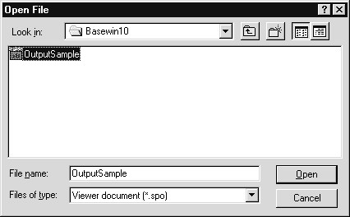
6) Click the Open pushbutton to open the document.

Figure 2.11 Output Viewer Window
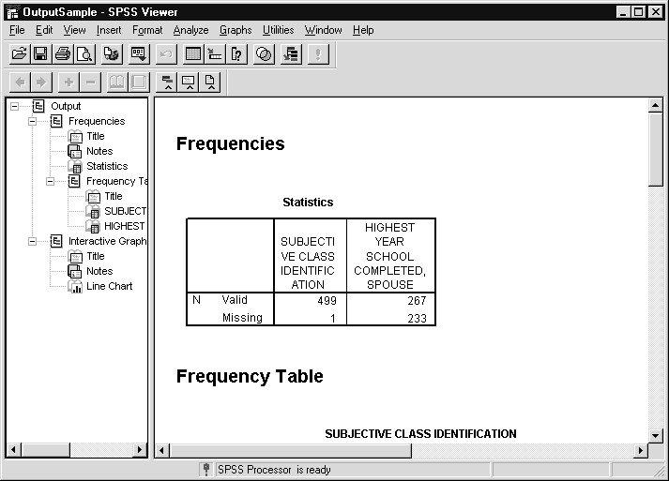
The Output Viewer window contains output (charts, pivot tables, text output, titles and notes) created by SPSS procedures. The Viewer window is split into two panes. The Outline pane, located on the left, contains an outline identifying the items contained in the window, while the Contents pane on the right displays the detailed results. You can move in the Viewer window by clicking on an item in the Outline pane, or by scrolling in the Contents pane.
If you find the Outline pane difficult to read, you can change the size and font of the outline elements using the View menu (click View..Outline Size or View..Outline Font within the Output Viewer window).
SHOWING AND HIDING OUTPUT | The Outline pane has a tree-like structure with the SPSS Output item, referring to all results in the window, at the topmost level. As shown in Figure 2.10, the secondary level contains items representing results from the two procedures run during the session in Chapter 1: Frequencies and Interactive Graphs. The boxes to the left of these items, which currently contain minus signs, are used to collapse (when minus sign is present ) or expand (when plus sign is present ) the items. If an item is collapsed, it no longer appears in the Contents pane.  We see from the Outline pane in Figure 2.10 that Frequencies contains six items besides the headers: Title (2), Notes, Statistics, Subjective Class Identification, and Highest Year of School Completed.  The labels for the latter two items are only partly visible. Looking at the  Contents pane, we see the title “Frequencies” and the Statistics table  (labeled “Statistics”), but no Notes. Returning to the Outline pane, notice
the open book icons beside Title ( ) and Statistics (), and the closed book icon beside Notes ( ). Items with open book icons in the Outline pane are shown in the Contents pane; those with closed book icons in the Outline pane are hidden in the Contents pane. To show the contents of the Frequencies Notes item we simply double click on the Notes closed book icon.
- Double click on the closed-book icon beside Frequencies Notes in the Outline pane (or click on the closed book icon
, then click the Show Item tool button on the Outline toolbar)
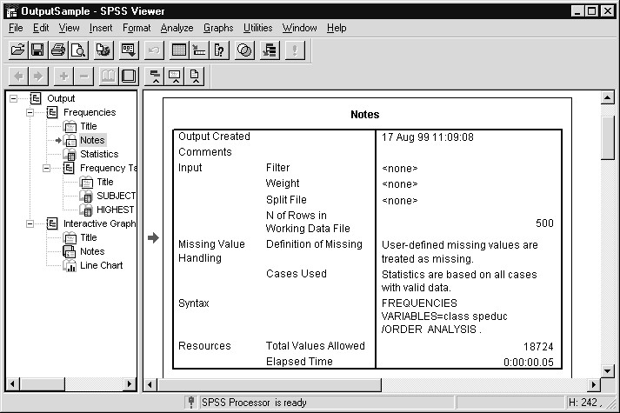
Figure 2.12 Notes Shown in Contents Pane
The Notes section presents technical information about the analysis: data file name, number of cases, missing value status, the SPSS Syntax command (see Chapters 4 and 11 for more information) that would run the analysis, and resources used. Since the Notes now appear in the Contents pane, an open book icon precedes the Notes item in the Outline pane. Also notice arrows point to the Notes item in the Outline pane and the Notes in the Contents pane to remind you which item is selected.
- Click the open book icon beside Subjective Class
Identification in the Outline pane

Figure 2.13 Pivot Table of Self-Reported Social Class
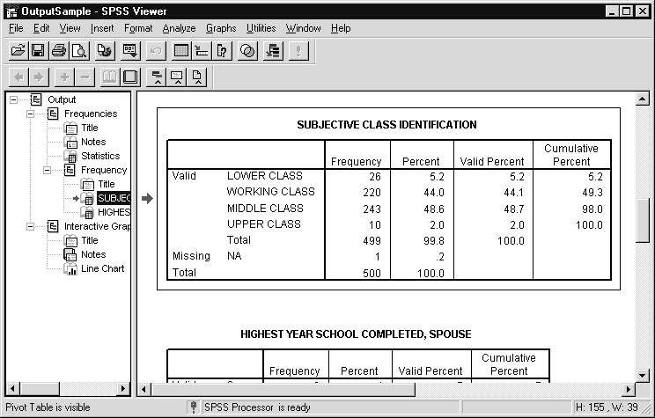
The Contents pane of the Output Viewer window scrolls to the frequency table of subjective class identification; arrows in each pane indicate the item currently selected. The frequency table is a pivot table that can be pivoted, edited in terms of font, style and content, and inserted into a word processing document or spreadsheet. Chapter 9 contains an introduction to some of these features.
COLLAPSING  AND DELETING  SPSS VIEWER ITEMS | If we no longer wish to see the frequency analysis in the Contents pane yet want to retain the results for later viewing, we simply collapse the item in the Outline pane.
1) Click the box containing the minus sign left of the first Frequencies heading in the Outline pane.

Figure 2.14 Collapsing Frequency Results in Output Viewer Window
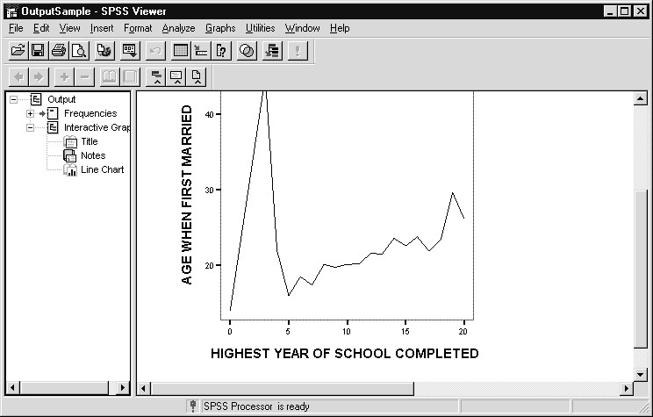
The items nested under Frequencies have disappeared from both the Outline and Contents panes, so the line chart is now visible. Also, a plus sign is now present to the left of Frequencies in the Outline pane. This enables us to later expand the frequencies output.
To delete an item from the Output Viewer window we only need select the item and press the delete key (or click Edit..Delete). Deletion can be performed at any level of the hierarchy in the Outline pane. To demonstrate we will delete all the output from the Interactive Graph item.
2) Click the Header icon beside the Interactive Graph item in the Outline pane

Figure 2.15 Selecting all Interactive Graph Items
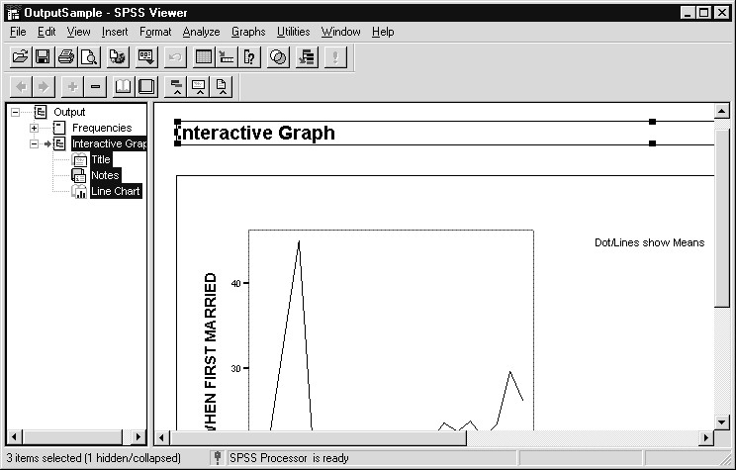
We selected all related Interactive Graph items (Title, Notes, and Line Chart) in both the Outline and Contents panes. We could have selected a single Interactive Graph item, for example Notes.
3) Click Edit..Delete (or press the delete key)

Figure 2.16 SPSS Viewer Window after Deletion
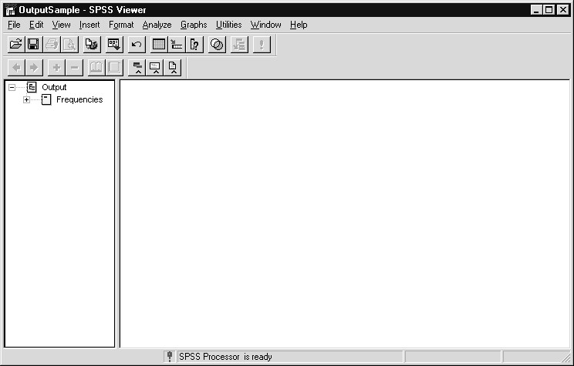
The Contents pane of the Output Viewer window is now empty because we have deleted all items related to the Interactive Graph and collapsed the main Frequencies item. If we expanded the Frequencies item in the Outline pane, we would again see frequency results in the Contents pane. We will now exit SPSS for Windows.
- Click File..Exit
- Click No when asked to save contents of the Output Viewer
Hint: In addition to hiding and showing, items in the Outline pane can be reordered (by clicking and dragging), and promoted or demoted in the Outline pane hierarchy (using the Outline toolbar). Also, most of the summary tables within SPSS are in the form of pivot tables. Pivot tables can be pivoted, edited in terms of font, style and content, and easily inserted into a word processing document or spreadsheet. As mentioned earlier, Chapter 9 contains an introduction to some of these features.
SUMMARY In this chapter we discussed the types of windows opened when SPSS for Windows runs. Secondly, we explored a number of features of the SPSS for Windows Help system, focusing on chart types. Finally, we discussed navigating and manipulating views in the Output Viewer window.

Chapter 3  TOPICS | Sources and Organization of Data  Sources of Data  Data Organization in SPSS  Survey Design  Sample Survey Questions  Design a Coding Scheme  Choices in Entering Data  Appendix: Sample Data from an Engineering Application
INTRODUCTIONerhaps the most difficult part of carrying out a research project is obtaining useful data. Often you may have good questions to ask, but finding the correct data to answer the questions is not always
P
easy. This chapter opens with a brief discussion of issues related to gathering data for a research project. There are numerous sources of data available to the insightful researcher. Quite often the data you need to address a specific issue may already be available. We will introduce the various options available with SPSS for Windows for reading in the data from some of these sources.
When secondary data (data previously collected by others) do not answer the questions being asked or are simply not available, it may be necessary to collect your own data. This process is expensive and time consuming, so it is critical that the methods used for collecting data are efficient and effective for obtaining the information you need. Part of this chapter will focus on survey research and using surveys as your primary source of data.
Some of the information we present in this chapter is taken from Chapters 1 through 4 of the SPSS 10.0 Guide to Data Analysis.
SOURCES OF Carol H. Weiss, in her book on Evaluation Research, states that the only DATA limits on sources and techniques for data collection are the ingenuity and imagination of the researcher (Carol H. Weiss, Evaluation Research, 1972). In the real world there may be other limitations than one’s imagination. When beginning a research project the source of data you select for your analysis will be determined by a number of intervening factors such as the resources available for collecting data, time constraints, or the exact data you need are just not available anywhere. When these factors or a host of others preclude original data collection you may need to turn to other sources.
Below is a partial list of sources of data.
interviews questionnaires observation
ratings (by peers, staff, experts)
psychometric tests of attitudes, values, personality, preferences, norms, beliefs
institutional records government statistics
tests of information, interpretation, skills, application of knowledge
projective tests
situational tests presenting the respondent with simulated life situations
diary records physical evidence clinical examinations financial records
documents (minutes of board meetings, newspapers, transcripts, etc.)
This list is by no means exhaustive. It is only to provide you with some ideas of available sources of data. The research objectives, the resources available, and a strong dose of ingenuity and imagination will guide you in selecting methods.
DATA  ORGANIZATION  IN SPSS  SURVEY DESIGN | Before considering the actual data to be used in this course, it might be useful to discuss the general way in which SPSS for Windows organizes data.  Rows  If you think of a data file residing in the Data View tab sheet of the Data Editor window, each row corresponds to a unit to be analyzed. For a survey of individuals, each row would represent a respondent. In a data file containing information on Fortune 500 companies, each row would correspond to a company. In a scientific experiment, each row might correspond to a single recorded observation. For sales summary data, each row might correspond to a time unit (for example, one month).  Columns  Each column in the Data Editor corresponds to a specific measurement or type of recorded information. In many areas of research these measurements are called variables, in some engineering fields they are  called characteristics. If in an interview we record five pieces of information from each individual, we would have five variables, or columns of data. If in a manufacturing process we record time of day, pH and temperature of a chemical process, we have three variables. Those using survey instruments should be aware that the number of variables or columns might be greater than the number of questions in a survey. This would occur if questions have several parts, or if multiple responses to a single question are permitted.  While there are exceptions to the general rules above (if the same individual is measured at two time points, should the data be placed in one row or two? Answer: it depends on the analysis, but if you wish to look at change at the individual level there should be only one row per individual), thinking about data in this way will facilitate your use of SPSS for Windows.  There are many excellent texts on designing surveys, defining a population, choosing a sample, and gathering data. The intent of this chapter is not to present you with this information (although some references are included) but rather to raise some of the issues related to these topics. SPSS is an excellent tool for analyzing survey information; however, the results you receive from the analysis are only as good as the information SPSS has to work with. The key to successful data analysis is to work with quality information. Asking the right questions, sampling from the correct population, working with a reliable sample, and clean data entry are all critical to the quality and reliability of the end product.
In the early stages of designing a survey instrument it is useful to consider the methods that will be used for data analysis. In determining the methods that will be used, two criteria should apply. First, what is the question you are interested in answering? Second, and critical to success for the first, is the type of data available to answer the question. The type of data collected and the question you want to answer will determine the statistical technique used for the analysis.
SAMPLE SURVEY The data used in this course are based on a survey of a national sample of U.S. adults done in 1991 by the National Opinion Research Center (NORC). This study has been performed almost every year since 1972, and about 1,500 respondents are interviewed each year. Demographic, attitudinal and behavioral questions are asked. For use in this class, we have selected a subset of 30 or so survey questions based on 500 (randomly sampled) of the 1,500 respondents.
We are interested in exploring these data to understand the distribution of such demographics as marital status, region in which the respondent lives, and age. We will also look at the distribution of age when first married, education, and how happy the respondent feels in general. In addition we will look at the relationship between political views and social class, and whether this relationship is the same for men and women.
Many additional questions can be asked of the data and you should review Appendix B, which contains the variable descriptions, with an aim of formulating research questions of your own. As an exercise you can then try to answer these questions using SPSS for Windows.
The General Social Survey is an interview study, so respondents answer questions posed to them by an interviewer. As such, the General Social Survey Codebook (General Social Surveys, 1972-1993: Cumulative Codebook, 1993) contains instructions to the interviewer, and not the questions as they would be worded in a self-administered survey. Below we present five questions as they might appear as part of a mail survey, but it is important to stress that this is not how the General Social Survey is conducted. The questions shown below will be used in Chapters 4 and 5 where we discuss data definition and labeling. A more complete description of the larger set of questions from the General Social Survey, including the data-coding scheme, is contained in Appendix B at the end of this guide.
- What is the highest grade in school that you finished and got creditfor?
- What is the highest educational degree you have received?
Less than high school High school Junior college Bachelor’s degree Graduate degree Don’t know
- Are you currently?
Married Widowed Divorced Separated
Never been married
- If ever married, how old were you when you first married?
- Gender?
Female Male
- Taken all together, how would you say things are these days— wouldyou say that you are?
Very happy Pretty happy Not too happy Don’t know
Examine the sample questionnaire (if time permits, also review the questions listed in Appendix B and Appendix C). Evaluate each question to see if it is carefully constructed to obtain one piece of information.
DESIGN A  CODING SCHEME  Identification  Fields  CHOICES IN ENTERING DATA | The answers to most of the questions on the sample survey are numbers. Numbers are easy to analyze; however, to analyze some of the other questions that have more than one alternative, you must develop a coding scheme. A coding scheme is a way to associate a particular data code with a questionnaire response. The codes are what you enter into a data file.  Coding schemes are arbitrary. For example, the gender question could be coded with a zero (0) for male and a one (1) for female. Or, the coding scheme could assign an “m” for male and an “f” for female. Either way is acceptable for SPSS. Whenever possible it is recommended that a coding scheme consist of numbers rather than alphabetic characters. Many statistical procedures will not work with alpha characters. For example, it is meaningless to get the average of a group of letters. It is more efficient to use numeric codes; however, it is acceptable to use character codes for nominal variables (variables for which each data value represents a category). Also, SPSS can produce numeric codes from string (alphabetic) codes using the AUTORECODE procedure.  Whenever you design a coding scheme for a questionnaire, you should try to figure out all of the possible responses you are interested in and assign a code for each different response.  The computer “crunches” the coded values to create tabulations, perform statistical tests, and draw graphs and charts. To make it easier to read your results, you can instruct SPSS to label the coded values. Your labels can just about duplicate the questionnaire response items.  For example, you can use the code f for gender and supply the label ‘Female’. Another example would be to use the code 1 to indicate strongly agree and supply the label ‘Strongly Agree’. Chapter 5 discusses how to supply such labels to SPSS.  One thing that you should be sure to do is to place an identification number on the questionnaire, even if this number is added after the survey is returned. Identification numbers let you identify which survey (or data) form corresponds to which computer record.  Now you must decide how to enter the data from the questionnaires into a file onto the computer. Look at the form and decide how to enter the values. You can decide where to enter the data values for each questionnaire item.
There are various methods of entering the data values. You can use the SPSS Data Editor window, or other software such as spreadsheet or database programs. One of the simplest methods outside of SPSS for small studies is to use a text editor such as the Windows Notepad and type the values in a columnar sequence. Here, when a response is missing, you can enter blanks by pressing the space bar and move to the columns for the next item. For high-volume processing of surveys, you might consider scanning the survey responses. Products such as Remark Office OMR and Teleform allow you to design survey forms that can be later scanned to record the responses.

 | SPSS DATA  ENTRY  SURVEY  REFERENCES SUMMARY | An alternative method involves software dedicated to data entry, such as the SPSS Data Entry program. Using this program you can design a survey form on the screen, enter responses using the form as a guide, and create an SPSS data file. It allows for validity checking and permits skip and fill rules.  There are a number of good references concerning survey design and the application of survey instruments. The following is a partial list of references for further reading in this area.  Alreck, P.L. and Settle, R.B. 1985. The Survey Research Handbook.  Irwin: Homewood, IL.  Dillman, D.A. 1978. Mail and telephone surveys. Toronto: John Wiley and Sons.  Forcese, D.P. and Richer, S. 1970. Stages of Social Research:  Contemporary Perspectives. Toronto: Prentice-Hall.  Fowler, F.J. 1984. Survey research methods. Beverly Hills: SAGE Publications.  Frey, J.H. 1983. Survey Research by Telephone. Beverly Hills: SAGE Publications.  Howard, G.S. 1984. Basic Research Methods in the Social Sciences. New York: Scott Foresman and Company.  Isaac, S. and Michael, W.B. 1981. Handbook in Research and Evaluation. San Diego: Edits Publishers.  Miller, D.C. 1983. Handbook of Research Design and Social Measurement. New York: Longman Inc.  Norusis, M.J. 1995. The SPSS 6.1 Guide to Data Analysis. Chicago:  SPSS Inc.  Rodeghier, M.R. 1995. Surveys with Confidence. Chicago: SPSS Inc.  Singer, E., and Presser, S. 1989. Survey Research Methods: a Reader.  Chicago: University of Chicago Press.  Warwick, D.P. and Lininger, C.A. 1975. The Sample Survey: Theory and Practice. New York: McGraw-Hill.  Wright, J.D. and Anderson, A.B. 1983. Handbook of Survey Research. London: Academic Press.  In this chapter we discussed issues involving sources of data and organization of data for analysis by SPSS for Windows. In addition, methods of coding survey data that facilitate statistical analysis within SPSS were reviewed.
APPENDIX:  SAMPLE DATA  FROM AN  ENGINEERING APPLICATION |  | To demonstrate that most of the same data organization and coding issues arise in studies involving physical, biological and health sciences, and engineering, we describe a data set used in a statistical process control study of voltage output from motors in a manufacturing plant.  The plant builds electric motors whose output is designed to be 350 volts with specification limits of +/- 5 volts. Recent process control testing found motors outside of the specification limit, and in order to investigate possible causes, data were collected from motors produced during different shifts, with wire obtained from different suppliers, and on different machines. Each row of data represents a motor that was tested and contains codes for shift, wire supplier and machine, as well as the voltage measure. Some of the data are displayed in the Data Editor Window below.

Figure 3.1 Voltage Study Data
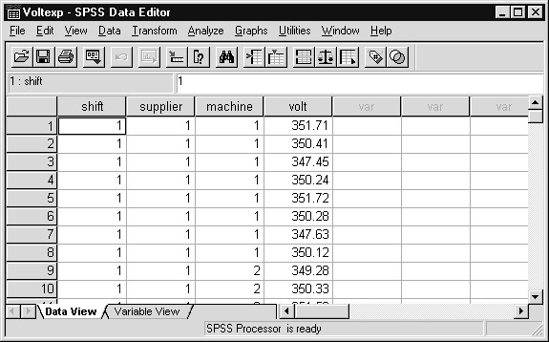
Numeric codes are used to identify the shift, supplier and machine. SPSS can provide descriptive statistics on voltage for the different shift, supplier and machine combinations. Also, more formal testing (analysis of variance) can be applied to these data to determine which factors (or combination of factors) result in significant differences in voltage. Labels can be supplied in SPSS (see Chapter 5) for the numeric codes so it will be easy to identify the subgroups in the Data Editor and Output Viewer windows.

Chapter 4  Topics | Entering and Reading Data  Entering Data Using the Data Editor  Reading Spreadsheets  Reading Databases Using the Database Wizard  Reading ASCII Text Data  Saving Data  Appendix: Saving Instructions
INTRODUCTIONata can be directly entered into SPSS for Windows, or read from a variety of sources. SPSS for Windows can access data stored as
D
Excel™ or dBASE™ files. In addition, SPSS for Windows can extract data from desktop, network and mainframe computer databases with supporting database drivers (for example, Oracle). Finally, SPSS reads data from a text file in either of two formats: fixed column or free field (data values are separated by a comma, blank, tab, or other character). In this chapter we provide an example of each of the following: entering data, reading spreadsheets, reading databases, and reading text files.
Also, SPSS has optional modules that directly transfer data to SPSS from Oracle Express Server/Personal Express, Arbor Essbase and Business Objects (Business Query) databases.
The data used in each example are based on a subset of the General Social Survey collected in 1991. For those examples in this chapter that involve directly entering data (using the Data Editor) or defining specific columns (reading ASCII text), we will use only a small number of questions from the study. This will facilitate instruction and reduce the amount of typing.
DATA FIELDS For examples presented in this chapter we will limit our attention to at most six, and sometimes fewer, questions from the General Social Survey 1991, even though the original data files contain more information. These variables are years of education, marital status, age first married, gender, age, and how happy was the respondent. In a later chapter we will resume work with the full set of variables. The coding scheme for the six questions appears below.
Question Description |  | Data Codes
Education Education in Years |  | 1= one year, etc.  98=Don’t Know  99=No Answer
Marital Status Respondent’s Marital Status |  | 1=Married  2=Widowed  3=Divorced  4=Separated  5=Never Married  9=No Answer
Age Wed | Age First Married | 18= 18 years, etc. 0=Not Applicable  98=Don’t Know  99=No Answer
Gender | Respondent’s Gender | F=Female M=Male
Age | Age in Years | 21= 21 years, etc. 98=Don’t Know  99= No Answer
Happiness | In General How Happy are You? | 1=Very Happy  2=Pretty Happy  3=Not Too Happy  8=Don’t Know  9=No Answer
Except for gender, all questions have numeric values. Notice that “don’t know” responses or refusals (no answer) were assigned numeric codes as well. We will later instruct SPSS for Windows to exclude these missing value codes from analyses.
ENTERING DATA  USING THE DATA EDITOR | Suppose we have data from the first three survey questions discussed above (education, marital status, and age first married) and wish to enter it directly into SPSS for Windows. We see two sample rows of data below.
Education Marital Status AgeWed
18 1 27
16 2 50
- If necessary, start SPSS for Windows by clicking
Start..Programs..SPSS for Windows..SPSS 10.0 for Windows,
- Click Cancel to close the Startup wizard
First we supply SPSS variable names for our three fields.
- Click the Variable View tab in the Data Editor window
- Type educ in the first row of the Name column
- Press the down-arrow key
- Type marital in the 2nd row of the Name column 7) Press the down-arrow key
- Type agewed in the 3rd row of the Name column
- Press the Enter key

Figure 4.1 Variable View Tab Sheet of the Data Editor Window
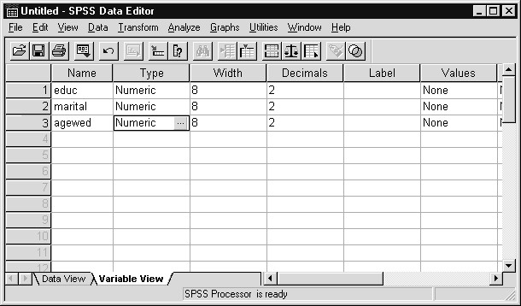
The Variable View sheet permits you to view, supply and modify definitional information about the variables in the Data Editor. This includes variable name, type, labels and missing values. We will discuss this tab sheet in much greater detail in Chapter 5. Here we use it only to supply variable names.
10) Click the Data View tab

Figure 4.2 Data Editor Window with New Variable Names
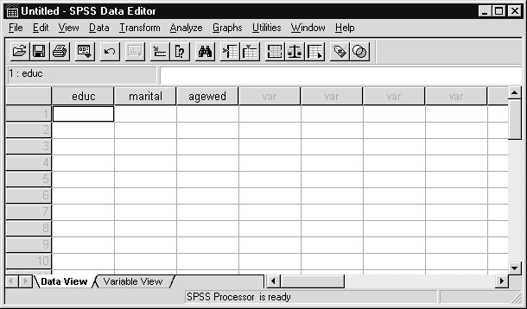
The variable names we entered appear at the top of the first three columns. Now to enter the data values.
- In the Data Editor window, click in the first cell (row 1, educ column)
- Type in the first row of data, separating the data values bytabs
18 (Tab) 1 (Tab) 27 (Tab)
11) Now enter the second row of data:
type 16 (Tab) 2 (Tab) 50 (Tab)

Figure 4.3 Data Editor Window with New Data
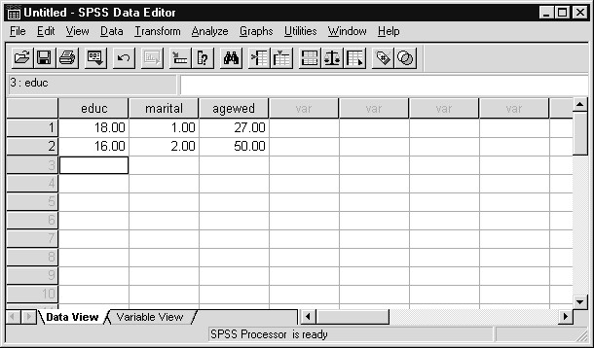
If we had not assigned names, SPSS would have automatically assigned variable names (var00001, var00002, etc.) as we entered the data. By default, numbers appear with two decimal places; you can change this within the Variable View tab sheet. If alphabetic or calendar data will be entered, the variable (column) must first be declared to be of “string” or “date” type, respectively, using—you guessed it—the Variable View tab sheet of the Data Editor window.
READING Figure 4.4 Survey Data in Excel™

SPREADSHEETS
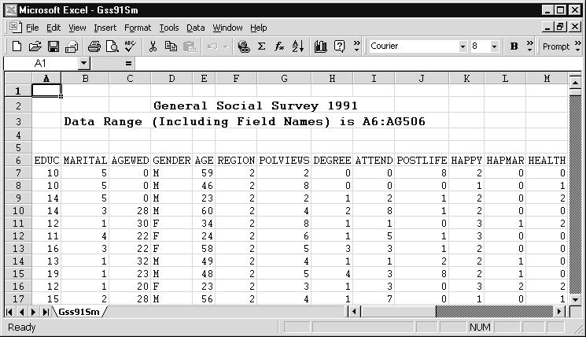
Above we see the General Social Survey data stored in an Excel™ 97 worksheet. Note that the first several rows contain heading information that SPSS cannot productively read. Also, notice that the row just preceding the actual data contains names (column headers or field names). If you alert SPSS for Windows to this, it can use these names as its own variable names. While not fully visible, the spreadsheet range A6:AG506 includes the row of names and the actual data.
Note SPSS can read only one row of names. If these names do not conform to the SPSS variable naming convention (contain 8 characters or fewer, must begin with a letter, and contain no blanks), they will be converted into valid SPSS names.
- Click File..Open..Data. Alternatively, you can click the Open
File tool button
- Move to the Basewin10 folder (within the c:\ Train folder) in the Open File dialog box.
- Click the drop-down arrow on the Files of Type: list, scroll to the Excel (*.xls) choice and click on it.
- Click Gss91Sm from the list of Excel files in the Folder window

Figure 4.5 Open File Dialog Box
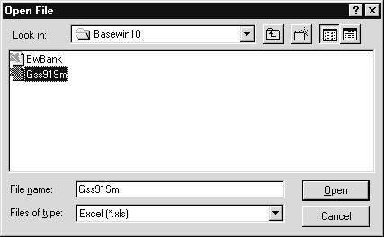
- Click Open pushbutton
An Opening Excel Data Source dialog box now appears. Here we indicate which worksheet we want to read (only one is present) and that variable names are present in the file. Also, we must provide a range that excludes the title lines.
- Verify that the Read variable names from first row of data check box is checked (since there are variable names in the spreadsheet)
- Verify that the Gss91Sm worksheet is selected in the
Worksheet drop-down list
- Click in the Range: text box and type A6:AG506 (the range) into the Range text box. Alternatively, a range name could have been assigned in Excel and entered here

Figure 4.6 Completed Opening File Options Dialog Box
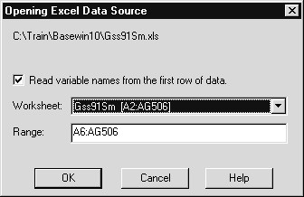
We have provided all information required for SPSS to properly read the spreadsheet. Due to the presence of the name and title rows, the "Read variable names from first row of data" checkbox must be checked and the data range (including the name row) specified. If there were multiple worksheets in the file, we would indicate which one to read.
9) Click on the OK pushbutton to read the data from the Excel worksheet; click No when asked to save the current data Figure 4.7 Spreadsheet Data in SPSS for Windows
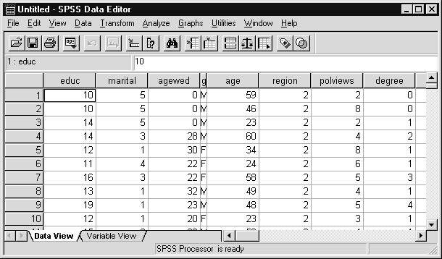
You should quickly review this summary to confirm that all data fields are interpreted correctly. Any problems reading the spreadsheet data will be reported in the Viewer window. Data from the Excel spreadsheet is now available for analysis using SPSS for Windows.
Tips  READING  DATABASES  USING THE  DATABASE  WIZARD  Inportant Note | If you are using a spreadsheet package other than Excel or Lotus, it can probably write a file in Excel format, which SPSS can read.  If you are using the most recent version of the spreadsheet and SPSS for Windows cannot read it, return to the spreadsheet program and try saving the file in an earlier version of the spreadsheet program. Then have SPSS read that form of the data.  If you have data stored on a PC, server or mainframe in an application  (database, spreadsheet) that supports database drivers (for example, Microsoft’s ODBC (Open Database Connectivity) protocol), you can read the data directly using SPSS. It is important to note that in order for SPSS to read a data source using the Database Wizard, database drivers (software programs that manage the communication between programs) specific to the database and supporting files must be installed on your machine. The database developer often supplies such drivers. Drivers for a number of (including mainframe) databases are contained in the SPSS Access Data Pack, included on the SPSS for Windows 10.0 CD-ROM (choose SPSS Data Access Pack from the SPSS 10.0 installation startup menu). In addition, drivers for Access, FoxPro and Excel are included with Microsoft Office products, can be downloaded from the Microsoft web site, and are included on the SPSS 10.0 CD-ROM (in the Microsoft Data Access Pack folder). Drivers can also be obtained from third-party suppliers. After the appropriate database drivers and supporting files are installed on your machine (they are usually installed by a person knowledgeable about the system), you can access database tables and other supported data from SPSS.  We will demonstrate by reading the General Social Survey 1991 data stored as a table (named GSS91SM) in an Access ™ database named GSS.  If the required database drivers are not installed on your training machine (your instructor can confirm this for you), this example will be discussed and not run live during the training seminar.

Figure 4.8 Survey Data in Microsoft Access™
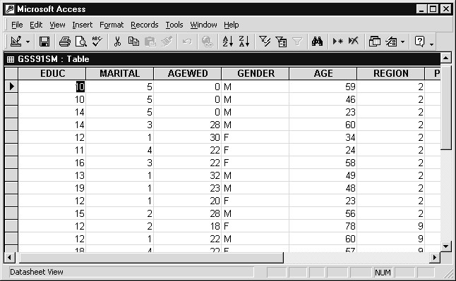
Above we see the General Social Survey data stored as a table within the Microsoft Access ‘97™ database program.
SPSS contains a Database Wizard to facilitate access to database tables. We will read data stored in the table named GSS91SM within the Access ‘97 database called GSS (GSS.mdb).
- Click File..Open Database..New Query
- Click the Gss91Small item (if present in the data source list box)
If the MS Access 97 Database item does not appear, then Microsoft ODBC drivers need to be installed before proceeding. They are contained in the Microsoft Data Access Pack folder on the SPSS 10.0 for Windows
CD-ROM.
Note If the MS Access 97 Database item appears, but not an item for Gss91Small, then the Gss91Sm Access table must be defined as a data source. Steps a through n can be skipped if Gss91Small is already defined as a data source on your machine; in this case simply click on Gss91Small and then click the Next pushbutton.

Figure 4.9 Database Capture Wizard Data Source Dialog Box
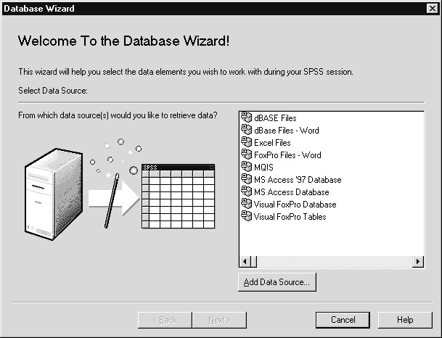
Defining a Data Source | Defining a Data Source (needed if Gss91Small does not appear in the data source list box – see Figure 4.9)
The data sources currently available appear in a list box; database drivers are installed for the file types (mostly databases) on this list.
- Click the Add Data Source pushbutton
- Click User DSN tab (if necessary)
- Click Add pushbutton
- Click on Microsoft Access Driver (*.mdb) in the Create New Source dialog box

Figure 4.9a New Driver Source List
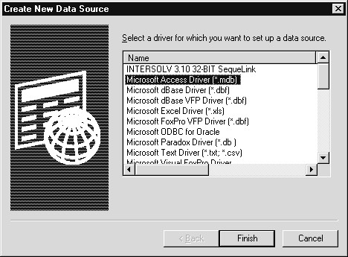
The number of drivers appearing in the list box depends on which database drivers have been installed on your system.
- Click Finish
- Type Gss91Small into the Data Source Name text box
(within ODBC Microsoft Access Setup dialog)
- Type General Social Survey 1991 into the Description text box

Figure 4.9b ODBC Microsoft Access Setup Dialog Box
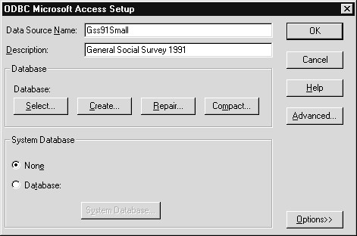
- Click Select pushbutton in the Database section
- Move to the c:\ Train\ Basewin10 folder
- Click Gss91.mdb in the Database Name list box

Figure 4.9c Select Database Dialog Box
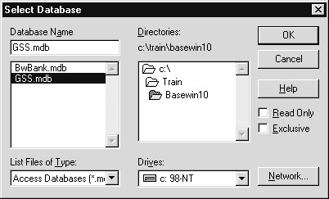
We are now pointing to a specific database file (GSS) as a data source.
- Click OK to confirm the database file selection
- Click OK to confirm the Access setup information
- Click OK to confirm the data source in the ODBC Data Source
Administrator dialog
- Click Gss91Small in the data source list box to select it

Figure 4.9d Database Capture Wizard Dialog with Gss91Small Data Source
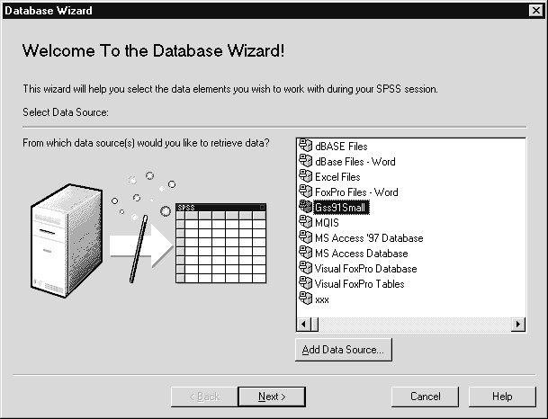
- Click Next pushbutton
- Click plus sign beside icon labeled GSS91SM in
Available Tables list box

Figure 4.10 Data Fields Available in GSS91SM Data Table
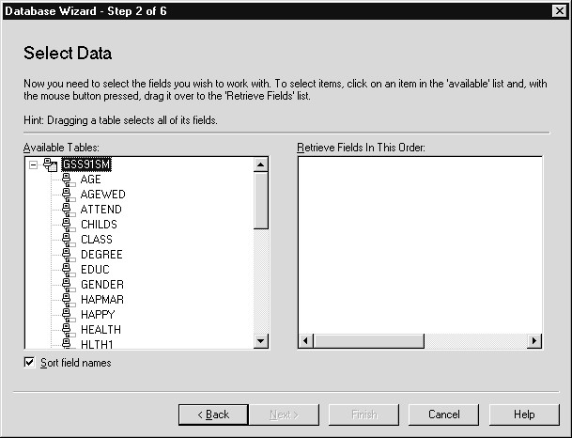
Only one table is stored in this database. Its icon can be expanded in the Available Tables list box in order to display all fields in the table. We can select as many individual fields as we need. Here we will select four fields (educ, marital, agewed and gender).
- Click the icon labeled EDUC and drag it to the Retrieve
Fields in this Order: list box
- Repeat for MARITAL, AGEWED and GENDER

Figure 4.11 Four Fields Selected from GSS91SM Database Table
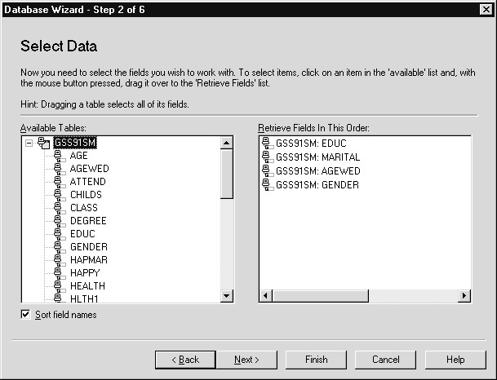
The selected fields are listed along with their table name. Fields from multiple tables can be selected.
7) Click Next pushbutton

Figure 4.12 Limit Retrieved Cases Dialog Box
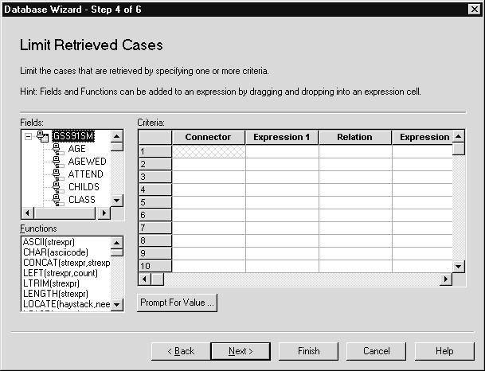
The Limit Retrieved Cases dialog box can be used to select only certain records for inclusion in the SPSS analysis (for example, males older than 30). The default is to retrieve all cases.
8) Click Next pushbutton

Figure 4.13 Define Variables Dialog Box
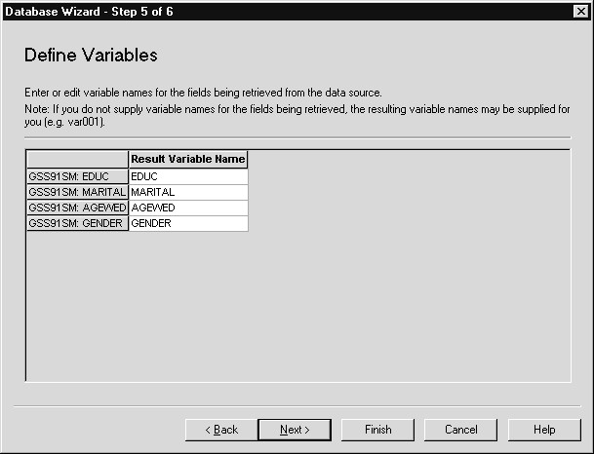
This dialog box displays the names that SPSS will apply to the retrieved data fields. Databases allow longer names than SPSS (recall SPSS variable names are limited to 8 characters). Since such names will be truncated or replaced, you have the opportunity to edit the names used by SPSS.
9) Click Next pushbutton

Figure 4.14 Resulting Query Statement
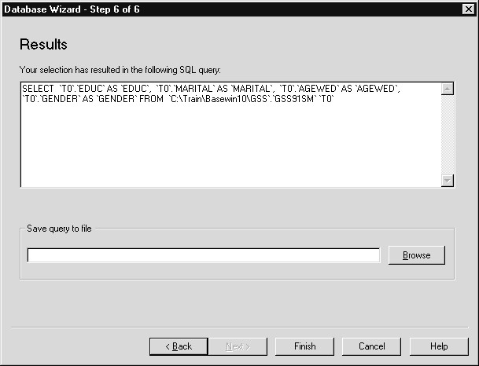
The database query resulting from our choices displays in a text window. This statement can be executed now, or saved in a file for later use. The default is to retrieve the data now, which we do by clicking the Finish pushbutton.
10) Click Finish pushbutton

Figure 4.15 Data from Access in SPSS Data Editor Window
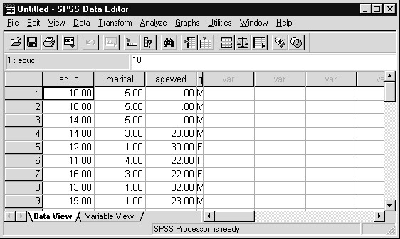
The data originally stored in an Access ‘97 database is now available for analysis within SPSS.
READING TEXT DATA
Data in text format originate from several sources: optical scanners; mainframe database programs can write data in text form; data entry or keypunch services often create text data files; word processing software can be used to enter data, then save it as a text file. Below we see, using the Notepad (click Start..Program..Accessories..Notepad), the beginning of the General Social Survey data set in text format (file is named Gss91Sm.dat).

Figure 4.16 Text Data in Fixed Column Format
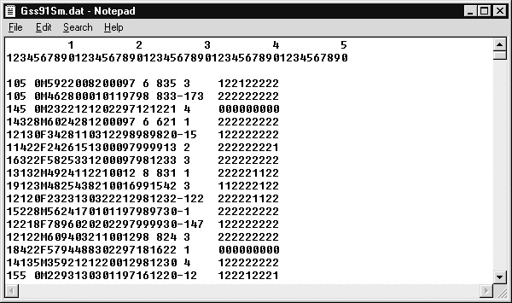

The top three lines are NOT part of the data file, but are simply reference lines we temporarily inserted to make it easier to read column positions. Each row represents a survey respondent. The first five variables are education, marital status, age first married, gender, and age. Education is stored in the first two columns (the first respondent had 10 years of education). Marital status is in column 3 (the respondent has never been married - code 5). Age first married is in columns 4 and 5 (having never been married, the respondent is coded 0). Gender is in column 6 (respondent is male- coded M). Age appears in columns 7 and 8 (the first respondent is 59). Although not easy to find, responses to the general happiness question are stored in column 14 (the first respondent is “pretty happy”- code 2). Files organized this way are said to be in fixed column format because values for a given field are found in the same columns across all data records. When instructing SPSS how to read such a file, you must know the column position(s) each variable occupies. Typically the program or individual creating the data file can supply this information. A summary table containing column positions for the six fields appears below.
Question Column Positions
Education 1-2
Marital Status 3
Age Wed 4-5
Gender 6 (Alpha)
Age 7-8
Happiness 14
- Click File..Read Text Data
We must first identify the data file to be read by SPSS and then define each data field that we want SPSS to process.
- Select Data (*.dat) from the Files of Type drop-down list
- Click Gss91Sm (.dat) in the Folder window (make sure you are in the c:\ Train\ Basewin10 folder)

Figure 4.17 Open Dialog When Reading Text Data
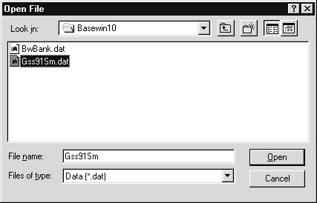
The Files of Type drop-down list box indicates that files with extension .dat will display (by default the type is Text (*.txt)). If your text file has a different file extension, select the All Files (*.*) choice on the Files of Type drop-down list.
- Click Open pushbutton
Figure 4.18 Text Import Wizard Step 1 – Predefined Format?
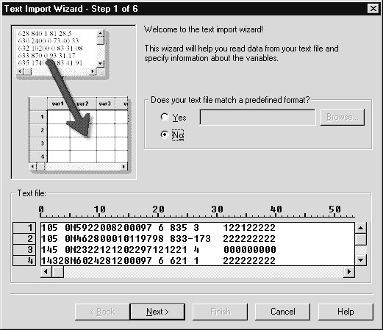
The Text Import Wizard previews the first few rows of data in the previously referenced text file, along with a column position ruler. This view will be used later to indicate the column positions of data fields of interest.
We are queried as to whether the text file matches a predetermined format. This would be the case if the variable names and column positions matched those of a text file we had previously defined in the Text Import Wizard and whose specifications we had saved. This is a useful feature for those who periodically receive text data in the same format. Examples of this would be an ongoing customer or employee satisfaction survey in which data are collected every quarter, or any type of sales or transaction data. Since we are defining data in this format for the first time, we accept the No (default) option.
- Click the Next pushbutton
- Click Fixed Width option button in the “How are your variables arranged?” section

Figure 4.19 Text Import Wizard Step 2 – Overall Data File Format
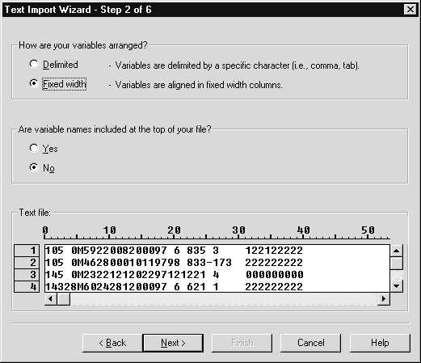
In the second Text Import Wizard dialog we provide two critical pieces of information. First, we indicate whether the data values are separated from each other (delimited) by a special character (blank, comma, or tab are commonly used), or whether they occupy fixed column positions (for example, age is always found in columns 7-8). The default is Delimited, and if accepted will lead to a later dialog in which the special delimiter character would be specified. Our data file contains variables in fixed column positions, so we made that choice, and will later be prompted for the specific locations of variables.
The second issue concerns whether or not variable names appear at the top of the file. This is often the case for delimited files, since then the single file contains both the variable (field) names and the data, but is rarely done for fixed column files. In our case the file contains no variable names; we will supply them later.
The text preview at the bottom of the dialog is useful in this context, since if you are unsure about either of these issues, a glance at the text preview can often resolve it.
7) Click Next pushbutton

Figure 4.20 Text Import Wizard Fixed Width Step 3 – Case Definition and Scope
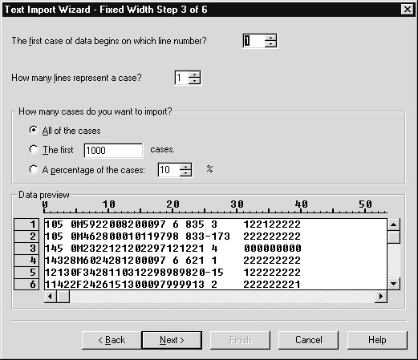
At this stage the Text Import Wizard addresses three issues, although the default values generally suffice. The first topic concerns the line on which the first case (observation, record) of data begins. Usually this is line 1 (the default), but in some instances files contain header information in the first few lines so the data values begin later. Also, you might want SPSS to read only the latter portion of your file, and one way to accomplish this is by changing the first case’s line number.
A second issue is whether or not a single case of data is spread across multiple lines in the text file. This is essentially a formatting question: if many variables are recorded, are they all placed in a single long line of text or are they broken up across several lines? If the latter, then you need to indicate how many lines in the text file represent a single case. The default value is 1, which is correct for our text file.
Finally, you can have SPSS read only portions of the data. By default, all cases in the file will be imported into SPSS. However, SPSS can read the first user-specified number of cases from the file (useful for testing analyses and reports on small portions of large data files) or sample a percentage of cases from the file (sampling is sometimes done from very large files to speed processing). We wish to read all cases from the file. It should be noted that you can later select or sample subsets of data for analysis (Data..Select Cases choice in the Data Editor window).
8) Click Next pushbutton

Figure 4.21 Text Import Wizard Fixed Width Step 4 – Providing Column Positions
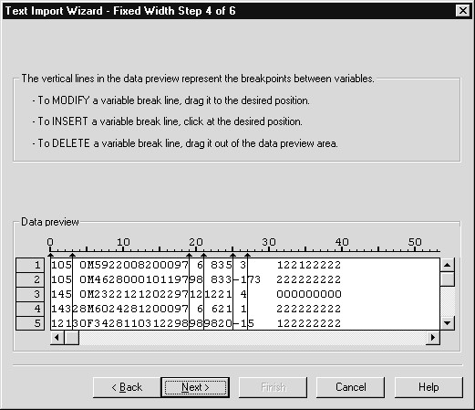
Initial
Break Lines

We now must provide the column locations of the variables we wish to read by inserting break lines at the starting and ending columns of each variable. Clicking at a column location within the preview window will insert a break line. For example, to mark the location for the happiness variable (in column 14) we must place a break line just before (position
14) and just after (position 15) the variable’s location in the preview window.
The Text Import Wizard will insert a default set of break lines in columns in which blanks consistently appear, based on an examination of the text file. For this file we see them at positions 3, 19, 21, 25 and 27. Since most of these are not relevant to the variables in which we are interested, we will adjust or remove them as indicated below.
We begin by defining the columns for the education variable (columns 1-2).
9) Click below position 2 in the preview window (just after the 10 at the beginning of the first line of data)

Figure 4.22 Supplying Column Positions for Education
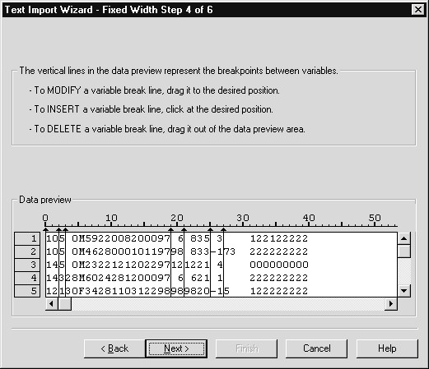
New
Break Line
Because the education variable begins the data line (starts in column 1), we need not insert a break line at position 0. By placing the break line at column 2, we have instructed SPSS to read a yet unnamed variable from columns 1-2 of the text file.
If the initial position is incorrect, simply click and drag it to the correct position. In addition, a break line can be removed by clicking and dragging it out of the preview window (to either the left or right).
Now we provide column positions for the remaining variables of interest.
If a break line is not already in place in position 3, then perform step (10); otherwise continue with step (11)
- Click below position 3 in the preview window (ending position for marital status in column 3)
- Click below position 5 in the preview window (ending position for age wed in columns 4-5)
- Click below position 6 in the preview window (ending position for gender in column 6)
- Click below position 8 in the preview window (ending position for age in columns 7-8)
- Click below position 13 in the preview window (starting position for happiness in column 14)
- Click below position 14 in the preview window (ending position for happiness in column 14)
Now to remove the automatically placed, but unneeded, break lines.
- Click on the break line at position 19 and drag it outside the Data preview window (to the right or left)
- Repeat step 15 (click and drag to remove the break lines) forthe break lines at positions 21, 25 and 27

Figure 4.23 Column Positions Defined
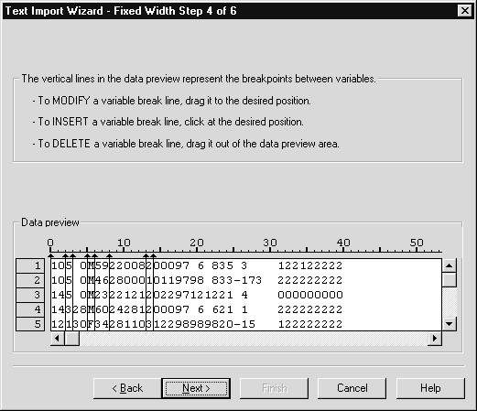
We marked the positions of the six variables we wish to read from the text file. Notice we skipped from age in columns 7-8 to happiness in column 14. However, since line breaks appear in positions 8 and 14, the Wizard will assume that these columns define a variable, which is not the case! Similarly, position 15 to the end of the record will be considered a variable. Neither of these column ranges actually represents a single variable, and we will instruct the Wizard to ignore (not import) these variables in the next dialog box.
After allowing for the exceptions just noted, we defined six of the many data fields contained in the text file. Thus you have the flexibility of reading only fields of interest.
18) Click Next pushbutton

Figure 4.24 Text Import Wizard Step 5 – Variable Names and Formats
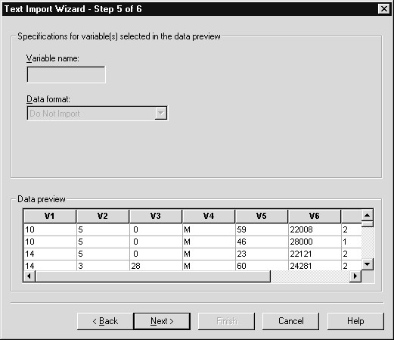
In this dialog you can change variable names and data formats (numeric, string, date, dollar, etc.) for the variables previously selected, and identify any variables that should not be imported.
The Data preview is now organized by variables (default names are V1, V2, etc., representing the first, second, etc. variables in the text file) and displays each variable’s values for the first few cases, based on the column position information supplied earlier. This serves as an easy way of spot-checking your variable definitions. If you notice any errors, simply click the Back pushbutton and correct the break line placements.
The Variable Name text box is blank because no variable is currently selected in the Data preview window. Notice there is a choice on the Data Format drop-down menu labeled “Do Not Import.. Strictly speaking, this is not a data format, but it does allow you to instruct the Data Import Wizard to ignore the selected variable when importing data. We use this feature to avoid importing the contents of columns 7-14 and columns 15 to the end of the record. These were, you might recall, defined in an ancillary fashion when we placed the break lines.

19) Click on V1 in the Data preview (to select it)

Figure 4.25 Variable Name (V1) and Format for Selected Variable
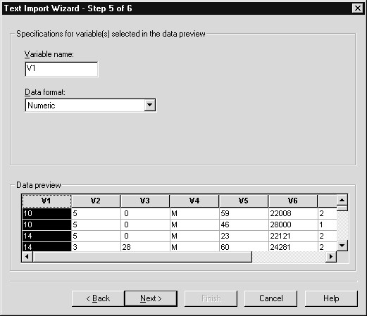
The selected variable’s name (V1) now appears in the Variable Name text box and its format (by default, numeric or string is assigned based on the data values) is in the Data Format list box. Either can be changed at this point. The first variable (education) is numeric, so we will simply replace the unhelpful variable name (V1) with one more useful (educ).
20) Double click in the Variable Name text box (to select the original name) and type educ (replacing V1)
Hint When instructed to type something into a text box, verify that the mouse insertion pointer appears within the box before typing. If the insertion pointer is not in the desired text box, click within the box to place it (or press the tab key until the insertion pointer is within the correct box).

Figure 4.26 Changing a Variable Name
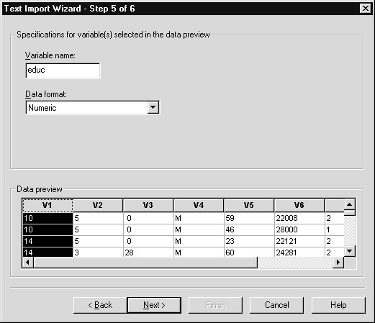
SPSS variable names can be up to 8 characters and must begin with a letter. Case is unimportant when entering the name. We can later change variable names within the Data Editor window, but it is usually done at this point as part of the data definition step.
- Click on V2 in the Data preview (to select it)
Note that the first variable in the Data preview is now named educ (not shown).
- Double click in the Variable Name text box and replace V2 with marital
- Click on V3 in the Data preview (to select it)
- Double click in the Variable Name text box and replace V3 with agewed
- Click on V4 in the Data preview (to select it)
- Double click in the Variable Name text box and replace V4 with gender

- If not already selected, click on the Data format drop-down arrow and select String

Figure 4.27 Reading a String Variable
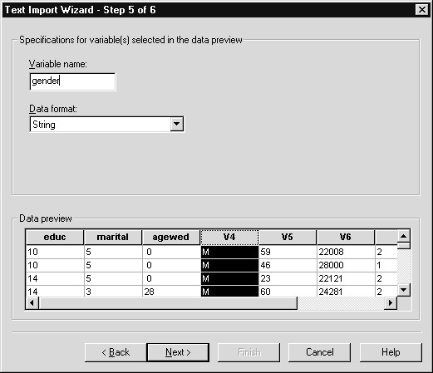
Gender is coded “F” (female) or “M” (male) and so its data format should be declared as string (character string or alphanumeric) if the Text Import Wizard has not already done this. The Wizard will initially define each variable to be numeric or string based on the data values of the variable. If the Data Format of Gender were defined as numeric while its values were string characters, this would lead to Gender having missing values for all cases following the text import. Date, comma, dollar and dot formats are also available on the Data format list.
Note that some SPSS procedures require numeric variables. If a string variable, such as gender, is later needed in an analysis requiring numeric variables, you can easily create a numeric form of the string variable within the Data Editor window by clicking
Transform..Automatic Recode. We will retain the string format for Gender.
To continue:
- Click on V5 in the Data preview (to select it)

- Double click in the Variable Name text box and replace V5 with age
- Click on V6 in the Data preview (to select it)
- Click on the Data format drop-down arrow and select Do Not Import

Figure 4.28 Instructing the Text Import Wizard to Not Import a Variable
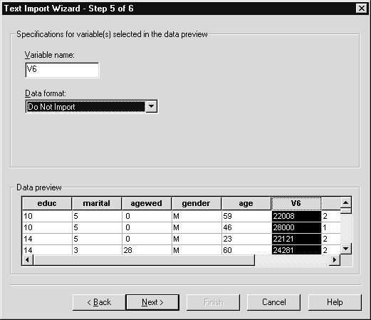
V6 is not a variable we actively defined. Rather, it was created as a byproduct when we placed the ending break line for age in position 8 and the beginning break line for happiness in position 14. A glance at its values in the Data preview (very large numbers) would, for this data, signal a problem with the variable. Declaring this variable’s Data Format as “Do Not Import” will result in it not being imported by SPSS.
- Scroll to the right in the Data preview so V7 and V8 are visible
- Click on V7 in the Data preview (to select it)
- Double click in the Variable Name text box and replace V7 with happy

Finally, we ask that Text Import Wizard not import the last variable (located in column position 15 to the end of the record). Recall it was created as a byproduct of our other variable definitions.
- Click on V8 in the Data preview (to select it)
- Click on the Data format drop-down arrow and select Do Not Import

Figure 4.29 Completed Variable Definition (Names, Formats, Variables Not Imported)
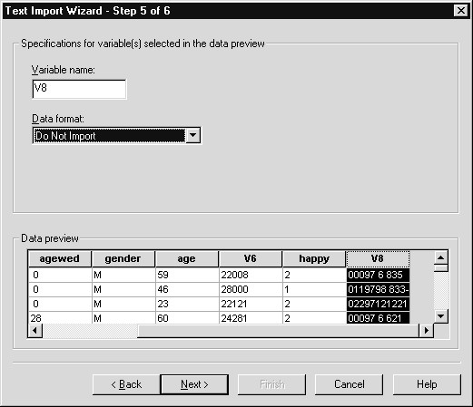
37) Click Next pushbutton

Figure 4.30 Text Import Wizard Step 6 – Saving Format Definition or Syntax
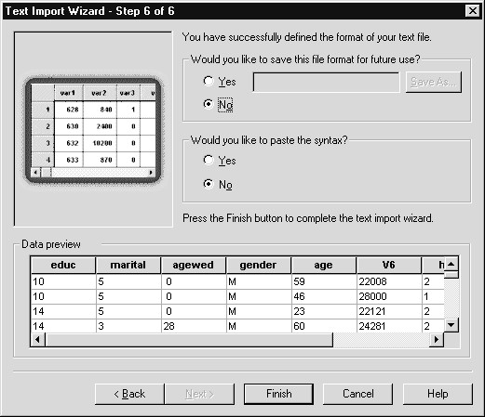
In the final step you have the opportunity to save the format (in this case variable names, formats, and column positions) of the text file for later Text Import Wizard use with other text data files having the same format. Since we don’t expect to apply this format again, we will not do so. There is also an option to paste the syntax. If this is chosen, then an SPSS command that can be used to later read the text file will be pasted into a Syntax window (and saved from there if you wish).
These options provide means of retaining the column positions, variable names, and data formats for later use with the same or other data files. They differ only in the format in which this information is saved. The first option (save the format) will store the information in a format that can be retrieved, displayed and used in the Text Import Wizard, while the syntax option will produce an SPSS command that will run independently of the Text Import Wizard. Syntax use is briefly introduced in Chapter 11.
38) Click Finish pushbutton and click No when asked to save the contents of the Data Editor

Important Note When you define a substantial number of variables, we recommend you save the format using this dialog. In this way, if any errors (for example, data errors, incorrect column positions, or forgotten variables) are found later, you can access and work from the saved format instead of reentering all the variable information.

Figure 4.31 Text Data in SPSS for Windows Data Editor
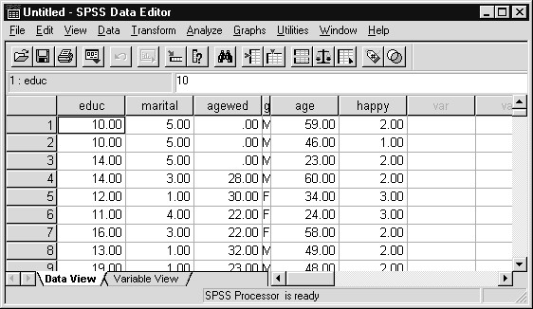
We defined only six of the many data fields contained in the text file.
SPSS will skip the remaining columns, since we instructed the Text Import Wizard not to import them; thus you have the flexibility of reading only fields of interest.
At this point you would typically add labeling, missing-value and formatting (for example, the number of decimals to display for educ) information to the variables in order to complete the definition process. Another possibility is to move directly to the analysis phase. Instead, we will save a copy of the SPSS data set for later use.
SAVING DATA To save an SPSS data file, the Data Editor Window must be the active window!
- Click File..Save As (make sure the SPSS Data Editor window is the active window)
- Verify that the desired folder (here c:\ Train\ Basewin10) is chosen
- Type Chapt4 in the File Name text box (.SAV is the standard extension for SPSS data files and will append to the file name by default). This completed dialog box appears below

Figure 4.32 Completed Save As Dialog Box
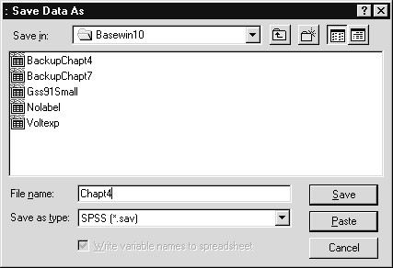
4) Click Save to save the data

Figure 4.33 Saved Data File in the Data Editor Window
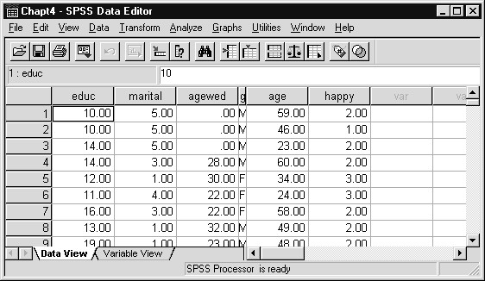
Notice that the name in the Title bar of the Data Editor window has changed from Untitled to Chapt4. This confirms that the file has been successfully saved as an SPSS data file. The file contains both variable information (names, type, and if provided, labels and missing value codes) and all data values.
SUMMARY  APPENDIX:  SAVING INSTRUCTIONS | In this chapter you have learned how to enter and read data into SPSS for Windows, and how to save an SPSS data file for later use.  While many operations in SPSS require just a few mouse movements, we found that reading a fixed column text file involved entering some detailed specifications (variable names, column positions, and for some fields, data type). If you wish to retain the information you entered for future use (to reapply to the same data file, or apply to a new data file) you can easily do so within the Text Import Wizard. In the final (6th) Text  Import Wizard step you can save file definition information in a form the Wizard can use, or as an SPSS syntax command. Choosing the latter option will paste into a text window (called a Syntax window) the SPSS instruction(s) that performs the function of the Wizard. These instructions, or SPSS syntax commands, can be saved, then later retrieved and run. If left unchanged, they will reproduce the results of the original dialog box choices. Alternatively, they can be modified and then run.  This feature, along with the automatic recording of SPSS instructions, is discussed in Chapter 11. Here we will quickly demonstrate this process by pasting from the last Wizard dialog the syntax used to read the text data file Gss91Sm.dat. First we return to the Text Import Wizard.
- Click File..Read Text Data
- Click Data (*.dat) on the Files of Type drop-down list
- Double click on Gss91Sm.dat in the Open window (the folder should still be c:\ Train\ Basewin10)
- Repeatedly click the Next pushbutton to advance to Step 6 of the Text Import Wizard
- Click the Yes option button in the “Would you like to paste the syntax?” section

Figure 4.34 Define Fixed Variables Dialog Box
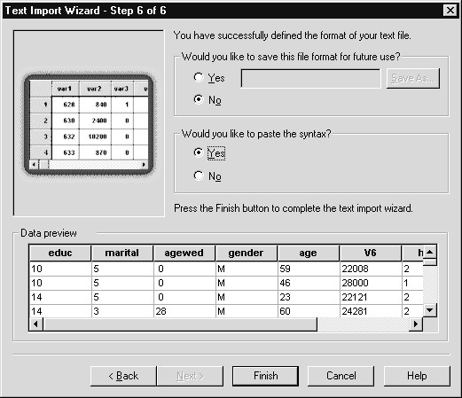
The specifications we entered earlier are retained in the Wizard dialog boxes. They will disappear if we exit SPSS for Windows or read another data file. Ordinarily, clicking the Finish pushbutton would run the instruction and reread the Gss91Sm.dat file. Since we requested that syntax be pasted, clicking Finish will produce a different outcome: SPSS syntax that reads the data will be created, but not executed.
5) Click Finish pushbutton

Figure 4.35 Syntax Window Containing Get Data Command
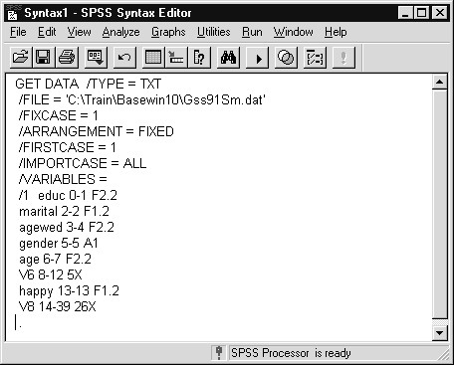
Clicking the Finish pushbutton caused SPSS for Windows to open a new text window (called a Syntax window) and paste a copy of the SPSS instruction (Get Data) required for reading the fixed column ASCII text file. The Get Data command contains the name of the data file to be read (you can change this in order to read a different file with the same format), the file type, the variable names and column positions. Note also the letters A or F following the columns. “A” indicates a string variable (for example, gender), while “F” marks a numeric (fixed numeric) variable. Also an “X” following the columns (for example, V6 8-12 5X) will result in the columns being skipped, which is what we chose for several fields (Do Not Import). Thus the Data List instruction contains all the information necessary to read the data file at some point in the future. As mentioned earlier, this command can be modified (changing the file name, adding additional variables and column positions) and then run. Details for the syntax rules that SPSS commands follow appear in the SPSS Base 10.0 Syntax Reference Guide (it is available on the CD-ROM containing SPSS for Windows 10.0) and in the relevant manuals for the SPSS optional modules. Also, see Chapter 11 in this course guide for more details.
To save these commands (and any others you might Paste during the session), simply click File..Save As when the Syntax window is active and supply a file name (the default file extension is .SPS). To use the Get
Data command in a later session, open the saved syntax file by clicking File..Open..Syntax and double click on the file name containing the syntax command. After the syntax window opens, click and drag across any commands you want to run (in order to select them). Finally, to run the command(s), click the Run tool button .
For an additional example, see the SPSS Syntax section in Chapter
11

Chapter 5  Topics | Variable View Sheet: Labels and Missing Values  What Are Labels and Why are They Important?  Reading an SPSS Data File  The Variable View Sheet  Adding a Variable Label, Changing Type and Format  Entering Value Labels for a Numeric Variable  Adding Value Labels for a String Variable  Treating Data Values as Missing Information  Missing Values for a Numeric Variable  Missing Values for a String Variable  Using Labeled Variables in a Procedure  Saving the Modified Data File  Exiting SPSS for Windows  Appendix: Entering Labels in Earlier Versions of SPSS
INTRODUCTIONn this chapter we will add labeling information and identify missing value codes, and make other changes to the variable dictionary for the data file in the SPSS Data Editor window. While these steps are
I
not required, the presence of labels renders the statistical output much more readable, and the declaration of missing value codes in the data (if any exist) insures that SPSS ignores the missing data when performing analyses. After providing this information, we will save an updated copy of the SPSS data file for use in later chapters.
WHAT ARE  LABELS AND  WHY ARE THEY IMPORTANT? | In Chapter 4 we saw that SPSS variable names can be at most eight characters long. Eight characters are generally not enough to describe the content of a survey question or a recorded measurement. To allow longer variable descriptions, SPSS has a provision for variable labels, which are labels of up to 256 characters in length (note: procedures that produce text output instead of pivot tables may only display 40-character variable labels) that appear in the output. For example, a survey variable named INCOME might refer to the respondent’s income, or total family income. The variable label “Respondent’s Income” would clarify the meaning of the variable.
Similarly, you can provide value labels that identify what particular data values represent. One of the General Social Survey variables is marital status, coded 1 if the respondent is married. If the value label “Married” is assigned to data value 1 for this variable, the label will appear when SPSS displays summaries involving marital status categories. Value labels (which can be up to 60 characters long, although SPSS procedures that produce text output instead of pivot tables may only display 20 character value labels) make it much easier to interpret statistical summaries involving variables whose values represent categories.
Neither variable labels nor value labels are required to run statistical analyses with SPSS. However, these labels add identifying information to the SPSS output, which is especially useful if others are to view these results. The table below contains labeling information about the General Social Survey variables that were defined in Chapter 4. We will add a few of these labels to the SPSS data file. Note that some of the codes represent missing information (Don’t Know, No Answer). Later in the chapter we will discuss how to inform SPSS that these data codes signify missing data.

Table 5.1 Labeling Information for Several General Social Survey 1991 Variables
Question Description |  | Data Codes
Education Education in Years |  | 1= one year, etc.  98=Don’t Know  99=No Answer
Marital Status Respondent’s Marital Status |  | 1=Married  2=Widowed  3=Divorced  4=Separated  5=Never Married  9=No Answer
Age Wed | Age First Married | 18= 18 years, etc. 0=Not Applicable  98=Don’t Know  99=No Answer
Gender | Respondent’s Gender | F=Female M=Male
Age | Age in Years | 21= 21 years, etc. 98=Don’t Know  99= No Answer
Happiness | In General How Happy | 1=Very Happy
 | are You? | 2=Pretty Happy  3=Not Too Happy  8=Don’t Know  9=No Answer
We will use the information in the Description column to provide variable labels, and that in the Data Codes’ column to supply value labels and missing values.
READING AN SPSS DATA FILE | Note: We need not perform this step if the data from Chapter 4 still reside in the SPSS Data Editor window.
At the end of the last chapter we saved an SPSS data file containing responses to several questions from the General Social Survey of 1991. Reading an SPSS data file is very easy; you simply:
- Click File..Open..Data from the main menu
If necessary, move to the Basewin10 folder (within the c:\ Train folder).
- Click on the up-one-level tool until you reach to top
level of the hard drive
- Double click on the Train folder in the Folder window
- Double click on the Basewin10 folder in the Folder window
Note the Files of type setting is SPSS (*.sav). This is because we chose Data on the File..Open submenu.
- Click Chapt4 in the Folders window to select it

Figure 5.1 Open File Dialog Box
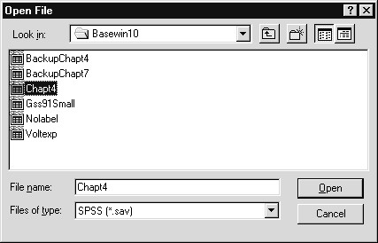
We have selected the SPSS data file we wish to retrieve.
6) Click Open pushbutton to read the SPSS Data File

Figure 5.2 General Social Survey Data in Data Editor window
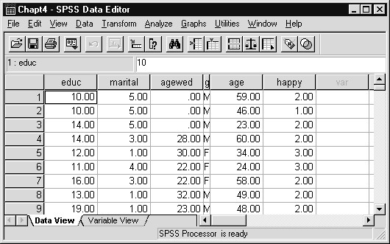
THE VARIABLE  VIEW SHEET | The Variable View sheet of the Data Editor window displays dictionary  (definitional) information about the variables contained in the Data Editor. These features can be thought of as properties of the SPSS variables.
1) Click the Variable View tab in the Data Editor window

Figure 5.3 Variable View Tab Sheet in Data Editor Window
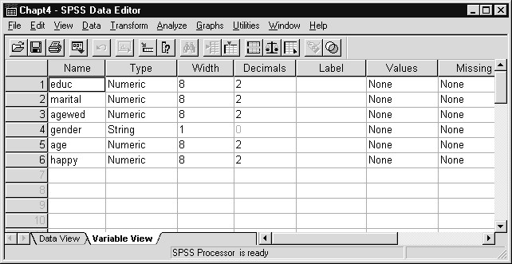
Within the Variable View sheet, each row represents a variable, identified by its entry in the Name column, and the other columns contain dictionary properties of the SPSS variable. New entries can be made (for example, adding variable or value labels) and current values can be modified (for example, changing the variable name or number of decimals displayed).
As we see in the figure above, the Name column stores the up-toeight character SPSS variable name. A variable’s type (numeric, string, date, etc.) is recorded in the Type column. The type settings for these variables were derived from the Text Import Wizard seen in Chapter 4. The Width and Decimals’ columns control how many spaces are reserved to display a variable's values (Width – here 8) and the number of decimal places shown (Decimals – here 2). The Label column stores variable labels, while value labels are accessed through cells in the Values column. Missing value codes are stored in the Missing column.
2) Scroll to the right to display the last columns in the Variable View sheet

Figure 5.4 Variable View Tab Sheet
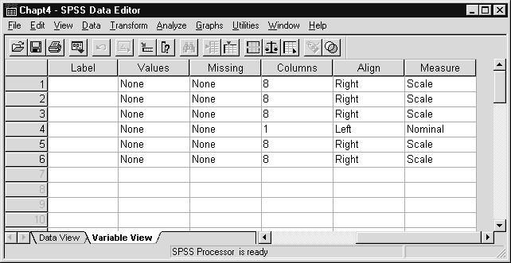
The Columns column in the Variable View sheet determines the column width used to display a variable’s values in the Data View sheet of the Data Editor window. Note that the Columns’ value in the fourth row (corresponding to the gender variable) is set to 1. Returning to Figure 5.2 (or by clicking on the Data View tab), we see that only one column is used to display gender values (and the variable name). The orientation (left justified, right justified, or centered) of a variable’s data values in the Data View sheet is controlled by its Align-column cell entry.
The Measure column permits you to supply the measurement type for the variable. Choices include scale (numeric interval and ratio scales, for example income in dollars), ordinal (a scale based on ordered categories, for example a 1 to 5 rating of degree of belief in the afterlife), and nominal (categorical). Choosing the appropriate measurement level is useful as a reminder when later running statistical analyses, and certain SPSS procedures (Interactive graphs and SPSS AnswerTree) make use of this information. See Chapter 6 for more detail on level of measurement and choice of statistics.
These settings can be modified for a variable by changing the cell entries in the Variable View sheet. As we will see, clicking on individual cells will invoke dialog boxes, drop-down lists, spin controls or text boxes, which allow us to modify settings. In addition, cell entries can be copied and pasted into other cells (see Chapter 11). This provides an efficient means of supplying a set of value labels or missing values to a collection of variables.
ADDING  VARIABLE  LABELS,  CHANGING TYPE AND FORMAT | Now that we are in the Variable View sheet for the data file, we will add a variable label and change the variable type and format. Recall we can proceed directly to statistical analyses, but as mentioned earlier, labels will aid output interpretation.  To demonstrate how to add variable labels, we will supply the label “Marital Status” for the variable marital. From within the Variable View sheet of the Data Editor window:
- Scroll left so the Label column in the Variable View sheet is visible
- Click in the cell located in the 2nd row (corresponding to marital) of the Label column
- Type Marital Status

Figure 5.5 Supplying a Variable Label
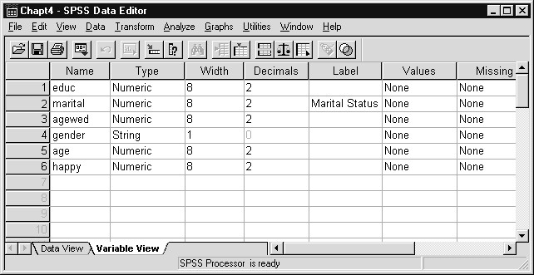
We have entered a relatively short variable label (most SPSS procedures support 256 character variable labels; a few procedures produce text output instead of pivot tables may only display 40-character labels) in the Label cell.
Since marital status is coded with integer values represent separate categories (1 = married, 2 = widowed, etc.), we will set its number of decimals displayed to 0 (from 2) and declare its measurement type as nominal. To change the number of decimals displayed for marital in the Data View sheet of the Data Editor or in listings appearing in the Output Viewer window.
- Click in the cell located in the 2nd row (corresponding to marital) of the Decimals column
- Erase 2 and type 0 in the Cell (alternatively, use the spin control that appears when the cell is selected to change the cell value to 0) (not shown)
In addition, we will set the number of decimals displayed to 0 for agewed (age first married).
- Click in the cell located in the 3rd row (corresponding to agewed) of the Decimals column
- Erase 2 and type 0 in the Cell (alternatively, use the spin control that appears when the cell is selected to change the cell value to 0) (not shown)
To change the measurement type for marital.
- Scroll right to display the last Measure Column in the
Variable View sheet
- Click in the cell located in the 2nd row (corresponding to marital) of the Measure column, then click the drop-down
arrow

Figure 5.6 Changing the Measurement Level for a Variable
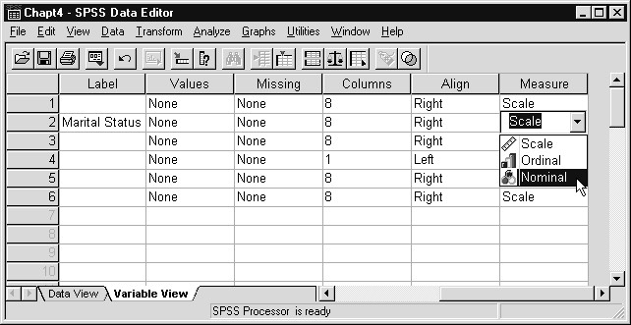
The Measure column cell drop-down list presents the measurement level choices (discussed earlier in this chapter and in Chapter 6).
10) Click Nominal from the Measure drop-down list

Figure 5.7 Measurement Level Change for Marital
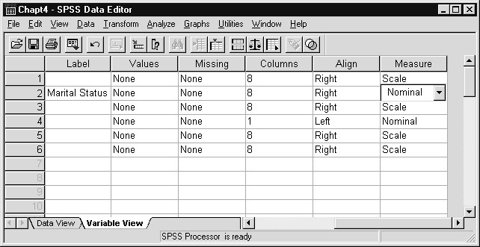
Since the Measure cell is still selected for the second variable (marital), the drop-down arrow is still visible. We have changed the measurement level for marital and could do so for other variables (for example, setting happy to ordinal).
At this point, we could examine the effects of these changes in the Data View window (we would see marital data values displayed with no decimals and the variable label would appear as a pop-up window). In addition, the variable label we just supplied will appear as part of the output for analyses involving the marital variable. We will see this later in the chapter.
Instead, we will proceed to supply value labels for the marital variable.
ENTERING  VALUE LABELS  FOR A NUMERIC VARIABLE | Recall that value labels are labels assigned to actual data values. We will demonstrate how to supply value labels for a numeric variable by entering labels for the five marital status codes (see Table 5.1 for the data values and labels).
1) Click in the cell located in the 2nd row (corresponding to marital) of the Values column

Figure 5.8 Values Cell Selected ( Button Visible)
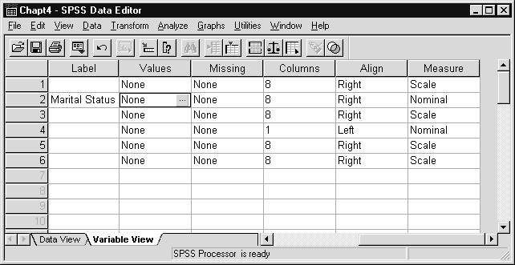
The Values cell for the marital variables (2nd row) indicates there are no value labels (None). The Continue button, visible because the cell is active, will take you to a dialog within which value labels can be entered. Unlike a variable label, since many value labels may be supplied for a single variable, we can’t directly enter them into a single spreadsheet cell.
- Click the button
- Click in Value text box
- Type 1
- Click in Value Label text box (or press the Tab key)
- Type Married

Figure 5.9 Adding a Value Label
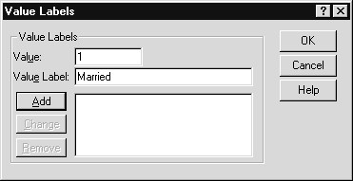
The value label “Married” will be associated with value 1 of the marital variable. At this point we can change either the value or label if corrections are necessary.
7) Click Add pushbutton to add the label to the list box

Figure 5.10 Value Label Added to List
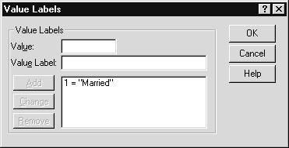
Once a value label has been added to the list, we can move on to the next label. You can remove a label by clicking on it in the list box, then clicking the Remove pushbutton. Labels can be modified by clicking on the label in the list box (at which point its value and value label will appear in the appropriate text boxes), making the corrections and then clicking the Change pushbutton. We will continue to add the remaining value labels for marital.
- Click in Value text box and type 2
- Click in Value Label text box (or press Tab key) and type
Widowed
- Click Add pushbutton
- Click in Value text box and type 3
- Click in Value Label text box (or press Tab key) and type
Divorced
- Click Add pushbutton
- Click in Value text box and type 4
- Click in Value Label text box (or press Tab key) and type
Separated
- Click Add pushbutton
- Click in Value text box and type 5
- Click in the Value Label text box (or press Tab key) and type
Never Married
- Click Add pushbutton

Figure 5.11 Completed Define Labels Dialog Box
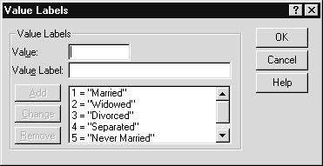
As we added the last label, a scroll bar appeared in the Value Labels list box. In this way, many value labels can be entered for a variable. You can use the Tab key to switch from the Value text box to the Value Label text box.
20) Click OK pushbutton to process the value labels

Figure 5.12 Value Labels Appearing in Variable View Tab Sheet
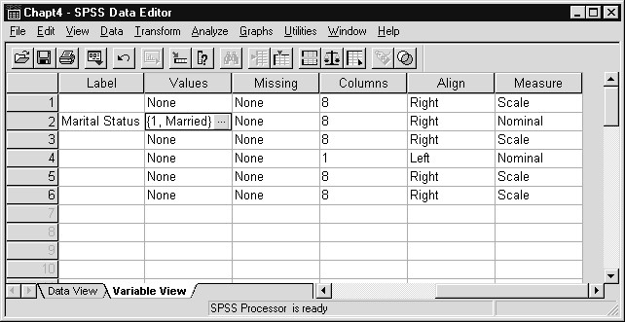
The first value label for the marital status (1, Married) now appears in the Values cell of the marital variable. We can view the other value labels for marital by clicking the button.
We can also display the value labels in the Data View sheet of the Data Editor Window.
- Click the Data View tab in the Data Editor window
- Click the Display Value Labels tool button and place cursor above marital (alternatively, click View..Value Labels to check Value Labels)

Figure 5.13 Data View Tab Sheet with Value Labels Displayed
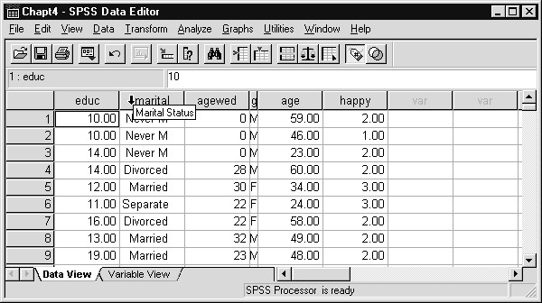
The variable and value labels for marital are now displayed in the Data View sheet of the Data Editor window. Similarly, these labels will appear in the output from statistical analyses that display the marital status categories.
Notice that the values for age first married (agewed) now display to the nearest whole number, due to the change in its Decimals property. When we turn off value label display in the Data View sheet, marital data values will also appear as whole numbers (not shown).
23) Click the Display Value Labels tool button again to turn off display of Value Labels
Notice that after originally clicking the Display Value Labels tool button, it appeared depressed; after clicking it the second time (turning off the display) it again appears flush with other tool buttons.
ADDING VALUE  LABELS FOR A  STRING VARIABLE | Value labels can be added for string (those that contain letters or other nonnumeric characters) variables using the same method shown for the numeric variable marital. An additional consideration is that case and spacing matter when entering a value for a string variable. For example, in our data file the capital letters “F” and “M” designate females and males, respectively. If we supplied a value label for the lower case letter “f”, it would never appear in SPSS output since there are no respondents with gender coded “f.” To supply value labels for gender, we begin from the Data Editor window.
- Click the Variable View tab in the Data Editor window
Since gender is a string variable, its measurement type (Measure column) is set to nominal (not shown).
- Click the cell in the 4th row (gender) of the Values column in the Variable View sheet
- Click the button in the 4th row (gender) of the Values column
- Click in Value text box and type F
- Click in Value Label text box and type Female
- Click Add pushbutton to add value label to the list box

Figure 5.14 Supplying a Value Label for a String Variable
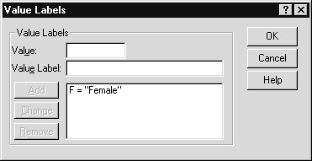
Again, take care to match the case and spacing of the string data values when entering them in the text boxes.
- Click in Value text box and type M
- Click in Value Label text box and type Male
- Click Add pushbutton
- Click OK pushbutton to process the value labels
TREATING DATA  VALUES AS  MISSING  INFORMATION  MISSING VALUES  FOR NUMERIC VARIABLES | For numeric variables, a blank data field or a data value that is not a valid number is automatically converted to a missing value by SPSS. This missing value, called system missing because the SPSS system  automatically makes it missing, is represented by a period (.) in the Data View sheet of the Data Editor window. In addition, system-missing values are excluded from statistical calculations within SPSS.  Surveys often let respondents choose “Don’t Know” or “None of the Above” as answers to questions. If codes for these responses are entered into the data file, you may want to exclude them from tables and statistical summaries. In engineering, physical and biological sciences, some automatic recording devices record a data value containing all 9s (for example, 999999) when the measurement fails for some reason. In all these instances SPSS provides a way to treat these data values as if they were missing. Also, for string variables, blank fields constitute valid values and must be declared as missing values if they are to be excluded from analyses. Up to three missing-value codes can be declared for each variable (and two of these can define a range of missing values). The reason for allowing three missing codes is to accommodate the most common reasons given for missing data in survey work: not applicable, don’t know, and refuse to answer.  Missing values are defined in SPSS for Windows within the Missing  Values dialog box, which can be reached by clicking the button in the cells in the Missing column of the Variable View sheet.  To demonstrate how to declare missing values for a numeric variable, we will use the agewed (age when first married) variable. Referring to Table 5.1, agewed is recorded in years and there are three missing value codes. Zero (0) indicates the question is not applicable (the respondent has never been married), 98 represents a “Don’t Know” response (unlikely, but possible: perhaps it was several weddings back), and 99 indicates that no answer was recorded (refusal or not recorded). To declare these data values missing in SPSS we start from the Variable View sheet in the Data Editor window:
  - Click the Variable View tab (if necessary)
  - Click the cell in the 3rd row (agewed) of the Missing column in the Variable View sheet
  - Click the button in the 3rd row (agewed) of the Missing column in the Variable View sheet

Figure 5.15 Missing Values Dialog Box
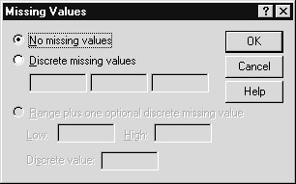
By default, the “No missing values” option button is selected. This does not imply that there are no missing values for agewed in the data, but rather that no data value has been designated as representing missing information. The second choice, “Discrete missing values” is the most commonly used choice. Here you can specify up to three distinct (discrete) missing value codes for the variable. Finally, the “Range plus one discrete missing value” jointly declares that a range of values, plus one specific value, represent missing information. These choices result in considerable flexibility in defining missing values, especially when you consider that the values declared missing can be different for each variable.
- Click Discrete missing values option button
- Type 0 in the first text box below the Discrete missing values option button
- Click in 2nd text box (or press the Tab key) and type 98
- Click in 3rd text box (or press the Tab key) and type 99

Figure 5.16 Completed Missing Values Dialog Box
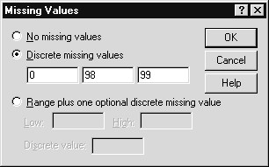
Typing errors can be edited by clicking in the relevant text box and changing the data value. If you later want to turn the missing value declaration off, return to this dialog box and click the “No missing values” option button.
8) Click OK to process the missing values

Figure 5.17 Missing Values Displayed in Variable View Sheet
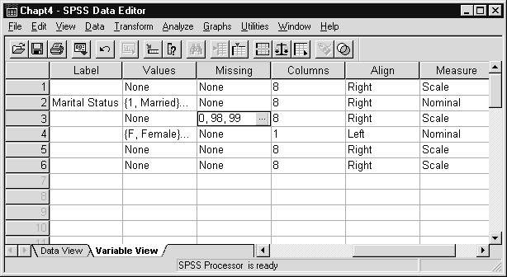
Notice that the list of declared missing values appears in the cell for agewed (3rd row) in the Missing column. It would be useful to supply value labels for these missing value codes; how otherwise would someone reading the results know what a zero means for age first married? However, we will not enter more value labels at this point.
Now analyses involving agewed will exclude the missing values from statistical calculations. Some procedures, like Frequencies, which we will see later in this chapter, will tabulate how many occurrences of each missing code exist in the data.
MISSING VALUES  FOR A STRING VARIABLE | Missing values are declared for string variables using the Missing Values dialog box in the same way as we did for the numeric variable agewed. However, care must be taken that the case (upper/lower) and spacing match the value to be declared missing. For example, if for a three column string variable the value “n a” indicates missing data (no answer), then precisely this string must be entered into the Define Missing Values dialog box. Note that strings such as “N A,” “NA,” or “na” do not match “n a” and would not correctly define the missing code.
We will declare a single blank space as the missing value code for
GENDER. This step would not be necessary for a numeric variable, since SPSS automatically converts blanks into the system-missing value. Again from within the Variable View sheet of the Data Editor window:
- Click the cell in the 4th row (gender) of the Missing column in the Variable View sheet
- Click the button in the 4th row (gender) of the Missing column in the Variable View sheet
- Click Discrete missing values option button in Missing Values dialog box
- Press the spacebar once (to enter one blank space into the 1st text box)

Figure 5.18 Declaring a Blank as a Missing Value for Gender
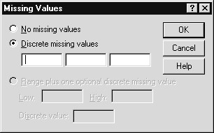
Unfortunately, we cannot see the single blank space in the screen above. However, it has been declared (trust us) and we can detect this in the Variable View sheet.
5) Click OK to process the missing value
Figure 5.19 Variable View Tab Sheet with Blank Declared as Missing

Value
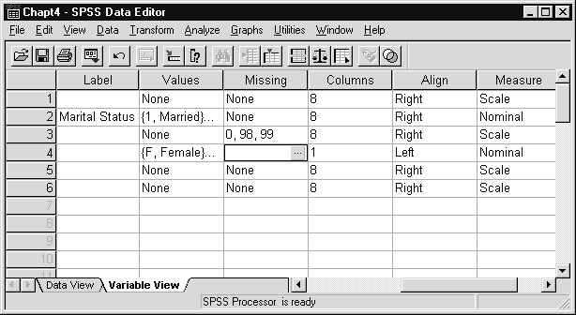
USING LABELED  VARIABLES IN A PROCEDURE | To demonstrate how labels and missing values are handled in SPSS output, we will run a simple analysis that produces frequency tables. The Frequencies procedure will be discussed in greater depth later in the
While we cannot identify the single blank space within the cell located in the 4th row (gender variable) of the Missing column, we can see that the text “None” that originally appeared in this cell (see Figure 5.17) has been replaced by a blank space, indicating that there is only one missing value defined and it is composed of blank(s). Although this example would be easier to demonstrate if an actual letter were used in the data set to designate missing (perhaps “X”), the blank is employed because it often occurs in practice. course.
- Click Analyze..Descriptive Statistics..Frequencies from the main menu
- Click agewed, then click the right arrow button to move agewed into the Variables list box
- Click gender, then click the right arrow button to move gender into the Variables list box
- Click Marital Status [marital], then click the right arrow button to move marital into the Variables list box

Figure 5.20 Completed Frequencies Dialog Box
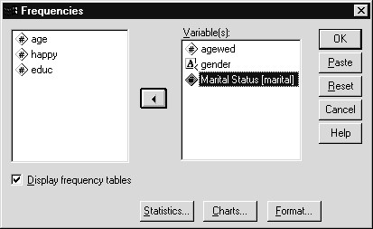
The variable label for marital appears in the list box beside the variable name. We request basic frequency tables based on age when first married, gender, and marital status of the respondent. Charts and additional statistics can be obtained using the Charts and Statistics pushbuttons. These variations will be pursued later.
- Click OK to run Frequency analysis
- Click the AGEWED item in the Outline (left) pane of the Viewer window.

Figure 5.21 Valid Values in Age First Married Frequency Table
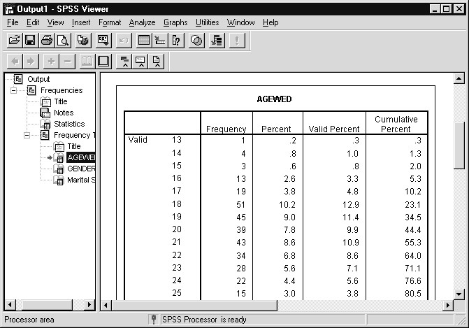
We see the youngest age first married is 13 (Value column) and that only one respondent was first married at that age (Frequency column). The Percent column contains percentages based on the entire sample, including missing values. The Valid Percent column excludes missing values from the percentage calculation. We see that these two percentages are not identical. The last column shows cumulative percentages based on the valid percentage calculation. Values following the “Valid” label in the first column represent valid data values.
7) Scroll to end of AGEWED frequency table in Viewer window

Figure 5.22 Missing Values in Age First Married Frequency Table
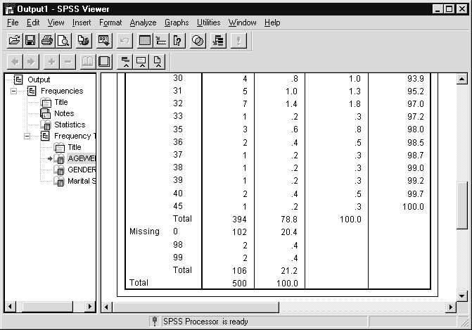
At the bottom of the table we see the three missing codes (0, 98 and 99). As we would expect, far more people were never married (code 0) than responded “Don’t Know” (98), or gave no answer (99). It would be very useful to have value labels for the missing values and they could have easily been added when we were working in the Variable View sheet. Notice that the third column (Percent), but not the fourth (Valid Percent), contains percentages for the missing value codes. Missing values are excluded from the Valid Percent calculation and the label “Missing” appears beside the first of the missing value codes. If we had asked for other statistics, such as means, the missing values would be excluded.
8) Click the GENDER item in the Outline (left) pane of the
Viewer window

Figure 5.23 Frequency Table with Value Labels
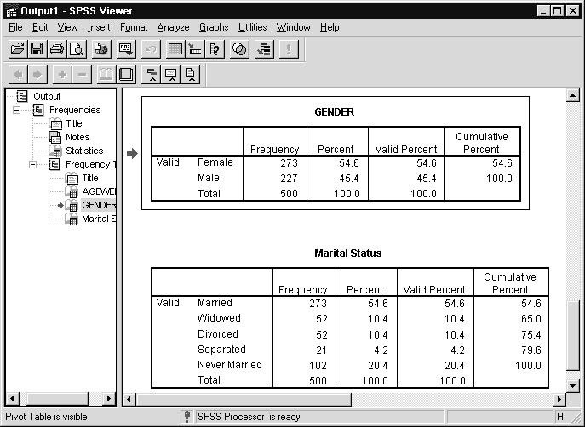
The value labels “Female” and “Male” appear in the table in place of the actual data values. There is no summary line for blank gender codes, indicating there were no missing values for gender in the data.
The variable label “Marital Status” appears at the top of the frequency table and the value labels substitute for the numeric marital status codes. Without value labels, it would be very difficult to interpret the output. Notice there were no missing values for marital status.
SAVING THE  MODIFIED DATA FILE | The labels and missing values we entered have been added to the SPSS data file residing in the Data Editor window. In order to retain this information, we must again save the contents of the Data Editor window. We will save this updated copy of the data under the name Chapt5. SPSS will assign the file extension .SAV. Remember that the Data Editor window must be the active window if we wish to save its contents.
- Click Window..1 Chapt4 - SPSS Data Editor
(Alternatively, click the GoTo Data tool )
- Click File on the main menu

Figure 5.24 File Menu
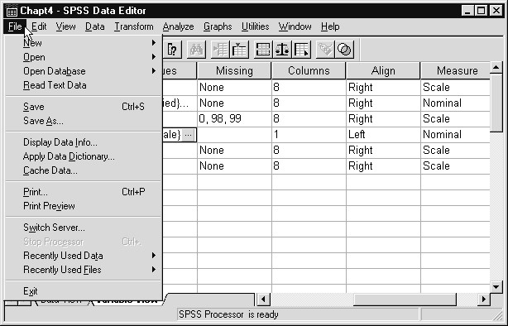
Two choices on the File menu permit you to save the contents of the Data Editor window: Save and Save As. The Save menu choice will immediately save the contents of the Data Editor (data, variable names, formats, labels, missing value declarations) under the current file name, and will overwrite the previous version of the file. The Save As choice will prompt you for a file name, and if the file name already exits, you will be asked if you wish to overwrite it. As such, Save As is a much safer choice to make. If the contents of the Data Editor window had not been previously saved as an SPSS data file (the Title bar would read Untitled) then both Save and Save As would lead to the same dialog box (Save Data As).
- Click Save As on the File menu
- Move to the Basewin10 folder (within the c:\ Train folder) if necessary
- Type Chapt5 in the File name text box

Figure 5.25 Save Data As Dialog Box
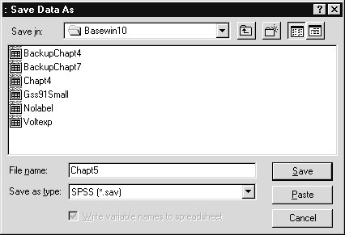
If Chapt5.SAV (recall that SPSS appends a .SAV extension to the file name) already exists in the Basewin10 folder, then when we click Save to run the save operation we would be asked if we wished to replace the file.
6) Click the Save pushbutton to save the updated SPSS data file

Figure 5.26 Data Editor After Saving Data File
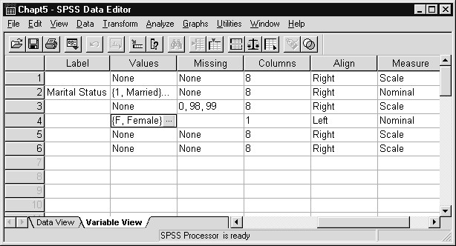
Notice that the file name in the Title bar of the Data Editor window has changed to reflect the new name for the data file.
EXITING SPSS FOR WINDOWS | Let’s now leave SPSS for Windows. As in many other Windows applications, you exit SPSS by clicking File..Exit from the main menu. When you exit, SPSS will ask you if you want to save the contents of any SPSS windows that have been modified since last saved. Here we will not be asked about saving the Data Editor window, since we just saved it, but will be queried about the Output Viewer window, which contains the results of the Frequency analysis we ran.
1) Click File..Exit to leave SPSS for Windows
Since we have not saved the contents of the Output Viewer window after we ran the Frequency analysis, SPSS asks if we wish to save them.

Figure 5.27 Save Contents .... Alert
If we click Yes, a Save As dialog box will open and we can save the output as an SPSS Viewer file. Output Viewer files are assigned an .spo extension. Such files can be later retrieved within SPSS by clicking File..Open..Output. Clicking the No button indicates we do not wish to save the output, while clicking Cancel would cancel the exit operation.
We will save the frequency output under the name Chapt5 (Chapt5.spo).
- Click Yes pushbutton
- Verify that you are saving into the Basewin10 folder (move to this folder if necessary)
- Replace Output1 by typing Chapt5 in the File name text box

Figure 5.28 Save As Dialog Box (Saving Output)
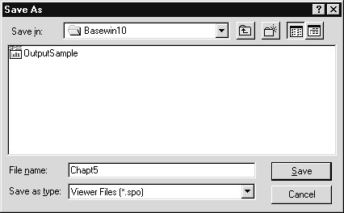
The output can be opened later by SPSS for Windows or examined using the SPSS SmartViewer or the SPSS SmartViewer Web Server. If we had thought of this beforehand, we could have earlier saved a copy of the output by clicking File..Save As when the Output Viewer window was the active window.
5) Click Save pushbutton to save contents of the Viewer window
We have now left SPSS for Windows and return to the desktop.
Hint: Copying and  Pasting Variable  Properties  Extensions | We saw how to supply value labels for individual variables. In surveys it is often the case that a series of questions would have the same labels (for example, the rating scale 1=Strongly agree,..., 5=Strongly disagree). Rather than repeatedly entering the labels, you would enter the labels once in the Variable View tab sheet, as we did earlier in this chapter, then copy the Values cell contents to the clipboard and paste them into the Values cells for all relevant variables. This Copy and Paste operation can be applied to the properties stored in the Variables View sheet. Chapter 11 covers this feature in more detail.  We did not make changes to all properties (columns) in the Variable View sheet. Another common change is to modify the column width for a variable in the Data View of the Data Editor window. For example, the width for gender was set to one column. To widen or narrow columns in the Data View sheet, you can change the Columns property in the Variable View tab sheet. Alternatively, you can change column widths directly by clicking and dragging the vertical border of a variable, beside its name, within the Data View sheet of the Data Editor window.

Note About the  Data  SUMMARY  APPENDIX:  ENTERING  LABELS IN  EARLIER  VERSIONS OF SPSS | We have declared measurement type, supplied labels, and added missing value codes for a few variables from the General Social Survey. This data file has been saved as Chapt5 (CHAPT5.SAV). If we were to continue the definition process, that is, read in a larger set of GSS variables and add labels and missing values, we would just apply the methods in the previous two chapters to the additional data fields. In the next chapter of this course we will begin using an SPSS data file named Gss91Small (Gss91Small.SAV), which contains a larger set of General Social Survey variables and complete labeling. We could have created this SPSS data file ourselves during the class, but entering all the labels and missing values would have taken up too much time.  In this chapter we have seen how to retrieve and save SPSS data files. In addition, we learned how to supply variable labels, value labels, measurement type and missing values for variables in the SPSS data file.  The division of the Data Editor window in Data View and Variable View tab sheets occurred in SPSS 10.0. Labels, missing values and formatting information are supplied through the Variable View tab sheet. In earlier versions of SPSS for Windows, such information would be entered through the Define Variable dialog box. This dialog can be reached (for users of SPSS 9.0.1 and earlier) by clicking on a variable name in the Data Editor window (there was only one sheet, which presented a data view) and then clicking Data..Define Variable. Alternatively, doubleclicking of a variable name within the Data Editor window would invoke the Define Variable dialog in earlier versions of SPSS for Windows.  For users of earlier versions of SPSS for Windows, Appendix D describes how to enter labels and missing values prior to SPSS 10.0.

Chapter 6 | Examining Summary Data for  Individual Variables
TOPICS | Measurement Scales and Summary Statistics  Producing Frequency Tables  Producing Summary Statistics with Frequencies  Producing Bar Charts and Histograms  Producing Summary Statistics with Descriptives  Statistical Definitions
INTRODUCTIONhis chapter discusses simple analyses of one variable and how the level of measurement of a variable influences the types of statistical procedures that should be used. In addition to summary
T
statistics, we discuss graphical representations of a variable’s
 | distribution.
WHAT TYPE OF  SUMMARY  INFORMATION IS  USEFUL  LEVELS OF MEASUREMENT | The Data View tab sheet of the Data Editor window displays the individual responses to particular variables so that you can see how each person responded on the General Social Survey. When you are looking at the responses from many people, it is convenient to summarize the information to answer questions such as:  What is the percentage of female respondents? Do more people find life to be exciting or routine?  What is the average age of the respondents?  What is the range in the number of hours of television watched per day?  What is the standard deviation of age in this sample?  Which SPSS procedure to use when summarizing data depends on the question you wish answered and how the variables of interest are measured. The most common categorization of measurement distinguishes among four different types of information. The categories are:
Nominal Variables have data values that identify group membership. Examples include state of residence, ethnicity, religious affiliation, and gender.
Ordinal Variables have data values arranged in a rank ordering with an unknown difference between adjacent values. Examples include satisfaction questions, such as HAPPY and HAPMAR in this file, or highest degree received.
Interval Variables are measured on a scale such that a one-unit change represents the same difference throughout the scale. Examples include IQ or SAT scores. Interval variables do not have true zero points.
Ratio Variables have the same property as interval variables, plus the additional property of a true zero. Because of this, proportions or ratios between values are meaningful measures. Examples are age, education in years, or the number of hours of television watched per day.
For most analytical purposes, interval and ratio variables can be considered identical, yielding three types of measurement scales.
APPROPRIATE  STATISTICS  PRODUCING  SUMMARIES FOR  NOMINAL VARIABLES | For each type of variable a particular measure of central tendency is most appropriate. By central tendency we mean one value that most effectively summarizes a variable’s complete distribution. Variables measured on a higher scale, such as interval/ratio, can also use measures of central tendency for lower scales of measurement (i.e., the mode, median, and mean are all suitable for interval/ratio variables).  Measurement Scale Measure of Central Tendency  Nominal Mode: The value that appears most often in a distribution.  Ordinal Median: The value that divides the ordered  distribution of responses  into two equal size groups (the  value of the 50th percentile).  Interval/Ratio Mean: The arithmetic average of a distribution.  In Chapter 5 we mentioned that the measurement level could be declared for a variable. Currently only the Interactive Graphics procedure and the SPSS AnswerTree product use these declarations. For other SPSS procedures, you can reference the measurement level by right-clicking on the variable within any variable list box and use this information to guide your analysis.  For nominal variables, a listing of the number and percentage of cases in each category is often sufficient. The Frequencies procedure in SPSS provides such information. To begin, we run SPSS for Windows and open the Gss91Small(.SAV) SPSS data file.
- Click Start..Programs..SPSS for Windows..SPSS 10.0 for Windows
- Click OK in the Startup dialog box after making sure that the Open an existing data source option and the More Files list box item are selected (or click Cancel to close the Startup dialog box, and click File..Open..Data from the main menu)
- Change folder to Basewin10 (located in the c:\ Train folder), then click on Gss91Small to select it
- Click Open button
To produce frequencies for the nominal variables MARITAL (Marital Status) and REGION (Region of Interview), do the following.
- Click Analyze..Descriptive Statistics.. Frequencies from the main menu. The Frequencies dialog box appears, with a list of variables in the Data Editor displayed on the left-hand side
- Select the first variable by clicking on Marital Status
[marital], then clicking on the arrow icon . Do the same
for Region of Interview [region]. The resulting dialog box is shown in Figure 6.1

Figure 6.1 Completed Frequencies dialog box
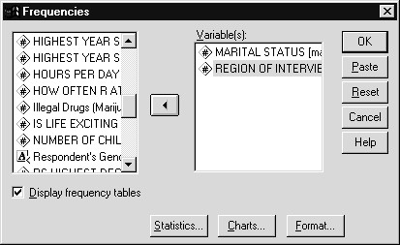
- Click the OK button, which causes SPSS to produce the frequency tables for each of the variables
The Output Viewer window displays the frequency table summaries. Figure 6.2 shows the valid and missing data summaries, and Figure 6.3 displays the frequency table for marital status.
- Click the open book icon beside Statistics in the Outline pane of the Viewer window (and resize the window if necessary to see the entire table)

Figure 6.2 Overall Summaries for Marital Status and Region
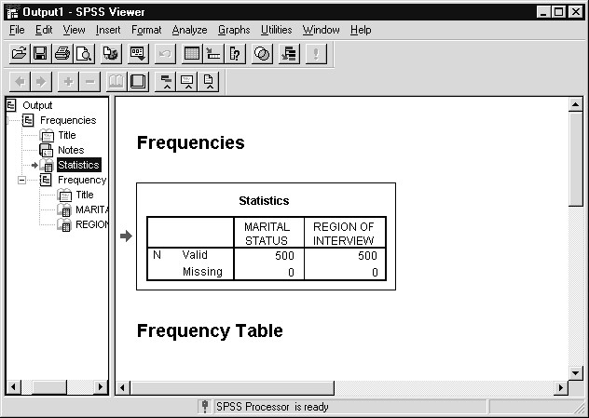
The Statistics pivot table produced by Frequencies indicates how many valid and missing cases there are for each variable in the Frequency analysis. Neither variable has any missing values. If additional statistics were requested (for example, modes), they would appear in the Statistics table.
9) Click the book icon beside Marital Status in the Outline pane (alternatively, scroll down to the Marital Status pivot table in the Contents pane)

Figure 6.3 Frequency Table for Marital Status
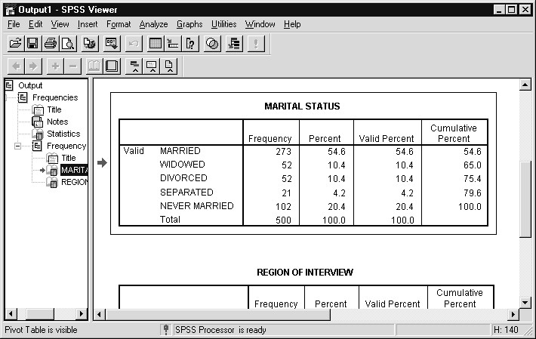
Each frequency table presents the following information:
The variable label (or the variable name if there was no variable label).
The first column contains the value labels defined in the file. For values without value labels, the data values themselves would appear. The “Valid” identifier in the first column indicates that the rows following it represent valid data values. The identifier “Missing” precedes the rows representing missing values, if any exist in the data. A system-missing value, which could be a blank numeric field in the original text file, would appear as a period (.) in the Data Editor window, and would also appear in the “Missing” group and be labeled “System Missing”.
The second column shows the frequency, or count, of the number of cases for a particular data value.
The third column shows the percentage of cases for a particular value based on the total number of cases in the file.
The fourth column shows the valid percentage of cases for a particular value. Each percentage in this column is based only on the number of cases with nonmissing values.
The fifth column shows the cumulative percentage for each value, from the lowest value to the highest valid (nonmissing) value. Each cumulative percentage is calculated by adding the valid percentage for a particular alue to the cumulative percentage from the previous value.
Totals appear at the bottom of the frequency table.
The Frequencies dialog box contains a button for specifying various statistics for the variables selected in this procedure. For nominal variables, the appropriate summary measure is the mode (which is a measure of central tendency).
Hint: Rather than repeat the Analyze..Descriptive Statistics..Frequencies sequence to return to the Frequencies dialog box, we can click the Dialog
Recall tool , which will produce a list of the most recently accessed dialog boxes. From this list we choose the dialog box of interest and will move directly to it (see Chapter 11 for more details).
- Click Dialog Recall tool
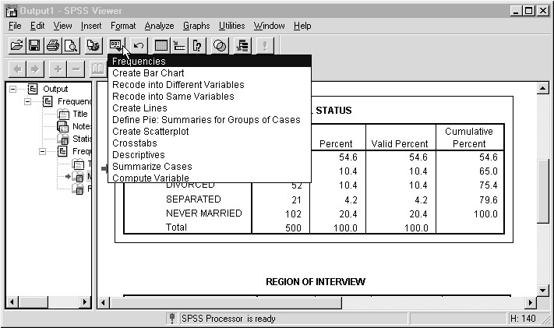
Figure 6.4 Dialog Recall List
The most recently accessed dialog box appears at the top of the list. We select a dialog box by clicking on its name.
- Click Frequencies in the Dialog Recall list
- Click the Statistics button in the Frequencies dialog box
- Click the check box for the Mode in the Central Tendency selections
Figure 6.5 displays the completed Frequencies: Statistics dialog box.

Figure 6.5 Frequencies: Statistics Dialog Box
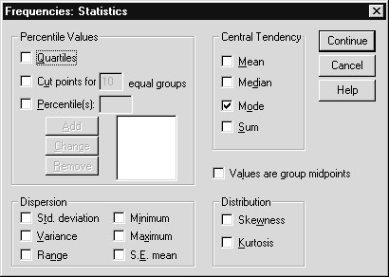
- Click Continue to return to the main dialog box, then click
OK to finish the request
- Click the open book icon beside the second occurrence of
Statistics in the Outline pane

Figure 6.6 Modes for Marital Status and Region
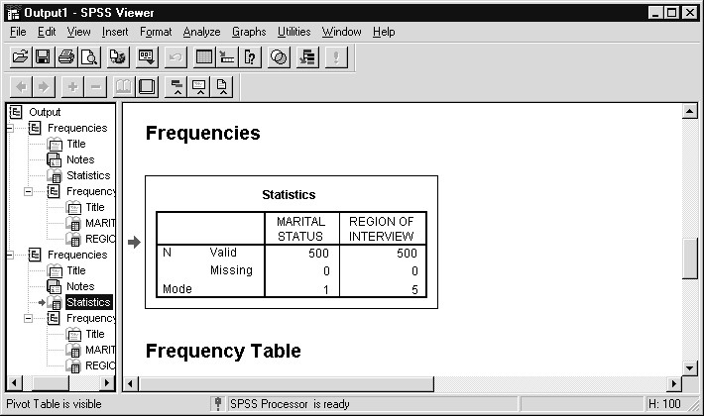
SPSS displays the requested statistics in the Statistics pivot table of the frequency output. We can see the beginning of the frequency tables (title) for the two variables at the bottom of the Contents pane. The
Statistics table reports the most frequently occurring value (the mode) as
1 for MARITAL, meaning that more respondents reported being married (273: see Figure 6.3) than any other category. If a variable is coded with alphanumeric values, statistics are not calculated. In some instances there can be a tie among a number of different values, and in those cases SPSS reports the lowest modal value and displays a message indicating there are multiple modes.
Hint: Note that the mode is reported as a number, as other statistics would be, while only labels appear in the frequency table. You can obtain information matching the values to the value labels by clicking Utilities..Variables, then clicking on the variable of interest. Alternatively, you can request that both data values and value labels appear in frequency tables and other pivot table output. This is accomplished within the SPSS Options dialog box (click Edit..Options), which we demonstrate in Chapter 7.
BAR CHARTS  DISPLAYING  FREQUENCY TABLES | It is quite common in reports and presentations to present the information in a frequency table in graphic format. SPSS can produce a bar or pie chart for any single variable (and more complicated bar charts as well). Bar charts are an effective means to see the distribution of values for a single variable that is measured on a nominal or ordinal scale, provided that there are not too many distinct values.
You can use the Charts button in the Frequencies dialog box to specify the type of chart you would like to see.
- Click Dialog Recall tool , then click Frequencies
- Click the Charts button to display the Frequencies: Charts subdialog box
- To obtain bar charts for both variables, click on the Bar charts option button in the Chart Type box, as shown in Figure 6.7

Figure 6.7 Frequencies: Charts Dialog box
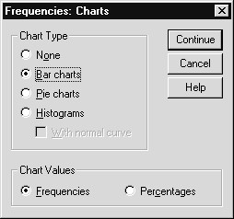
A pie chart option is also available within the Frequencies: Charts dialog box, as are histograms, which are appropriate for interval scale (numeric) variables that take many values.
- Return to the Frequencies dialog box by clicking on Continue, and then click OK
SPSS processes the request and sends the frequency tables we have previously seen and the bar charts to the Viewer window.
- Scroll to the bottom of the Outline pane of the Output Viewer window and click on the open book icon beside the Bar chart of Marital Status item (resize the Viewer window if necessary)

Figure 6.8 Bar Chart for Marital Status
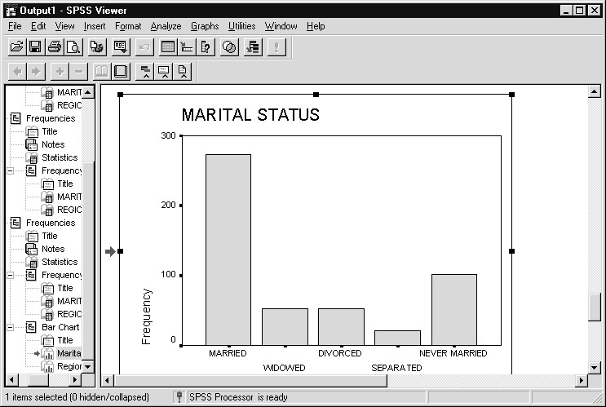
We now see the bar chart of marital status. You can view other charts in the Viewer by one of these methods.
- Clicking on the open book icon beside a chart item in the Outline pane (for example, the item “Bar chart of region of interview”).
- Scrolling in the Contents pane to move sequentiallythrough the charts and tables in the Viewer window.
To display the bar chart for region:
6) Click the open book icon beside the “Bar chart of Region of Interview” item in the Outline pane

Figure 6.9 Bar Chart for Region of Interview
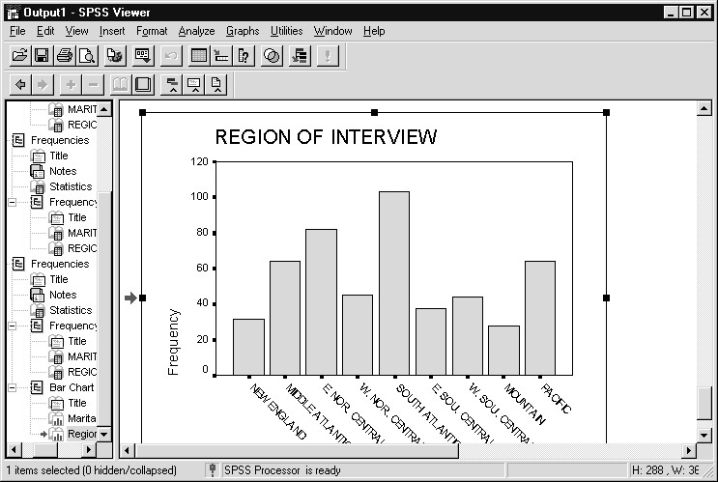
A later chapter will show how to modify various aspects of the chart, including colors, patterns, and orientation, plus adding titles.
Hint To display the frequency table and bar chart for a variable as consecutive items in the Viewer window, choose the “Organize output by variables” option in the Frequencies: Format dialog box.
PRODUCING  SUMMARIES FOR  ORDINAL VARIABLES  Hint: | In this section we will produce frequency tables and appropriate summary statistics and bar charts for ordinal variables. We will examine highest degree received (DEGREE) and self-reported general happiness (HAPPY).  Since both the Data Editor and Viewer windows contain the Analyze and Graphs menus, we can run additional analyses from either window.
- Click Dialog Recall icon , then click Frequencies
- Since SPSS retains the specifications from the previousrequest, return to the default settings by clicking on the Reset button
- Place the variables R's Highest Degree [degree] and
General Happiness [happy] in the Variable(s) list box
For ordinal variables, the mode and median are both useful measures of central tendency.
- Click the Statistics button, and then click the Mode and
Median check boxes in the Central Tendency area. Next click Continue
- To produce bar charts, click the Charts button, and then select Bar chart(s) in the Chart Type area
- Then click Continue followed by OK in the Frequencies dialog box to process the request
- Scroll in the Contents pane of the Viewer window so that the
Statistics table and the beginning of the frequency table of
R's Highest Degree (DEGREE) are visible

Figure 6.10 Frequency Table and Central Tendency Statistics for Highest Degree Received
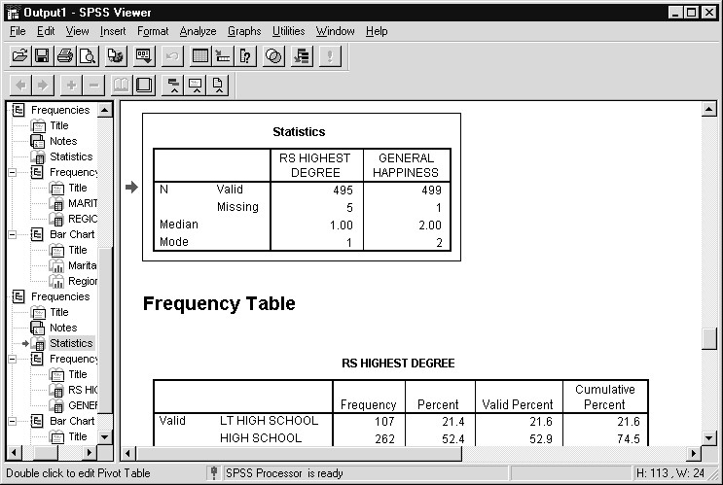
Figure 6.10 displays the summary statistics for both variables and the frequency distribution for highest degree received. The mode is 1, as more people report a high school diploma as their highest degree than any other category. The median, or midpoint, is also 1, since the 50th percentile occurs in the high school category (cumulative percentage for those with a high school degree or less is 74.5%). In fact, 52.9% of the valid cases are in the high school category.
The two bar charts have been added to the Viewer window. To view them, click on the open book icon for either chart item in the Outline pane, or scroll down in the Contents pane of the Viewer window.
PRODUCING  SUMMARIES FOR  INTERVAL OR  RATIO  VARIABLES WITH FREQUENCIES | A frequency table or bar chart showing every distinct value of an interval or ratio variable such as age or age when first married becomes too lengthy to scan easily. However, you can get a fairly reasonable representation of the distribution by producing a histogram of the values. A histogram groups together adjacent values and displays a bar at the midpoint of the grouping. At the same time, you can suppress the display of the frequency table. In addition, we will request summary statistics and measures of dispersion commonly associated with interval and ratio variables.
- Click Dialog Recall tool , then click Frequencies
- Click the Reset button to reset the dialog box
- Suppress the display of the frequency tables by deselecting(clicking on the check box) Display Frequency Tables. After you select this, SPSS displays the warning message shown in Figure 6.11. This message reminds you that unless you request some statistics or charts, no output will be produced
Figure 6.11 Frequencies Warning Message When Display Frequency

Tables Has Been Turned Off
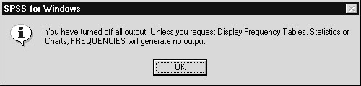
- Click OK to acknowledge the message
- Put Age of Respondent [age] and Age When First Married [agewed] in the Variable(s) list box
- Click the Statistics button, then select Mean, Median, Mode, Std. deviation, Minimum, and Maximum. Then click Continue
- Click the Charts button, then select Histogram(s). Also click the With normal curve check box to have SPSS display a normal curve superimposed over each histogram. Then click Continue, and OK in the main dialog box
- Click the open book icon beside the last Statistics item in the Outline pane

Figure 6.12 Summary Statistics for Age and Age When First Married
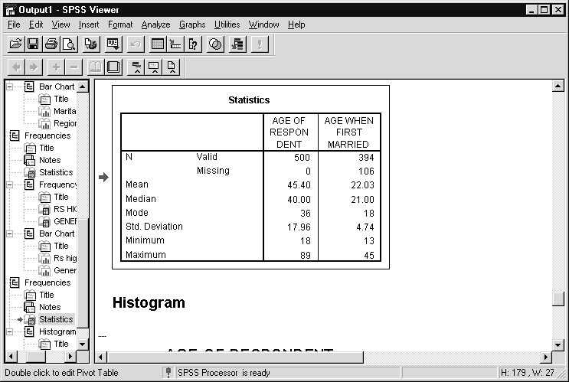
The summary statistics produced in the Viewer window are shown in Figure 6.12.
The statistics for all variables appear in a single table. If you want the statistics for each variable to precede its frequency table (or in this instance, histogram), it can be controlled through the Format button in the Frequencies dialog box.
The mean age of respondents was about 45.4, with the youngest being 18 and the oldest 89 (actually, all ages 89 and above are coded to 89). The median or midpoint of age is 40, indicating that the distribution is probably not perfectly symmetrical, a point we will check graphically below. Note that the most common age when first married is 18.
9) Click the open book icon beside the “Histogram of age when first married” item

Figure 6.13 Histogram of Age When First Married with Normal Curve
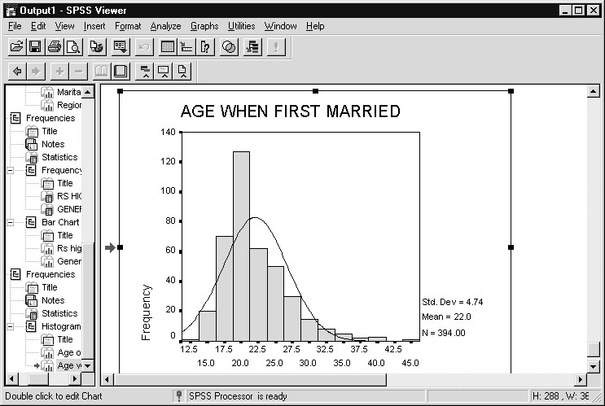
The histogram produced for AGEWED does not follow the normal curve. There is a large bunching of cases around age 20, but few cases before that (most people don’t get married before 18), and it also has some cases at ages above 35 that are far to the right of the distribution. A great deal of information is summarized concisely in this graph. Take a look at the histogram for current age if you wish.
PRODUCING  SUMMARIES  WITH THE  DESCRIPTIVES PROCEDURE | When you only need to quickly see summary statistics for interval or ratio variables, but no frequency table or graphics output, the most efficient method to request this information is to use the Descriptives procedure. It is also accessed in the Descriptive Statistics section of the Analyze menu choice.
- Click Analyze..Descriptive Statistics..Descriptives. A dialog box appears as in Figure 6.14
- Select the variables Highest Year of School Completed
[educ], Age of Respondent [age], and Age When First Married [agewed]

Figure 6.14 Descriptives Dialog Box
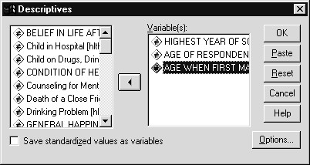
- Click on OK
By default, Descriptives produces the mean, standard deviation, minimum, and maximum, and valid number of cases for each variable. Clicking on the Options button can change them. The output from Descriptives is displayed in Figure 6.15. The variables are listed in the order they appear in the Variable(s) list box (this can be changed in the Options section). The numbers here should look familiar.
- Click the open book icon beside the Descriptive
Statistics item (under Descriptives) in the Outline pane

Figure 6.15 Descriptives Output for Education, Age, and Age First Married
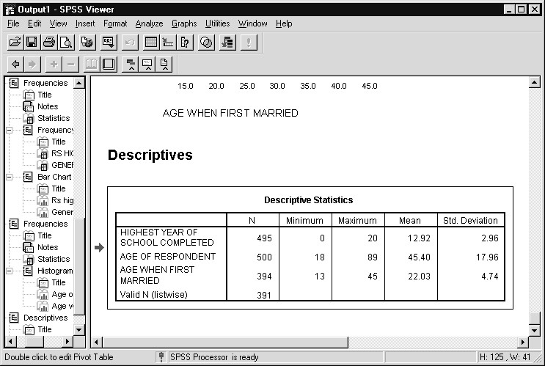
STATISTICAL  DEFINITIONS | If you come across an unfamiliar statistical term when viewing results in SPSS pivot tables, you can easily obtain a definition. To do so you would click on the term of interest within the Pivot Table editor (Chapter 9 reviews many aspects of the Pivot Table editor) and select “What’s This?” help.  To demonstrate, we will obtain information about standard deviations, which appear in the results we just produced.
- Double-click on the last Descriptive Statistics pivot table in the Contents pane of the Output Viewer window (to invoke the Pivot Table editor)
- Right-click on the Std. Deviation column heading in the pivot table

Figure 6.16 Context Menu in Pivot Table Editor (When Text Selected)
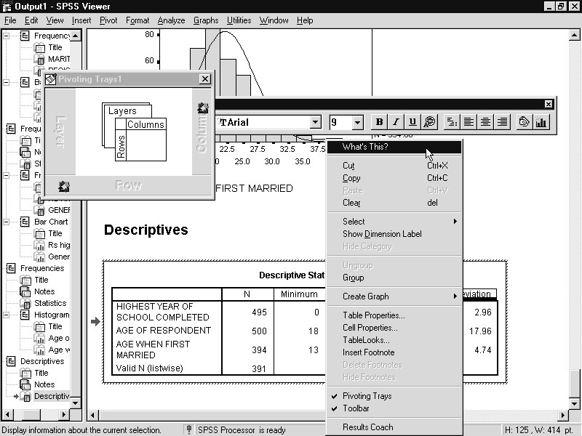
The Pivot Table editor permits you to edit and reformat SPSS pivot tables and we will cover these features in Chapter 9. Here we invoke the editor only to select a term in the output about which we want information.
3) Click What’s This? on the Context menu

Figure 6.17 Information about Standard Deviations
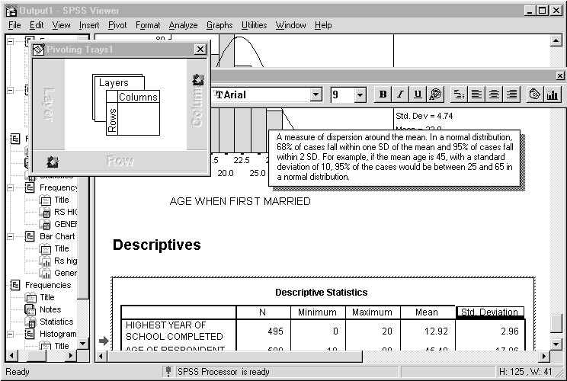
A brief definition and example of the selected term appears in a popup window. The “What’s This?” feature can be quite useful when you are unsure of the meaning of a statistical summary.
We will now exit SPSS.
- Click File..Exit
Hint: SPSS will prompt you to save the output when you exit SPSS if there have been any changes to the Output Viewer window. We could also have saved the contents of the Viewer window earlier by clicking File..Save As when the Viewer window was the active window. You should save the Output Viewer’s contents if you wish to retain the statistical tables and charts for later viewing in SPSS, or to transfer them to other applications.
Here we will not save the contents of the Viewer window.
- Click No when asked to save contents of the Output Viewer window
SUMMARY In this chapter you have learned how to produce frequency tables, summary statistics, and graphics for several types of variables.

Chapter 7 | Modifying Data Values
TOPICS | Displaying Values in SPSS Output  Recode Values into the Same Variable  Recode Values into a New Variable  Create a New Variable with a Mathematical Expression  Check the Results of a Transformation Procedure
INTRODUCTIONata that you receive from an outside source or from your own
D
surveys or interviews may not always be in the best form for analysis and reporting. Often you may want to group together
values of a variable with similar or closely related meanings. SPSS allows you to change your data by combining several categories into one category, or by changing the coding scheme for a variable. You can choose to assign the new values to the existing variable or to a new variable. This type of action is requested by the RECODE procedure.
At other times you may wish to modify an existing variable, or create a new variable, which will contain the results of some mathematical operation (such as adding two variables together, taking the square root of a variable, etc.). This type of action is requested by the COMPUTE procedure.
DISPLAYING  VALUES IN SPSS OUTPUT | SPSS displays value labels in summary tables if such labels exist. Generally, this is desirable in that the results are more readable and attractive; it is unlikely that a manager reading the frequency table is interested in knowing that marital status “divorced” is coded 2 rather than 4. However, there are situations in which you might want to display both the data values and value labels. A common instance would be when you use SPSS to modify data values and want to check the results. Here it can be very helpful to view the actual data values in the output and is critical for the purpose of debugging when a change goes awry.  For this reason, we will change one of the SPSS options in order to display both the data values and value labels in pivot tables. At the end of this chapter, we will restore the option to its default so later results look more attractive. There is a brief discussion of SPSS options in the appendix to Chapter 11 and more extensive coverage in the SPSS Base
10.0 User’s Guide.
Click Edit..Options
Click Output Labels Tab in the SPSS Options dialog box
The Output Labels tab sheet controls which combination of labels, variable names and values appear in the Outline pane (top area) and in Pivot Tables (bottom area). We request that both values and value labels appear in pivot tables.
Click arrow under Variable values in labels shown as: Click Values and Labels choice
Figure 7.1 Output Labels Tab Sheet in the SPSS Options Dialog Box
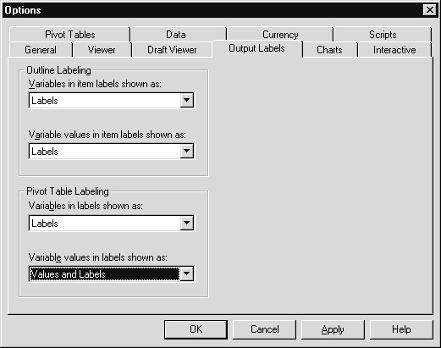
Click OK
Now we will see both values and the value labels in the frequency tables used to check the outcomes of our data modifications.
RECODING  VALUES INTO  THE SAME VARIABLE | If you don’t already have the Gss91Small(.SAV) file open, please reopen it before continuing (from within SPSS click File..Open..Data, and double click on Gss91Small in the c:\ Train\ Basewin10 folder).  One question in the General Social Survey asks the respondent whether she thinks of herself as liberal or conservative, with responses on a seven-point scale from “Extremely Liberal” to “Extremely Conservative” (the variable POLVIEWS). For purposes of reporting, imagine that we want to group the respondents into three categories: those of liberal leaning, those of conservative leaning, and those who are neutral (who choose the “Moderate” response for this item). Let’s check the current distribution of values for POLVIEWS by requesting a frequency table.
- Click Analyze..Descriptive Statistics..Frequencies
- Put Think of Self as Liberal ..[polviews] in the Variable(s) list, then click OK
- Click the open book icon beside the “Think of Self as
Liberal or Conservative” item in the Outline pane
Figure 7.2 shows the frequency table for political view. More people report themselves to be Moderate than any other position, and there are more people on the conservative side (169) than on the liberal side (115).

Figure 7.2 Frequency Output for POLVIEWS
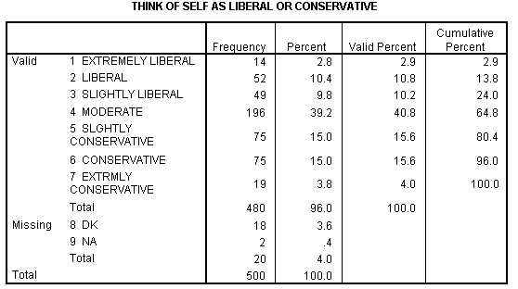
We can group the values of POLVIEWS with the Recode..Into Same
Variables selection. Please note that after doing so, the values of POLVIEWS really have been changed, although not in the Gss91Small file on disk. What have been altered are the values in the Data Editor window. To redo the recode operation, we would have to reopen the GSS file. To permanently change the values of POLVIEWS, we would have to save the Data Editor window to the same Gss91Small(.SAV) file name.
Here’s how we go about recoding. First, note that since transforming data is a data operation, the Transform menu choice is only available within the Data Editor window.
- Click the Goto Data icon to make the Data Editor window active (alternatively click Window..Gss91Small - SPSS Data Editor)
- Click on Transform..Recode..Into Same Variables. This opens the dialog box shown in Figure 7.3
- Place Think of Self as Liberal ..[polviews] in the Variables(s) list box

Figure 7.3 Recode Into Same Variables Dialog Box
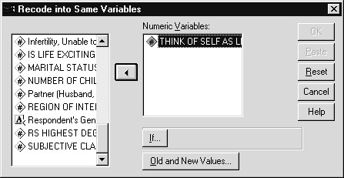
- Click the Old and New Values button to specify which values to recode and what they should be recoded to.
SPSS now opens the Recode into Same Variables: Old and New Values dialog box. Within this box, you specify on the left-hand side the existing values that you want to change, then on the right-hand side the new value into which the old values should be grouped. You then must add these specifications to the Old -> New: box. You can also recode existing values for numeric variables directly to system-missing.
- Click the first Range option button in the Old Value area.
Then type 1, click in the through box, and type 3
- Click in the Value text box with the New Value area, then type 1. Then click on the Add button. This places the first recode specification in the Old --> New: box
- Click the Value option button in the Old Value area, then type 4 in the Value text box
- Click in the Value text box in the New Value area and type 2, then click on Add
- Click the first Range button again, then type 5, click in the through box, and type 7
- Click in the Value box in the New Value area, type 3, then click on Add. The dialog box should look like Figure 7.4. If it does, click on Continue

Figure 7.4 Completed Old and New Values Dialog Box for Political Views
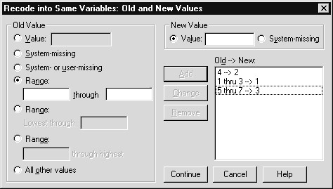
11) Click OK in the Recode main dialog box
SPSS changes the values of POLVIEWS as specified in Recode, reducing the number of valid values from seven to three. All those of a liberal persuasion now have a value of 1, those of conservative persuasion have a value of 3, and those on the fence are coded with a 2.
When transforming data in SPSS, you should always verify that the data were modified correctly (since it is so easy to make typing errors). One way to do so is to search for values that should now be nonexistant in the Data View sheet of the Data Editor. Notice that the Data Editor window became the active window after the Recode request was processed.
- Verify that the Data View tab sheet is active (if not click the
Data View tab)
- Select the variable POLVIEWS by clicking once on its column heading
- Click Edit from the main menu, then click Find. Alternatively, you can click once on the Find icon in the standard tool bar
- In the dialog box that appears, type 5 in the Find what text box. This is shown in Figure 7.5

Figure 7.5 Search for Data Dialog Box with the Value of 5 Selected for POLVIEWS
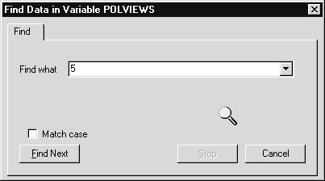
5) Click the Find Next button. SPSS searches in the POLVIEWS column and displays the message “ 5 Not Found,” as we expected. This window is displayed in Figure 7.6

Figure 7.6 Information Message that Value 5 was Not Found for POLVIEWS
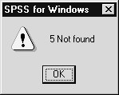
6) Click OK, then Cancel to close the Find dialog box
Of course, a more comprehensive test of the effect of recoding is to request a frequency table for POLVIEWS. After doing so (click ,
Frequencies, then OK), we see the output in Figure 7.7. Comparing the frequency table in Figure 7.7 to that in Figure 7.2 can check the results of the Recode. In Figure 7.2 we see that there are 14 + 52 + 49 = 115 liberals. In Figure 7.7 SPSS reports 115 people in category 1, which correspond to those with a liberal position, so the recoding was done correctly.

Figure 7.7 Frequency for Recoded POLVIEWS
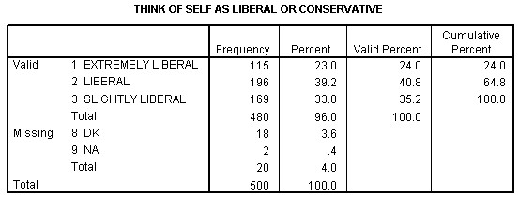
Notice that values that were not mentioned in the recode specifications remain unchanged (values 8 and 9, labeled DK and NA respectively). In this instance that was acceptable because the values we didn’t mention are the missing codes, and we wanted them to remain missing. However, an obvious problem is that the value labels for POLVIEWS are no longer accurate, which usually happens when a variable is recoded into itself. How should we change the labels to make them accurate? Since we discussed value labels in Chapter 5 we will outline the changes here, but not show the screens.
- Click Goto Data button, then click the Variable View tab of the Data Editor window
- Cick the Values cell for the Polviews variable (7th row) and then click the button
- Click 1=”Extremely Liberal” in list box (of the Value Labels dialog) to select it, replace EXTREMELY LIBERAL with Liberal in the Value Label text box
- Click Change pushbutton
- Repeat for 2 (new label should be Moderate) and 3 (new label should be Conservative)
- Click 4= “Moderate”, then click the Remove button
- Repeat for 5, 6 and 7
- Click OK to process label changes
RECODING VALUES INTO A NEW VARIABLE | Rather than changing the values of an existing variable, it is quite common to create a new variable to hold new recoded values, thus preserving the original values in the existing variable. This procedure allows you to use either the old or new coding scheme in various analyses, and it has the advantage of allowing you to change your mind about the recoding specifications and do them over again without having to reopen the data file.
The respondent’s highest year of school completed ranges from 0 to 20 years. To see this, run the Frequencies procedure for education (EDUC). The output from that request is shown in Figure 7.8. Now for reporting purposes, it is often helpful to group a variable like educational attainment into a smaller number of categories, and we shall do so here. Furthermore, we will place the grouped codes into a new variable, called GRPEDUC, to represent grouped education. Although the decision of how to group education is somewhat arbitrary, we will create three groups with these ranges: 0 to 12 (high school or less); 13 to 16 (undergraduate); and 17 and above (graduate school).

Figure 7.8 Frequency Table for Education
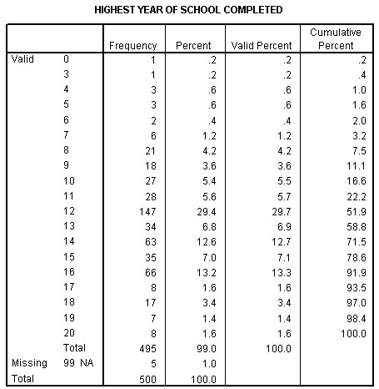
- Click Goto Data icon to return to the Data Editor window
- Click Transform..Recode..Into Different Variables from the main menu. SPSS opens a dialog box allowing you to choose variables to recode and name the new variables, as shown in Figure 7.9

Figure 7.9 Recode Into Different Variables Dialog Box
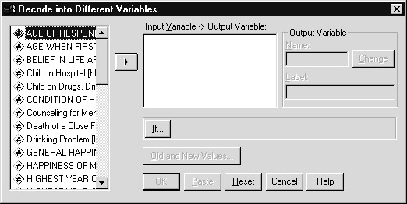
- Place Highest Year of School Completed [educ] in the Input Variable -> Output Variable box by double-clicking on that variable
- Click in the Output Variable Name text box and type
GRPEDUC to create the new variable
- Click in the Label text box (or press the tab key) and supply the variable label “Education - 3 Groups”. Then click on the Change button to register the new output variable. The dialog box should now look like Figure 7.10

Figure 7.10 Recode Dialog Box with GRPEDUC Named and Labeled
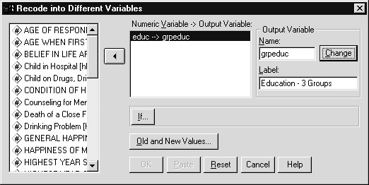
- Click on Old and New Values...
- As you did for POLVIEWS, click on the first Range option button. Type a 0, tab over, then type 12. Then click in the Value box under New Value and type 1, click on Add
- Do the equivalent for the group of 13 to 16 years, assigning it a value of 2
- Do the equivalent for the group of 17 to 20 years, assigning it a value of 3
- When recoding to a new variable, any unspecified old valuesare undefined for the new output variable and are assigned the system-missing value. By referring to Figure 7.8 you can see that EDUC currently has 99 coded as user-missing (labeled NA under Missing in frequency table), and we want to retain this coding in GRPEDUC. To do so, click on the System- or user-missing option button, then on Copy old value(s), and on Add. Your dialog box should look like
Figure 7.11

Figure 7.11 Completed Recode Specifications for GRPEDUC
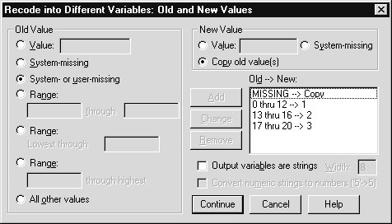
11) Click on Continue, then on OK in the main Recode dialog box
SPSS adds the new variable to the end of the Data Editor window. To see its column, switch to the Data View tab sheet and press the End key.
Then run Frequencies on GRPEDUC (Click Dialog Recall button , click on Frequencies, remove Highest Year of School Completed [educ] and add Education - 3 Groups [grpeduc] to the Variables list box, then click OK). Figure 7.12 shows the results of that procedure. Eventually, the new values of 1, 2, and 3 should be labeled to explain which years of education are included in each.
Caution Notice that there are now four categories for GRPEDUC because, while the missing code of 99 was retained, the missing value flag for this value was not. If there had been value labels for EDUC they also would not have been passed to GRPEDUC. This is an important lesson, and it means that a newly created variable must be labeled and, often, missing value codes must be redefined, depending upon how the recoding was done in the dialog box. These actions can be accomplished in the Variable View sheet of the Data Editor window.

Figure 7.12 Frequencies Output for GRPEDUC
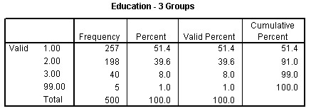
COMPUTING NEW  VALUES | The COMPUTE procedure, under Transform in the main menu, allows you to create simple or very complex mathematical equations as necessary. SPSS offers an extensive array of functions and other operations to help you compute new values for an existing variable or in a newly created variable. In this exercise we will examine the length of time between a person’s first marriage and their current age.
To create such a new variable, we must subtract AGEWED (age first married) from AGE. This is a simple mathematical expression but it will allow us to illustrate several features of Compute. Note that variable names, not labels, are used in Compute expressions.
1) Click Goto Data icon to move to the Data Editor window, then click Transform..Compute
The Compute Variable dialog box appears as displayed in Figure 7.13. The Target Variable text box contains the name of the variable that will receive the computed values. The Numeric Expression text box is where the actual mathematical expression is constructed. The expression can consist of existing variables, constants, arithmetic operators, and functions. You can type directly in this text box, or paste selections from the calculator pad, variable list, and functions list, or combine the two methods, to create the expression in the text box.

Figure 7.13 Compute Variable Dialog Box
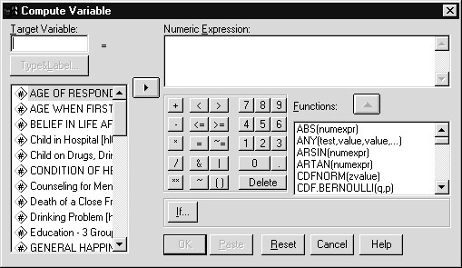
Notice that the grpeduc variable is not positioned alphabetically in the variable list box. New variables are only integrated alphabetically (if this is the display option) into variable lists when the data file is saved. 2) Begin by specifying a new variable name in the Target
Variable box. Type AGEDIF in the box
3) Then click on Type&Label to bring up the Compute Variable: Type and Label dialog box. This feature allows you to provide a variable label for the new variable and to specify whether the variable should be numeric or string. By default SPSS considers new variables to be numeric and assigns a display width of 8 characters with 2 decimal places. Type the label “Years since first marriage.” Click on Continue to process the label. The dialog box should look like Figure 7.14

Figure 7.14 Compute Variable: Type and Label Dialog Box for AGEDIF
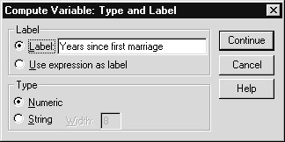
- Now we have to create the equation for AGEDIF. Select Age of Respondent [age] from the variable list, then click on the arrow symbol to paste it into the Numeric Expression box
- Click once on the “-” symbol in the calculator pad
- Place Age When First Married [agewed] in the Numeric
Expression box (select AGEWED, then click ). The dialog box should now appear identical to Figure 7.15
- If everything looks correct, click on OK

Figure 7.15 Completed Specification to Create AGEDIF with Compute
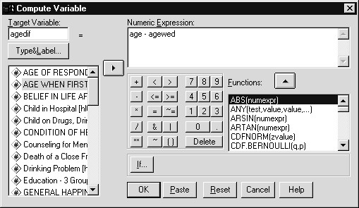
SPSS creates the new variable and places it at the end of the Data Editor. Go to the last column in the Data View sheet of the Data Editor to view AGEDIF. Figure 7.16 shows what you should see.

Figure 7.16 Data Editor with AGEDIF Added
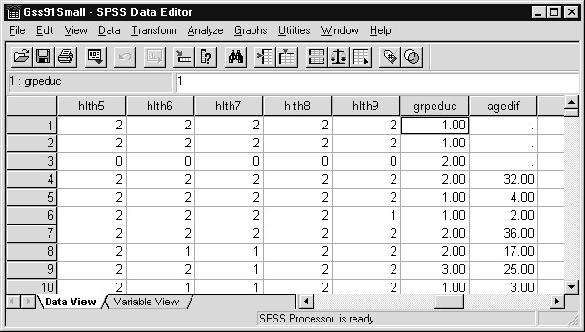
Notice that the first three cases have a period listed for AGEDIF. When SPSS computes the values for the target variable, any cases with system-missing or user-missing values for any of the variables in the mathematical expression are excluded from the calculations. SPSS then assigns a system-missing value to the target variable. To learn more about this process, and to check our work, we will list the data values for
AGE, AGEWED, and AGEDIF.
LISTING DATA VALUES | One of the most helpful procedures in SPSS produces a listing of data values for selected variables in the Data Editor. It is the Case Summaries procedure under the Analyze..Reports menu choice. It is often used to check the results of a data transformation operation or to produce simple reports.
- Click Analyze..Reports..Case Summaries. When you do, you see the dialog box shown in Figure 7.17
- Place Age of Respondent [age], Age When First Married
[agewed], and Years since first marriage [agedif] in the Variable(s) list box
- Move to the Limit cases to first text box and type 20 (replacing the 100). This tells SPSS to list only the first 20 cases in the file instead of the first 100

Figure 7.17 Case Summaries Dialog Box
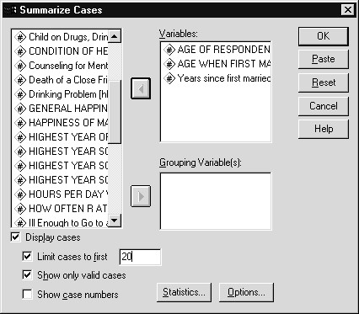
- Click on OK
- Click the open book icon beside Case Summaries in the
Outline pane
The resulting output is shown in Figure 7.18. Notice that where SPSS has placed a system-missing value for AGEDIF, AGEWED had the label NAP (not applicable). That corresponds to the value 0, which is defined as a missing value for AGEWED, so SPSS couldn’t subtract AGEWED from AGE. Otherwise the calculations appear to have been done successfully.
As explained above, AGEDIF had a display format of two decimal places (the display format does not affect the accuracy of calculations or how values are actually stored by SPSS).

Figure 7.18 Case Summaries Output for the First 20 Cases (partial list)
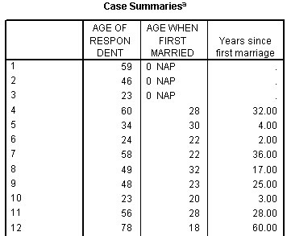
It is often helpful to examine summary statistics for newly computed variables, and the Descriptives procedure is an efficient means to do so.
- Click on Analyze..Descriptive Statistics..Descriptives
- Place Age of Respondent [age], Age When First Married [agewed], and Years since first married [agedif] in the
Variable(s) list box, click on OK, then click the open book icon beside the Descriptive Statistics item
Figure 7.19 shows the results of this request. The mean length of
time between the respondent’s first marriage and his or her current age is about 26.6 years. Also, 394 of the 500 people in the file have been married at least once, hence the 394 valid values for AGEWED and AGEDIF.

Figure 7.19 Output From Descriptives Procedure
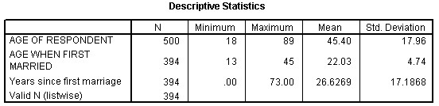
Having finished the last of our data checking analyses, we will return to the SPSS Options dialog box and set the pivot tables display option so that only value labels are displayed (the default). This provides a more attractive table for final reports and publications.
Click Edit..Options
Click Output Labels Tab in SPSS Options dialog box Click arrow under Variable values in labels shown as:
Click Labels choice
Click OK

SAVING AN  UPDATED COPY  OF THE DATA SUMMARY | Whenever you finally exit SPSS, you must decide whether or not to save an updated copy of the data. If you do not, then the recoded POLVIEWS and EDUC and the computed AGEDIF would be lost and have to be recreated again to use in another session. It is much more efficient to save the current copy of the data in the Data Editor window. Before saving the file, we would usually add the labels and missing value codes to the variables, as explained above.  - Switch to the Data Editor window either by clicking on  Window from the main menu, then choosing Gss91Small SPSS Data Editor from the list of windows, or by clicking the Goto Data icon  - Click on File..Save As from the main menu. To make a new copy of the data file, type GSSCHP7 in the File Name text box. This is a safe method of saving the data because it does not overwrite the old version of the SPSS data file. This is especially important here because POLVIEWS was changed, and if we overwrite Gss91Small(.SAV), we would lose the original codes for POLVIEWS  - Click on Save to finish the operation  GSSCHP7(.SAV) now contains the recoded variables and the newly computed AGEDIF, plus all the original variables.  In this chapter you have learned how to transform data values in SPSS for Windows.

Chapter 8 | Crosstabulation Tables
TOPICS | Creating Crosstab Tables to Explore the Relationship Between Variables  Adding Appropriate Percentages to the Table  Using the Chi-square Statistic to Decide Whether Two Variables are Related  Producing Tables with a Control Variable  Additional Features of Crosstabs
INTRODUCTIONrosstabulation tables (also called contingency tables) display the relationship between two or more categorical variables. The variables can be coded on either a nominal or ordinal scale, and
C
their type may be either numeric or alphanumeric. One way to think about a crosstabulation table is as a joint frequency distribution for more than one variable. The size of the table is determined by the number of distinct values for each variable, with each cell in the table representing a unique combination of values. The Crosstabs procedure can be found under the Summaries section of the Analyze menu.
Appropriate summary measures are counts and percentages in each cell. Statistical tests can be requested to determine whether there is a relationship between the variables in a table and, if there is, the strength of the relationship can be estimated.
A SIMPLE  CROSSTABULATION | Using the General Social Survey file, we will begin by creating a crosstab table to explore the relationship between a respondent’s political position and his self-perceived social class. The former is measured by POLVIEWS, which we recoded in Chapter 7 from seven categories to three categories, although it remains an ordinal variable. Self-perceived social class (CLASS) is a variable that measures whether someone believes himself to be a member of the lower, working, middle, or upper class. A crosstab table for these two variables will investigate whether or not social class in the United States is related to general political position, as many have suggested.
Before running the Crosstabs procedure, we produce a frequency table for CLASS.
- First, open the data file GSSCHP7.SAV, which contains the new variables we created in Chapter 8, plus labels that were added. Hint: Click on File..Open..Data, move to c:\ Train\ Basewin10 and double click on the file GSSCHP7
- Then click on Analyze..Descriptive
Statistics..Frequencies, put Subjective Class
Identification [class] in the Variable(s) list, and click on
OK.

Figure 8.1 Frequencies Table for CLASS
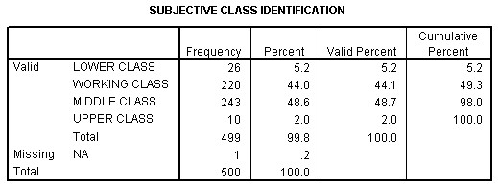
The frequencies table for CLASS is displayed in Figure 8.1. Only ten people indicated they are members of the upper class, or about 2.0% of the file. This is a small fraction, and when using crosstab tables, it is best if no one cell has a small (under 5 or so) expected number of cases. Accordingly, we will combine the upper-class and middle-class categories for the analysis. This is a common technique when doing crosstab analysis. The correct procedure to use in SPSS is Recode.
- Click on the Goto Data icon in the Standard Tool Bar to switch to the Data Editor window
- Click on Transform..Recode..Into Same Variables
- Put Subjective Class Identification [class] into the
Variable(s) list, then click on Old and New Values
- Click on Value in the Old Value area, type 4, and click on Value in the New Value area and type a 3. Click on Add to finish the specification. Your dialog box should look like Figure 8.2

Figure 8.2 Recode for CLASS to Combine Upper and Middle Classes
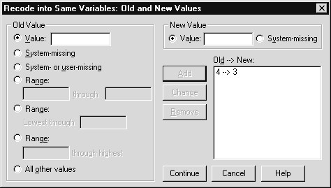
5) Click on Continue, then OK to complete the request
Before producing the crosstab table, we need to change the value label for the value of 3 for CLASS to indicate that it now contains two categories.
- In the Variable View sheet of the Data Editor window, click in the cell in the Values column for the CLASS variable, and then click the button
- Click in the Value text box and type a 3
- Tab to the Value Label text box and type Middle and Upper Class
- Click the Add pushbutton. SPSS will warn you that there is already a label for this value and ask you if it is OK to replace it. Click on OK
- Click OK to finish the process
We are now ready to create our first crosstabulation table.
- Click on Analyze..Descriptive Statistics..Crosstabs from the main menu
The minimum specification for Crosstabs is one row variable and one column variable. It is somewhat arbitrary as to which variable is placed in the row or column (more important, as we will see, is how percentages are calculated). We will put POLVIEWS in the row dimension.
- Click on Think of Self As Liberal..[polviews] and place it in the Row(s) list box
- Click on Subjective Class Identification [class] and place it in the Column(s) list box. Your dialog box should look like Figure 8.3
Note SPSS contains a checkbox option to create a clustered bar chart
(displaying counts) for each crosstabulation table requested in the Crosstabs dialog box. We produce such a chart in Chapter 10.

Figure 8.3 Crosstabs Dialog Box Requesting One Table
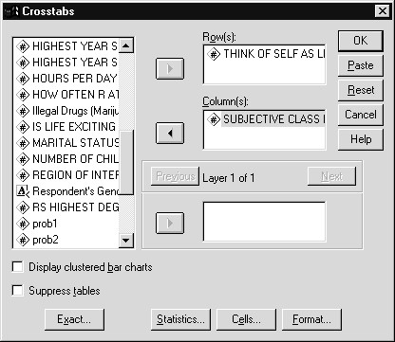
4) Click on OK to process the request
SPSS produces two tables in the Output Viewer window, as shown in Figure 8.4. The first table, labeled “Case Processing Summary,” details the number of valid cases for the crosstab table. To be included in the analysis, a person must have given nonmissing responses to both questions. We see that 480 people, or 96% of the sample, will be included in the crosstab table.
The second table is the actual crosstab. Its title is taken from the variable labels of POLVIEWS AND CLASS. There are nine cells in the table because each variable has three valid values, so 3 * 3 = 9 cells in total. The cells of the table show the count or number of cases for each joint combination of values. Thus, looking at the upper left cell, we see that 7 people report themselves to be liberal and members of the lower class. At the bottom of each column and the right of each row are the total counts. Thus, for example, there are 115 liberals in the sample (and these values are equivalent to the frequencies distribution for each variable).

Figure 8.4 Crosstabulation Table of POLVIEWS and CLASS
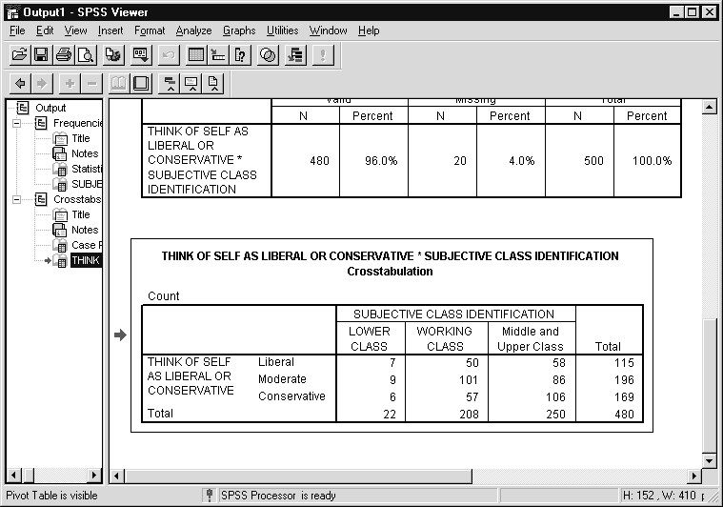
The purpose of creating a crosstab table is to explore the relationship between two variables. As the table stands now, does it appear that POLVIEWS and CLASS are related? If so, how?
ADDING CELL PERCENTS | Since it is difficult using only the count to analyze a crosstab table, various percentages are typically added to describe the distribution of cases. The particular percentage requested—whether based on the row or column variable—is determined by one’s interest, by which variable might be considered to be a predictor, or by the exact question to be explored.
In the POLVIEWS by CLASS table, we might be interested in examining how political position affects perceived social class. If so, we will request row percentages based on POLVIEWS.
- Click the Dialog Recall tool and click Crosstabs
- Our specifications are retained from the previous Crosstabsrequest. To ask for additional information in the cells, click on the Cells button. The Crosstabs: Cell Display dialog box appears, as shown in Figure 8.5

Figure 8.5 Cell Display Dialog Box to Add Percentages
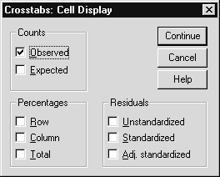
- By default, only the Observed count is selected. Click on Row in the Percentages box, then click on Continue
- Click on OK in the Crosstabs dialog box to process the request
Figure 8.6 shows the new crosstab output. In each row, the percentages listed add to 100%. Does adding the percentages make it easier to understand the relationship between POLVIEWS and CLASS?

Figure 8.6 Crosstabulation of POLVIEWS and CLASS with Row Percentages Added
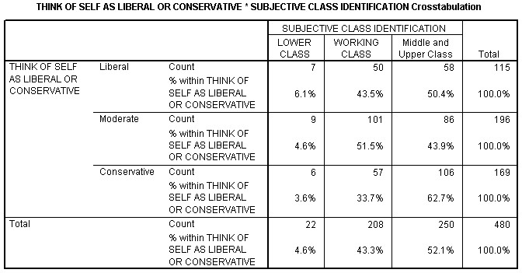
We now see that more conservatives consider themselves to be middle or upper class (62.7%) than do liberals (50.4%). Moderates are more likely to state they are members of the working class. At least for liberals and conservatives, these trends are compatible with what many commentators claim: that conservatives are more likely to be better off, financially and socially, than liberals.
What if we think that one’s social class might affect one’s politics? If so, we want to percentage the table in the opposite direction by columns, or CLASS.
- Click Dialog Recall tool and click Crosstabs
- Click on Cells. Click on Row to deselect it, then click on Column to select it
- Click on Continue, then on OK. The resulting table is in Figure 8.7

Figure 8.7 Crosstabulation of POLVIEWS and CLASS with Column Percentages Added
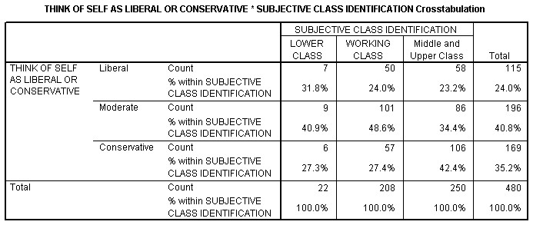
Now the percentages add to 100% down each column. A table percentaged by CLASS allows us to answer questions like these:
- Which class is more likely to report being conservative?Answer: Middle and upper classes, at 42.4%.
- Are working-class or middle- and upper-class respondentsmore likely to be liberal?
Answer: The working class, but the difference is so small (24.0% to 23.2%) that it may not be statistically significant.
As you can see, adding percentages is a very important aid for interpreting a crosstabulation table. Moreover, the direction of percentaging should be determined by substantive considerations, i.e., what you want to learn, which variable might be a predictor, and so forth.
OBTAINING THE  CHI-SQUARE STATISTIC | No matter how a table is percentaged, determining whether two variables are statistically independent or, conversely, related, is not something that should be decided based solely on counts and percentages. The Crosstabs procedure will produce several statistics that can be used to assess the existence of a relationship between two variables. Perhaps the most commonly used statistic is the chi-square test of independence.
  - Click Dialog Recall tool , then click Crosstabs
  - Click on Cells and add Row percents back to the table. Click on Continue
  - Click on the Statistics button. The Crosstabs: Statistics dialog box appears
  - Click on the Chi-square check box to select that test. The dialog box should look like Figure 8.8
Figure 8.8 Crosstabs: Statistics Dialog Box with Chi-Square Requested
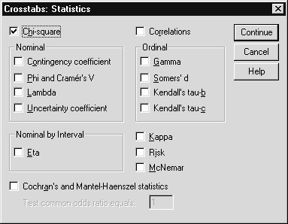
  - Click on Continue, then on OK
A third table, labeled “Chi–square Tests,” is added to the crosstabulation output in the Viewer Window. Figure 8.9 displays that table. Above this, the percentages and counts in the crosstab table itself are the same as we saw before in Figures 8.6 and 8.7.
There are three chi-square values listed in the table, but only the first two are of interest here (there are two, since there are two standard methods of calculating a chi–square statistic). The chi–square test is a direct measure of whether or not POLVIEWS and CLASS are statistically independent. SPSS calculates a significance level for the statistic, which for the Pearson chi–square is about .008. This means that there is only a very small chance, about .008/1, or 1 in 125, that we would obtain the joint distribution of POLVIEWS and CLASS as found in the crosstab table if they are unrelated in the U.S. population.
Since that probability is so low, we conclude that the two variables are, indeed, related. How they are related has been discussed in the previous section, for example, that conservatives are more likely to consider themselves members of the middle or upper class than liberals or moderates. But we couldn’t be confident of that statement until we had used a test to assess statistical independence.

Figure 8.9 Chi–square Test Output from Viewer Window
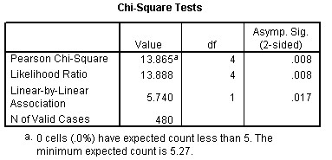
ADDING A  CONTROL VARIABLE | Crosstab tables always have one variable on the row and one on the column, but SPSS allows the user to include a third variable as a layer to create separate tables for each valid value of the layer variable. This variable is often referred to as the control variable, and it is introduced in an analysis because you suspect that a relationship might differ across values of the control variable. For example, for those who are married, general happiness with life might be strongly related to happiness in marriage, except for those in poor health, where just being in poor health causes general happiness to decrease. If so, then adding health as a control variable to the general happiness—happiness in marriage relationship is important at better understanding what drives general happiness.
In our case, we will use gender as a control variable because we suspect that the relationship between political position and subjective social class identification might be different for men and women.
- Click Dialog Recall tool , then click Crosstabs
- Add Respondent’s Gender [gender] in the Layer variable list. The dialog box should appear as does Figure 8.10

Figure 8.10 Crosstabs Dialog Box with a Layer Variable Added
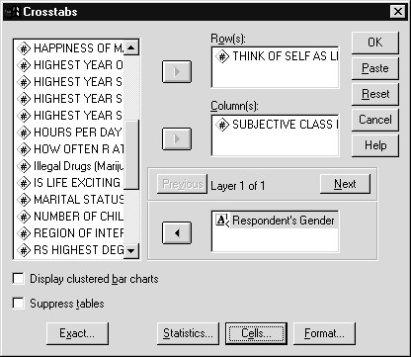
- SPSS will create a very large table if we leave the otherspecifications as is, so instead click on the Cells button, and then deselect Rows and Columns in the Percentages box
- Click on Continue, then OK to process the request
SPSS creates one crosstabulation table for all three variables. The table has a separate section, or subtable, for each valid value of GENDER, one for females and one for males. It is shown in Figure 8.11

Figure 8.11 Crosstabulation of POLVIEWS by CLASS by GENDER
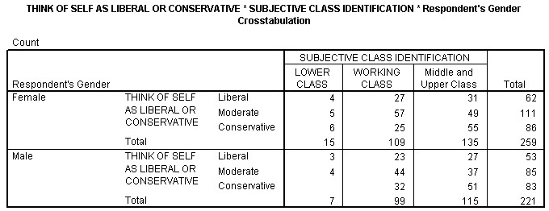
By examining each subtable, it is clear that the relationship we discovered between political position and subjective social class does not vary by gender. For both sexes, conservatives are more likely to report being a member of the middle or upper class, and moderates are more likely to report being from the working class. The chi-square test is reported separately for females and males. It indicates that, at the .05 significance level, POLVIEWS and CLASS are related for females, as we found for the single table that combined men and women. However, the significance reported for males is slightly above the .05 level (.073 to be exact).
Figure 8.12 Chi–Square Tests for Females and Males for POLVIEWS by

CLASS
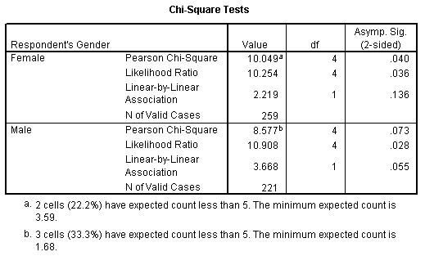
As a statistical aside, each table has some cells with an expected frequency less than 5. This fact can complicate the interpretation of the chi-square test, and you can read more about interpretation and what to do when this occurs in the SPSS 10.0 Guide to Data Analysis. Please note that the SPSS Exact Tests option provides improved significance tests (exact tests) when cells in the crosstab tables have small expected frequencies. If the SPSS Exact Tests option is installed, then an Exact pushbutton will appear in the Crosstabs dialog box (see Figure 8.3).
Also, in Figure 8.11 we see that a cell is left blank when there are no cases for that combination of values, i.e., no males who see themselves as lower class and rank their political position as conservative.
RESULTS COACH | In Chapter 6 we used the “What’s This?” context-menu choice to obtain information about statistical terms appearing in SPSS pivot tables. SPSS also contains a Result’s Coach that helps to explain results appearing in SPSS pivot tables. We will demonstrate the Result’s Coach by applying it to the Chi-Square Tests pivot table just produced.
- Right-click on the last Chi-Square Tests pivot table
- Click Result’s Coach on the Context menu
(Alternatively, double-click on the pivot table to open the Pivot
Table editor, and then click the Result’s Coach tool on the Format toolbar)
- Click Next pushbutton

Figure 8.13 Result’s Coach for Chi-Square Tests Pivot Table
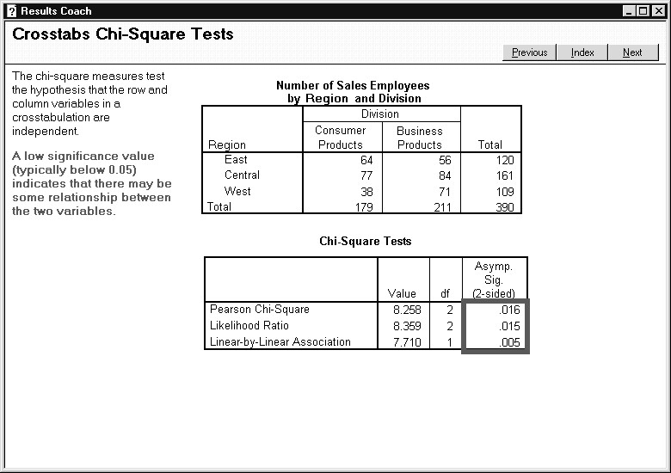
After calling the Result’s Coach, help appears that describes the contents of the selected type of pivot table and how they are typically used. Here, the Result’s Coach states what the chi-square measures test and indicates the meaning of a low significance value, which we recently discussed in this chapter. This is a useful aid when interpreting results in SPSS pivot tables.
4) Click the Close box to close the Result’s Coach
Saving Results To use the output in the Viewer later (Chapter 9), from the Viewer window:
- Click on File..Save As...
- Make sure that the Basewin10 folder (under c:\ Train) is selected, and type CHAPT8 in the File Name box
- Click on Save to save the crosstab output

ADDITIONAL  FEATURES OF CROSSTABS | For efficiency you can place many variables in the Row, Column, and Layer lists in the Crosstabs dialog box. This will create crosstab tables based on each combination of the row and column variables. Adding layer variables will create subtables based on each value of the layer variable. Thus if three row variables and five column variables are specified, 15 separate tables will be produced.  The Crosstabs dialog box includes a Format button. From there you can change whether the row variable is listed in ascending or descending order.  In the main dialog box (refer to Figure 8.3), a checkbox is included labeled “Suppress tables.” If you make this selection, SPSS produces only the statistics requested but not the crosstab table itself.
SUMMARY | In this chapter you have learned how to use crosstabulation tables to explore the relationship between two or more variables.

Chapter 9  TOPICS | Pivot Tables  Editing a Table in the Pivot Table Editor  Change the Order of Variables and Statistics in a Row or Column  Move Variables from One Dimension to Another  Change the Width of a Column  Edit and Modify Text  Apply a Predefined Format to a Full Table  Reorder Categories Within a Pivot Table  Creating Graphs from Pivot Tables
INTRODUCTIONuch of the output in the Viewer window is presented
M
in tables that can be edited in a variety of ways. These tables are called “pivot tables” because they can be pivoted
interactively. The available editing tools allow you to transpose the rows, columns, and layers of tables; change the nesting order within a dimension; add or modify titles, captions, and labels; change the format of one or more cells; and apply a predefined format to a table. You should be able to create exactly the table you need in SPSS, either for printing directly or to move to another software program. In addition, you can create graphs directly from values in pivot tables.
EDITING A PIVOT TABLE | To begin working with pivot tables, we need to open an Output Viewer file. If you already have the output from Chapter 8 open, skip the next steps. If not:
  - Click File..Open..Output to reach the Open File dialog box
  - Click on the file CHAPT8 to select it (in the c:\ Train\ Basewin10 directory), then on the Open button
Once this set of output is open, click on the book icon for the second crosstab table we created. This is the table for POLVIEWS and CLASS that included the row percents. As a reminder, we’ve displayed it again in Figure 9.1.

Figure 9.1 Crosstab Table of POLVIEWS and CLASS
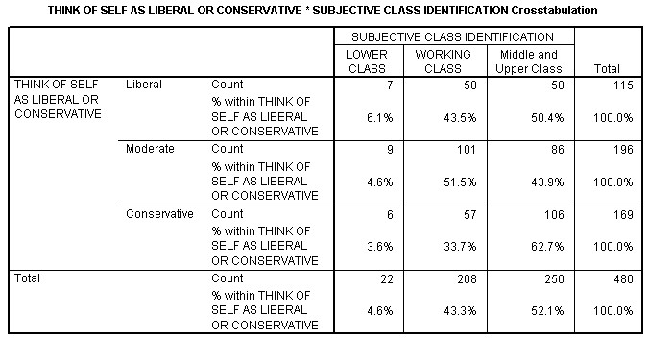
To edit this pivot table:
1) Double–click anywhere on the table
This activates the Pivot Table editor, which operates in place on the crosstab table. A crosshatch border is placed around the table to indicate its changed status. The menu bar and tool bar have both changed.
Note: If you make a mistake and deactivate the Pivot Table editor at any point during this chapter, simply double click on the crosstab table again.
The table can be edited right now, but to demonstrate additional features, let’s display the Pivoting Trays (if the trays are already visible on your screen, skip this step).
1) Click on Pivot from the main menu, then on Pivoting Trays
(to check the item)
These actions modify the SPSS Viewer window as shown in Figure 9.2. In addition, we altered the Viewer window by reducing the width of the Outline pane so essentially the full table can be viewed on-screen in the Contents pane. The Pivot Tray window contains three trays identifying the “Layer,” “Row,” and “Column” dimensions. In each tray are icons that represent the various elements of a pivot table. The icons represent variables and statistics; for example, in the Row tray the two icons represent the variable POLVIEWS and the statistics (Count and Row Percent), respectively.

Figure 9.2 Pivot Table Editor with Pivot Tray While Editing Crosstab Table of POLVIEWS and CLASS
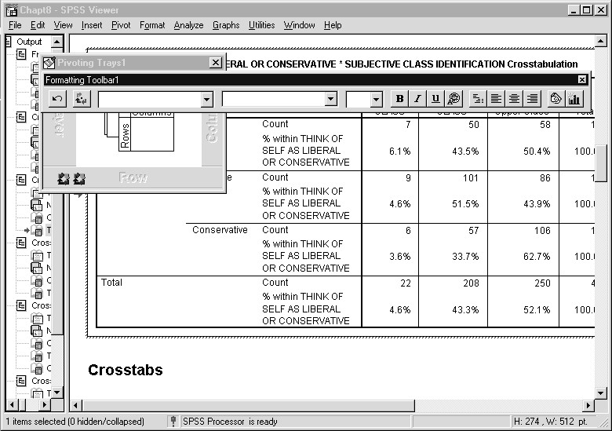
If you are unsure as to what element is represented by an icon, just move the cursor over that icon. When you move the cursor over the icon a ToolTip pop-up will tell you which table element the icon represents. Let’s try this.
1) Move the cursor over the leftmost element in the Row tray
When you do, you’ll see the variable label appears for POLVIEWS, as shown in Figure 9.3.

Figure 9.3 Pivot Table ToolTip Pop–up Displayed for POLVIEWS
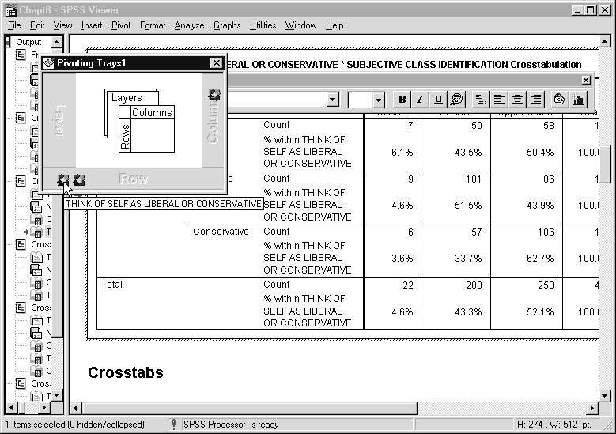
CHANGING THE  DISPLAY ORDER IN A DIMENSION | When SPSS creates a table, you may decide that its default format is not appropriate for including in a report or presentation. One reason may be that the location of a variable or statistic, i.e., its row or column position, may not be optimal. Perhaps you’d like to reduce the width of a table by moving variables from the columns to the rows, or vice versa, or perhaps the nesting order in a dimension is not attractive or effective. When you want to modify the position of an element in a pivot table, you only need drag an icon from one tray to another (to change dimensions) or from one position to another in a tray (to change the nesting order).
The table in Figure 9.2 is rather long and, more to the point, puts the count and row percentages in each cell. This happens because the statistics are nested under POLVIEWS. To create a more compact table with subtables for the count and percentages, do the following.
1) In the row dimension pivot tray, click on the icon for POLVIEWS (Think of self as liberal...), hold the left mouse button down, and drag it to the right of the icon for Statistics, then release the mouse button
The table will be redrawn as shown in Figure 9.4. The table has become more compact, with separate subtables for the count and row percentage. This is because POLVIEWS is nested under Statistics, which means all categories of POLVIEWS appear under each type of statistic we requested.
Figure 9.4 Crosstab Table with POLVIEWS Nested Under Statistics
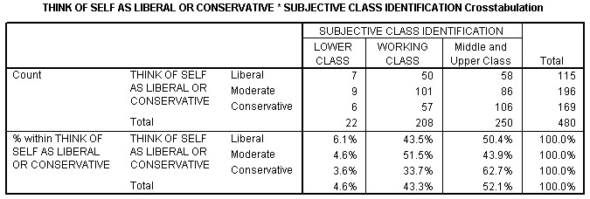
TRANSPOSING  ROWS AND COLUMNS | As you might surmise, if you drag an icon from one dimension to another, the corresponding element of the table is moved. Let’s try this by modifying the table to put POLVIEWS in the Column dimension and CLASS in the Row dimension. The order in which you move icons is not important, so long as you remember what each icon represents.
- In the Row dimension pivot tray, click on the icon for
POLVIEWS, hold the left mouse button down, drag it to the
Column dimension, either above or below the icon for CLASS, and release the button
When you do this, notice how odd the table appears. Fortunately, we’re not done yet.
- Now drag the icon for CLASS to the Row dimension pivot tray, making sure to place it to the right of the Statistics icon

Figure 9.5 Crosstab Table with POLVIEWS and CLASS Transposed
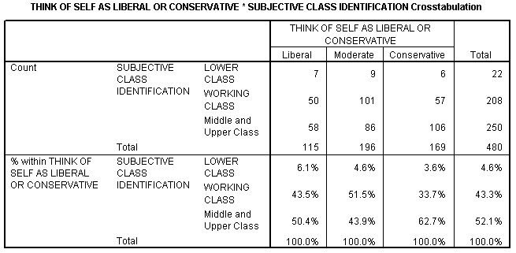
The table has now been rearranged into Figure 9.5, with CLASS forming the rows and POLVIEWS the columns. To make a wholesale swap of all the elements in the rows and columns, choose
Pivot..Transpose Rows and Columns from the Pivot Table menu. And if you want to return the elements to their default dimensions, the Pivot menu choice contains a Reset Pivots to Defaults selection that will do just that.
3) Click the close box of the Pivot Tray window and
Formatting Toolbar to close them
Important Note  CHANGING COLUMN WIDTHS | As a general point, no formatting changes you make to a table cause SPSS to recalculate any statistics. Specifically, changing the dimensions of a variable or variables DOES NOT change the calculation of any statistics. So if you examine the table in Figure 9.5 you’ll see that the percentages add to 100% in each column. This is because in Crosstabs we requested row percents, and SPSS calculated them based on the original row variable, POLVIEWS, which now defines the columns. The label for the row percentage statistic has not changed and still reads “% within  THINK OF SELF AS LIBERAL OR CONSERVATIVE,” which is correct.  But this might be confusing, since the statistics label remains in the row. Why is that?  Changing the order of the elements in a pivot table is helpful, but that’s usually not sufficient to create an attractive table. One common modification is to narrow or widen individual columns so that labels don’t wrap or to create a more balanced look. This can be done easily in the Pivot Table editor by dragging a column border to the new width. When you change the width of a column, you always move the right border.
If you examine Figure 9.5, you’ll see that because the value labels for CLASS are longer than the value labels for POLVIEWS, this table is not quite as compact or attractive as the previous one in Figure 9.4. Also, the statistics label “% within Think of Self as Liberal or Conservative” spans across three lines. The appearance of this table with statistics labels and CLASS on the row dimension might be improved if the width of the columns for the statistics labels and the value labels of CLASS were increased a bit.
It is important to note that you can change any vertical category border in the table, whether or not its border is displayed. For example, the Statistics element occupies the first column in the table (in the Row dimension). To make this column wider:
- Move the cursor slowly in the table between the word“COUNT” and the label “SUBJECTIVE CLASS
IDENTIFICATION.” It will turn into a double–headed arrow
- Now hold down the left button and drag the cursor to the right
Notice that as the pointer is dragged, a ToolTip displays the new width (in points). Drag the pointer until the width is about 140 or so points. The table will look like Figure 9.6. Until you release the mouse button, the table is not reformatted, but the new position of the right border of the Statistics column is displayed for review.

Figure 9.6 Modifying the Column Width for the Statistics When No Border Is Visible
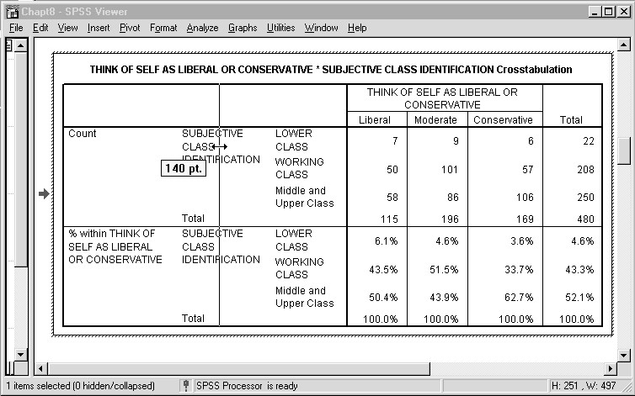
3) Now release the left button. The table is rearranged as shown in Figure 9.7

Figure 9.7 Modified Table with Wider Column for Statistics
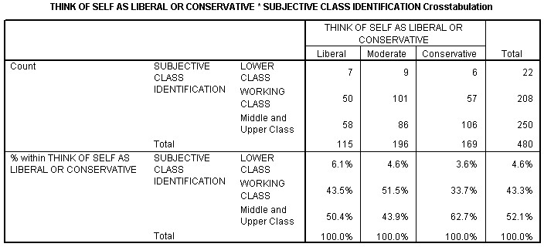
The table has been redrawn with a new column width for the statistics element. Any vertical column can be altered in this same manner.
Perhaps more important to the look of the table, we now change the width of the column for the value labels of CLASS.
- Place the mouse pointer on the value labels for CLASS andmove it slowly until it is directly over the right border of the column. The pointer will change to a double-headed arrow
- When it does, hold down the left mouse button and drag the border to the right (to about 115 points) Figure 9.8 Modifying the Width of the Column for CLASS
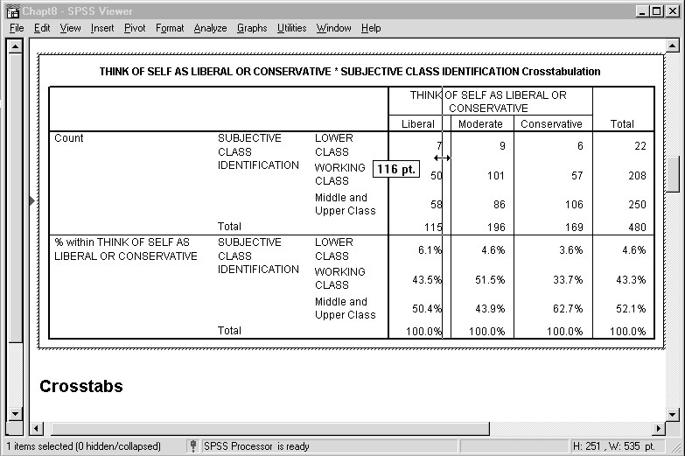
- Now release the left button.
The width of the column containing the variable label “Subjective Class Identification” may increase as well. If so:
- Place the mouse pointer on the variable label “Subjective ClassIdentification” and move it slowly to the right until it changes into a double-headed arrow (not shown)
- When it does, hold down the left mouse button and drag the border to the left (to about 85 points - not shown)
The table is rearranged as shown in Figure 9.9
Figure 9.9 Modified Table with Increased Width for the CLASS Column
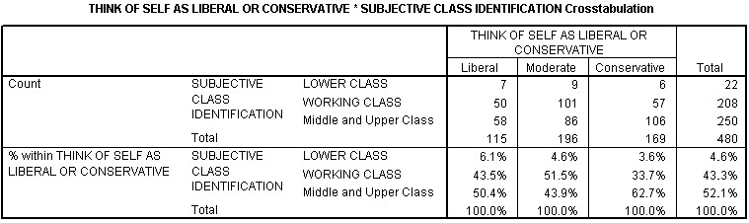
The new table is wider, but has fewer rows. It doesn’t quite fit in the Viewer Window, but you can scroll over to see the full table (we captured the full table in Figure 9.7 to make it easy to view its new appearance). This table is very different, yet contains the same information as the one we began with in Figure 9.2.
REMOVING OR  ADDING LABELS | The Pivot Table editor supplies several options to edit the various labels in the table. You can directly type in a new label, selectively hide or display labels for a dimension, and cut and paste labels as with other Windows programs.
The table may be more to our liking now, but we hardly need to repeat the label “SUBJECTIVE CLASS IDENTIFICATION” twice. It would be better to remove the label from its current position and display it at the top of the Column dimension. Here’s how to accomplish these two tasks:
1) Click once on either variable label for CLASS (Subjective Class Identification). When you do, the cells for the two labels both become highlighted with a dark border, as shown in Figure 9.10. This is how cells look when they are selected in the Pivot Table editor.

Figure 9.10 Variable Label Cells for CLASS Selected
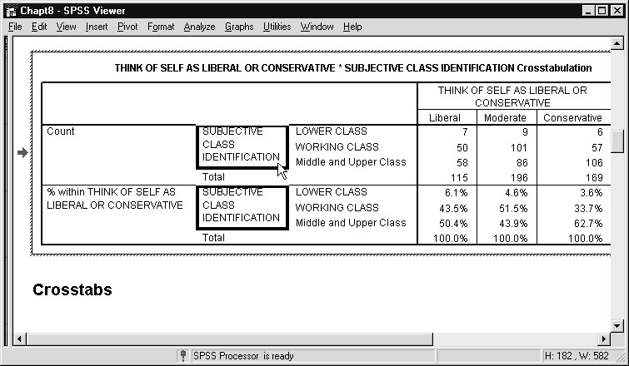
- Now hit the Delete key, or click on Edit...Cut. The variable labels for CLASS will be cleared
- Move the mouse pointer slowly until it is directly over the rightborder of this column. The pointer will change to a double– headed arrow
- When it does, hold down the left mouse button and drag the border to the left (to about 40 points). This will narrow the width of the column whose text we deleted
- To deselect the cells, hit the Escape key
This is generally the best way to deselect a cell in a table. Otherwise, if you try to click away from the cell that has been selected, you may select another or deactivate the Pivot Table editor. However, don’t follow this advice when you type in new text.
- Next right-click on any of the value labels for CLASS
A Context menu appears with several options. One of them is Show Dimension Label, which will display the appropriate label for this element. You can see this in Figure 9.11

Figure 9.11 Context Menu Displayed for the CLASS Dimension
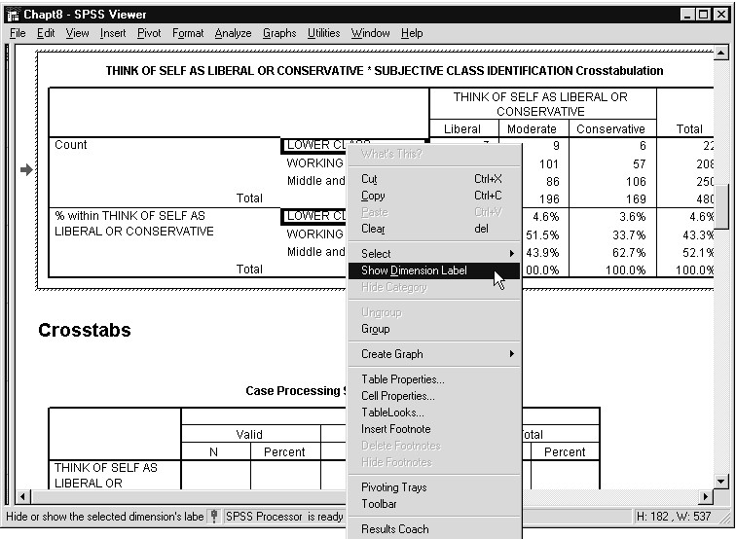
7) Move the cursor down to the Show Dimension Label and left-click. Then hit the Escape key to deselect the value label cells. The result is shown in Figure 9.12.

Figure 9.12 Modified Table with a Dimension Label Displayed for CLASS
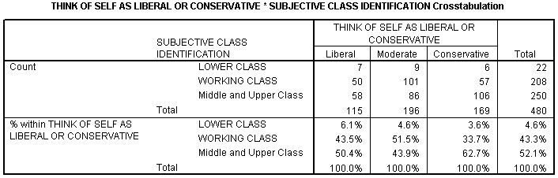
We’ve removed one label and displayed another. When we removed the variable labels for CLASS from their own cells, SPSS automatically reduced the width of that column (compare Figure 9.12 to Figure 9.9).
EDITING TEXT SPSS tries to waste as little space as possible when displaying a table. SPSS allows you to change the font characteristics of text by selecting a cell and then using the font choices from the menu. You can also type in a new label if the old one won’t do. You can make a variety of changes, and we’ll only scratch the surface here.
To illustrate these features, we’ll change the font size for the table title, then modify the title itself. If you look at Figure 9.12, the title is bolded but could stand to be a little larger so that it will stand out when printed in a report. First we have to select the title.
- Click once anywhere on the title. When you do, a dark border appears around the text
- The default point size for the title is 9 (and the default font isArial). Click the drop-down arrow in the font option on the toolbar (if the toolbar is not visible, click View..Toolbar) and select a point size of 11. Alternatively, you can select
Format...Font from the menu to accomplish this change
The title is now larger, but the word “Crosstabulation” appears on a second line. Since it’s fairly obvious that this is a crosstab table, let’s remove this word to try to create a one-line title.
- Now double click in the title cell. The full title will become highlighted as shown in Figure 9.13
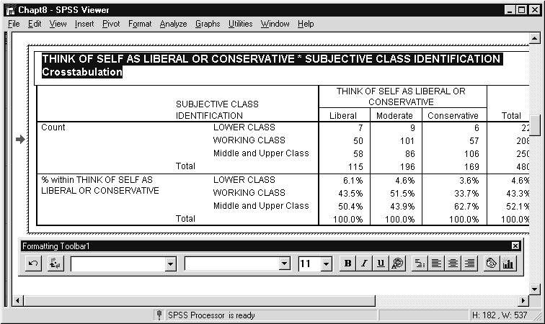
Figure 9.13 Table with Title Text Selected
- You can now edit the title to remove the word
“Crosstabulation.” Be careful not to hit the Delete key first or you’ll lose the whole title. When you’ve made this change, hit the Enter key to record the change. If instead you hit Escape, the text will revert to the previous contents of the cell
Figure 9.14 displays our table with the modified title. All the text visible in the table can be modified in a similar manner.

Figure 9.14 Table with a New Title
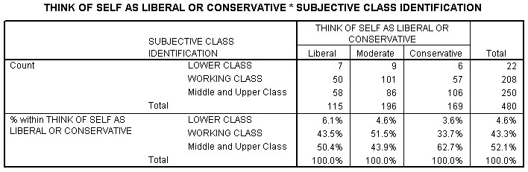
TABLELOOKS One way to change the global appearance of a table is to apply a TableLook. Each TableLook consists of a set of table properties, including general appearance, cell properties, fonts, borders, and the like. SPSS supplies many distinct TableLooks for your use, and if these are not adequate, you can save custom TableLooks that you create in the Pivot Table editor.
When you select a TableLook, SPSS provides a preview of the table format in the TableLooks dialog box. If you have previously edited a cell or cells in a table, SPSS will by default not change those cells to the new TableLook. You have the option, though, of resetting all cells to the current TableLook format.
We’ll review two TableLooks for our crosstab table. To begin:
1) Choose Format...TableLooks from the menu. You’ll see the dialog box in Figure 9.15
The available formats are listed in the TableLook Files box. The Sample area provides a preview of the table. Buttons are supplied to edit a TableLook and then save it. The Browse button lets you look in other directories for additional TableLooks that you or others may have created. The default choice of As Displayed is highlighted in the TableLook Files box, which simply means that SPSS is displaying the system default format plus any modifications you’ve made.

Figure 9.15 TableLooks Dialog Box
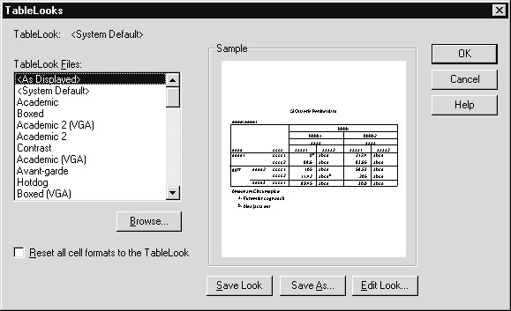
- Scroll down the list until you see the Times Roman choice and click once on it. Notice how the table in the Sample area changes
- Now click OK
You are returned to the Pivot Table editor and the table has changed to Times Roman font. Additionally, the table has been reduced in width, as you can see in Figure 9.16. In particular, note the statistics column and the column containing value labels for CLASS, whose widths we increased earlier, have been narrowed. Because TableLooks override column widths set manually, you should apply your TableLook before changing individual column widths. What has not changed is the title because the user had modified that cell. If you want to set all the cells to a TableLook format, check the Reset all cell formats to the TableLook box and reapply the format.

Figure 9.16 Times Roman TableLook
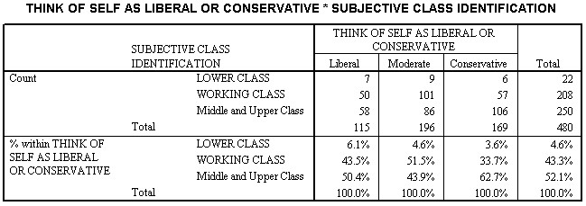
We’ll finish the editing of our table by applying another TableLook.
- Select Format...TableLooks from the menu
- Choose the Academic 2 TableLook, then click on OK

Figure 9.17 Academic 2 TableLook
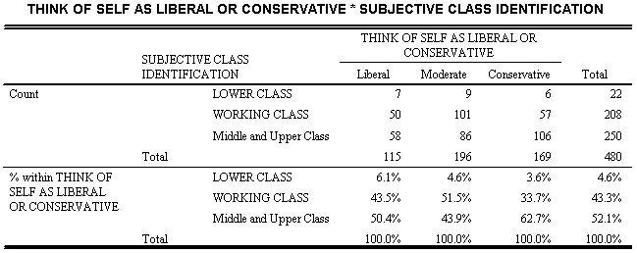
The new table is shown in Figure 9.17 (compare to Figure 9.16). This format removes the vertical lines and adds thicker horizontal rules at the top and bottom. As before, the title doesn’t change because it has been edited.
There are many other TableLooks to try, plus the System Default choice, which will return the format of the table to what it was originally at the beginning of this chapter (it doesn’t move the table elements back to their original positions, though). And there are many other editing choices to try, including the ability to change the color of text, but we’ve given you enough to get started and to demonstrate the power of the Pivot Table editor.
REORDER PIVOT  TABLE CATEGORIES | SPSS contains Pivot Table Editor options that permit reordering of pivot table categories by dragging, grouping of pivot table categories under a heading, and rotating labels in a pivot table to make better use of space. Here we demonstrate category reordering by moving the “Middle and Upper Class” social class group from the last to the first position in the table.
- Click on the Middle and Upper Class label anywhere in the pivot table
- Keep the mouse button depressed and hold the mouse steadyfor a moment, then drag the cursor to the Lower Class category label and release the mouse button
As you perform the drag operation, arrows will appear beside the cursor signaling the category move. Make sure the arrows appear when you drag; if they don’t, the Pivot Table editor interpreted your action as a simple click and drag to select several categories.

Figure 9.18 Moving a Category within a Pivot Table
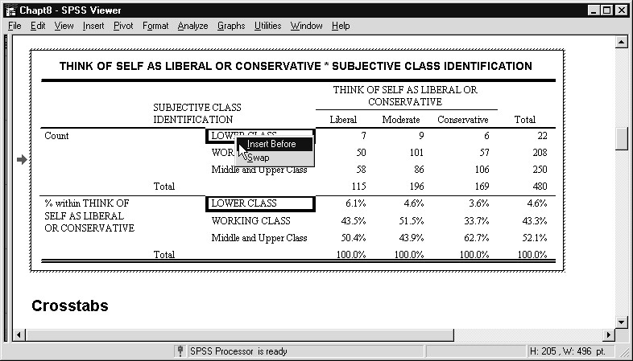
After releasing the mouse button a pop-up window gives you a choice of inserting the dragged category (“Middle and Upper Class”) before the target category (“Lower Class”), or to simply exchange (swap) the two categories throughout the pivot table.
3) Click the Insert Before menu choice

Figure 9.19 Pivot Table After Moving Category
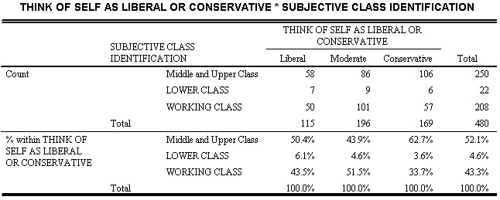
The “Middle and Upper Class” category now appears first throughout the pivot table. This feature allows you to reorder your table after viewing the summary statistics.
CREATING  GRAPHS FROM PIVOT TABLES | SPSS allows you to create graphs directly from a pivot table. As we saw in Chapter 1 and will explore in much greater detail in Chapter 10, graphs can be created from the Graphs menu. However, there are times when you might wish to create a chart based on values contained in a pivot table.  This is accomplished within the Pivot Table Editor by selecting those data cells containing values you wish to plot, then right-clicking and choosing the Create Graphs option on the Context menu. You can select all data cells to plot all values in a pivot table, or select specific rows and columns. The appropriate variable and value labels from the pivot table will appear in the chart. The chart itself will be inserted in the Viewer window immediately following the originating pivot table. Be aware that if your pivot table contains a mixture of summary statistics, for example counts and percents, or means and standard deviations, you generally would not want the different statistics to appear in the same graph.  We demonstrate this feature by creating a bar chart based on the percentages (groups and totals) from the crosstab pivot table we have been editing.
- In the percent section of the pivot table, click the data cell located in the Middle and Upper Class row and Liberal column (its value is 50.4%)
- Shift-click the data cell located in the WORKING CLASS row and Total column (its value is 43.3%)
This will select (highlight) three rows of data values, all subjective class identification categories, but not their total. However, the Total column that summarizes the polviews variable (liberal through conservative) is included. Thus our chart will be based on the column percent values and will include the column totals. To request the chart:
- Right-click on any one of the selected data cells
- Click Create Graph on the Context menu

Figure 9.20 Requesting a Graph from a Pivot Table
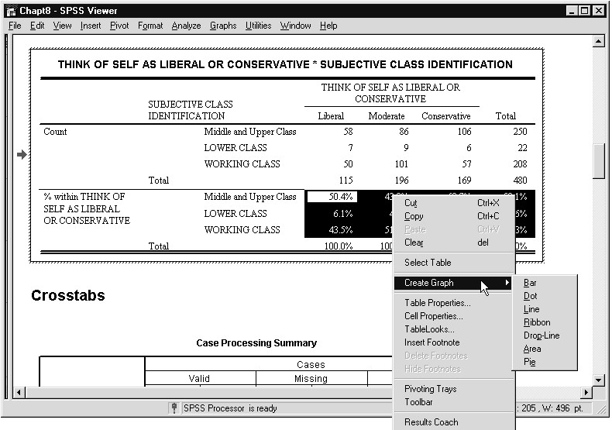
Several different types of graphs can be based upon the values in the selected data cells.
5) Click Bar from the Create Graph menu
Figure 9.21 Clustered Bar Chart Based on Selected Cells in Pivot Table
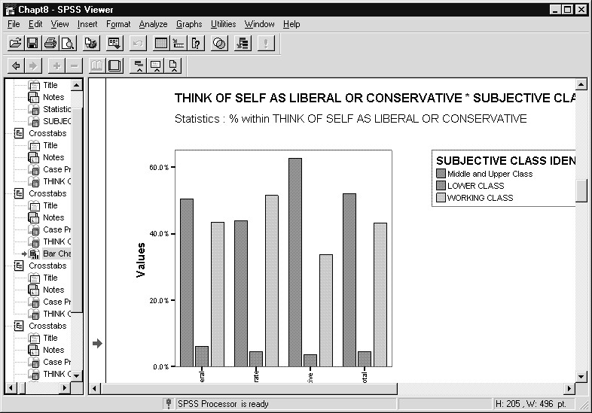
The clustered bar chart displays the values and associated variable and value labels from the selected cells in the pivot table. The graph (it is an Interactive Graph) is inserted into the Viewer window just below the pivot table on which it is based. It can be edited within the Interactive Graphs editor (details covered in Chapter 10).
These Interactive-graph editing features include the capability of reordering the categories on the horizontal axis or in the legend in various ways.
Depending on which cells (or rows and columns) are selected, you can produce a variety of views of the contents of a pivot table. This provides a simple yet powerful method of producing charts to accompany summaries for any type of pivot table. For example, bar charts could display the values of regression coefficients.
_{SUMMARY} In this chapter you learned how to use the Pivot Table editor to modify tables in the Viewer window.

Chapter 10  Topics | Creating Charts  Creating a Pie Chart (Standard Graph)  Editing a Standard Graph  Creating a Stacked Bar Chart (Interactive Graph)  Editing an Interactive Graph  Adding a New Variable to an Interactive Graph  The Interactive Chart Manager  Adding an Element to an Interactive Graph  Creating a Scatterplot (Interactive Graph)  Exporting a Chart  Saving Charts
INTRODUCTIONhis chapter introduces some of the fundamental operations of the SPSS charting procedures. We will produce some of the most common charts or graphs used for business and research purposes,
T
and we will also edit them with some of the tools available in the SPSS
Chart Editors.
SPSS 8.0 added Interactive graphs (Interactive choice on Graphs menu) to the standard graphs available in earlier versions. Interactive graphs allow you to change the charted variables and summary functions after creating the chart, and you can later add elements (for example, error bars, connecting lines, smoothers) to an Interactive graph. As a result, the SPSS Chart Editor windows differ for the two types of charts
(standard, Interactive), and in this chapter we will see examples of each.
SPSS places each chart in the Viewer window as a separate item. You’ve already seen this feature in Chapter 6. In this chapter you’ll learn more about the available options to save charts.
Note About Chart  Colors |  | By default, SPSS for Windows will produce color charts. Since this course guide is not produced in color, different shades appear instead of the different colors you will see on your screen. These may be difficult to distinguish. To have standard charts use different fill patterns instead of colors, click Edit..Options, then click the Graphics tab and select the Cycle through patterns option button. Chapter 11 contains a brief introduction to the Options dialog box. For Interactive graphs, you can specify Legend variables as Styles instead of Colors within the individual chart dialog boxes.
CREATING A PIE  CHART  (STANDARD GRAPH) | To begin, access the data file that we previously used in Chapters 8 and 9, GSSCHP7.SAV, by clicking on File...Open..Data, then selecting this file in the c:\ Train\ Basewin10 subdirectory.
Many charts that you can produce display the graphical equivalent of a frequency or crosstabs table (or even more complicated output). There are two charts commonly chosen to display the equivalent of a frequency table: a pie chart and a bar chart. We will begin by creating a pie chart to display the self-rated health of people in the GSS file. The Graphs menu contains the choices for creating different types of charts.
1) Click Graphs...Pie. SPSS opens the Pie Charts dialog box

Figure 10.1 Initial Pie Charts Dialog Box
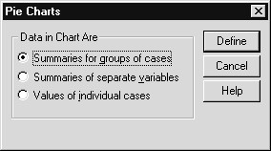
Whenever you request a standard (contrasted to Interactive) chart,
SPSS will begin by opening a dialog box similar to what you see in Figure 10.1. This dialog box typically allows you to choose between displaying summaries (i.e., graphic elements, such as a bar or pie slice) for groups of cases, separate variables, or individual cases. Many common charts are created by grouping cases, so the dialog box has that option button selected as the default choice. For a pie chart, this means that each slice of the pie will represent a unique value or category of one variable (in this case HEALTH), with the size of the slice corresponding to some statistical measure, such as the actual number of cases or the percentage of the total number of valid responses in this category.
- Click on Define to move to the next dialog box, which is shown in Figure 10.2
In the Define Pie dialog box you specify which variable to display, what a slice should represent, titles for the chart, and a few options.
- Click the N of Cases option button in the Slices Represent box
(if not already selected). Then select Condition of Health
[health] from the source variable list and place it in the
Define Slices by: list box

Figure 10.2 Define Pie: Summaries for Groups of Cases Dialog Box
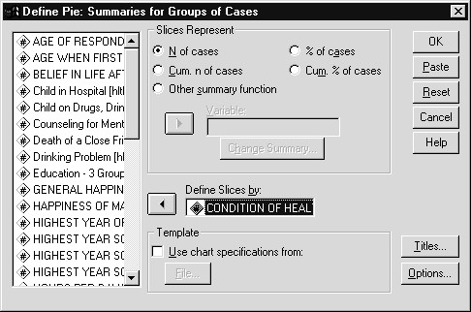
4) To create the chart, click on OK
SPSS draws the chart and displays it in the Viewer window, shown in Figure 10.3.

Figure 10.3 Pie Chart of HEALTH in the Viewer Window
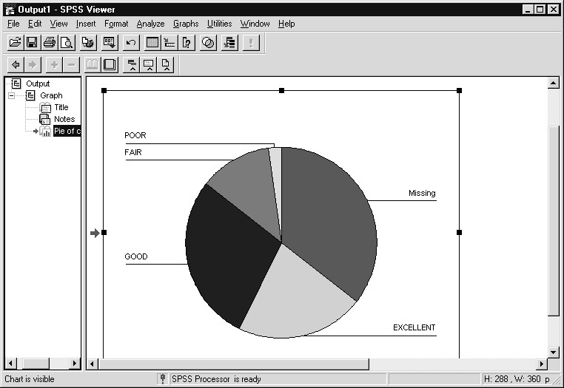
This pie chart uses all the data values for HEALTH and includes no title, so it may not be exactly what you want. However, with some minor editing, you can turn this chart into a more compelling presentation.
EDITING A  STANDARD  GRAPH –  ADDING A TITLE  Note: Editing  Standard and  Interactive Graphs | 1) Double click anywhere on the chart to move it to its own SPSS Chart Editor window.  The result of this action is shown in Figure 10.4. Notice that the main menu bar changes, as does the tool bar. The new window may be somewhat small; if so, maximize it by clicking on the maximize button in the upper-right corner of the window.  The tool buttons and dialog boxes used to edit standard graphs differ from those used to edit Interactive graphs. Both chart editors are reviewed in this chapter.

Figure 10.4 Pie Chart in Its Own Chart Editor Window
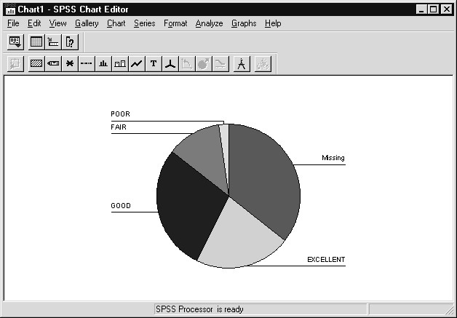
2) To add a title to the chart, click on Chart from the main menu, then on Title. SPSS opens the Titles dialog box. You can enter a two-line title and a line of subtitling as well as specify how the titles should be justified (Interactive graphs allow additional title and caption lines). To add a one-line title, type “Respondent’s Self-Rated Health” in the Title 1 text box. The dialog box should now look like Figure 10.5

Figure 10.5 Completed Titles Dialog Box
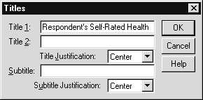
3) Click on OK to redraw the pie chart
EDITING A  STANDARD  GRAPH –  SUPPRESSING DATA | For many chart types in SPSS, user-missing data is included by default. This setting can be changed through the Options button in the main chart dialog box. To remove the missing data from this already-created pie chart, we can use the Series menu choice.  1) Click on Series, then Displayed. SPSS opens the Pie Displayed Data dialog box
2) Click once on Missing to select it, then click on the left arrow
to place it in the Omit box

Figure 10.6 Pie Displayed Data Dialog Box
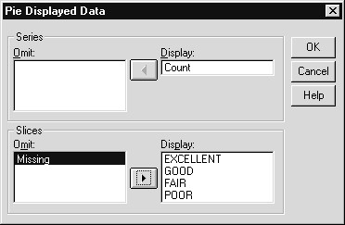
3) Click on OK to have SPSS redraw the chart
Figure 10.7 shows the edited pie chart with a centered title and the missing slice removed.

Figure 10.7 Edited Pie Chart
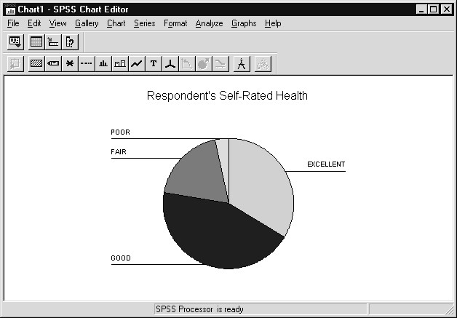
EDITING A  STANDARD  GRAPH –  CHANGING LABEL FORMATS | You can further modify a chart by specifying how the labels for the slices should be displayed, by asking for the values of the slices (here the number of cases in each slice) to be displayed, plus changing characteristics of the line connecting a label to a slice. To display both the labels and values, we will:
- Click on Chart from the menu, then on Options. This menu choice can also be selected by clicking on the chart options tool from the Chart editor tool bar. SPSS opens the Pie Options dialog box
- Click on the Values check box in the Labels area so that both it and Text are selected
By default, SPSS justifies the labels and values on the outside of the slices. To change this format and put the labels outside, values inside the slices, you must use the Format pushbutton.
- Click on the Format pushbutton. Then click on the Position drop-down list and scroll down until you see Numbers inside, text outside and click on that choice
- To change the display format for the values, which by defaultincludes two decimal digits, change the 2 in the Decimal places box to 0
The completed Pie Options: Label Format and Pie Options dialog boxes are in Figure 10.8.

Figure 10.8 Completed Pie Options Dialog Boxes
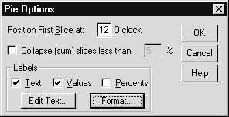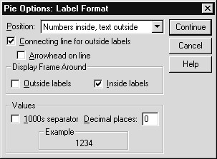
5) Click on Continue, then on OK to make these changes
Figure 10.9 shows the customized pie chart. SPSS can only place the number of cases in each slice where the value fits.

Figure 10.9 Customized Pie Chart for HEALTH
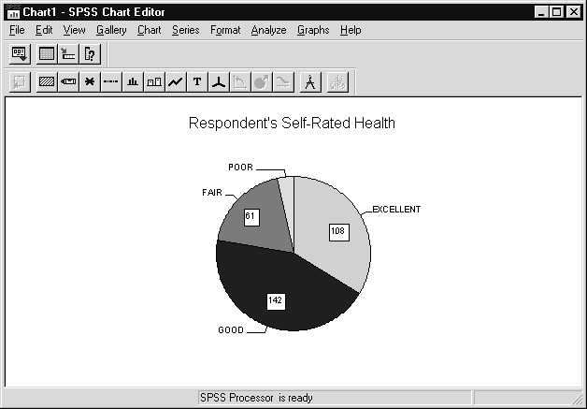

SAVING A CHART

Hint: Changing the Chart Type for Standard Graphs
It is important to make a distinction in SPSS between exporting and saving a chart. In the SPSS Viewer window, charts can be exported. Exporting a chart means saving it in one of several standard graphic formats, such as JPG or TIF. The saved file can then be used in a wide variety of other software. However, the exported file cannot be read back directly into SPSS.
To save a chart in SPSS you only need to save the chart, along with the other contents of the Viewer window, as a Viewer document with the extension “spo” (so SPSS will recognize it). Whenever you want to edit or print the chart, just open the Viewer document. And, of course, you can always delete unwanted output from the Viewer window before saving it.
At the end of this chapter, we’ll save the output created in this chapter and also try exporting a chart.
The same type of information can often be displayed graphically in several formats. For standard graphs, SPSS allows you to easily change the chart type in the Chart Editor window by using the Gallery menu. All new chart types consistent with the current chart will be active when you click on Gallery.
INTERACTIVE GRAPHS:

CREATING A
STACKED BAR CHART
In Chapter 9 we discussed crosstab tables. You can create a bar chart that displays the same information as contained in the cells of a crosstab table with standard or Interactive graphs. In this next exercise, using an Interactive graph we will investigate the relationship between the respondent’s self-rated health and whether, during the last year, he or she was ill enough to go to a doctor (the variable HLTH1: Ill enough to go to doctor).

Although we can request a new graph from the Chart Editor window, we will close the Chart Editor window and return to the Viewer window.
- To return to that window, select File...Close from the Chart Editor menu. We return to the Viewer window, with the pie chart selected
- Click Graphs...Interactive…Bar from the main menu. The Create Bar Chart dialog box is displayed

Figure 10.10 Create Bar Chart Dialog Box (Interactive Graph)
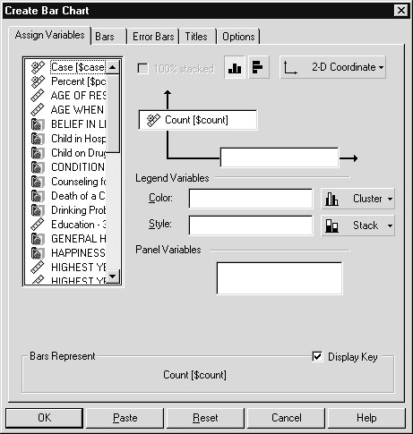
A variety of bar charts (simple, clustered, stacked, 2-D, 3-D, and multiple bar charts representing different subgroups (panel)) can be created from this dialog box. Since it is an Interactive graph, you can later change the variables, summary functions and dimensionality of the chart. The Assign Variables tab is visible. You assign variables to the vertical and horizontal axes by dragging and dropping variables from the source list box into the target boxes placed along the vertical and horizontal arrows. Note that the 2-DCoordinate chart choice is selected
on the dimension drop-down list. If we desire a three-
dimensional bar chart, we need only select the 3-D choice
from the list and a third axis arrow will appear. The
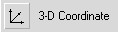
and horizontal buttons control the orientation of the
vertical
bar chart. At this point (or later) you can specify such features as bar shape (Bar tab), error bars (when the vertical axis displays means- Error Bar tab), titles, subtitles and captions (Titles tab), and category order, chart looks (colors, styles, fonts) and size (Options tab).
You can produce stacked or clustered bar charts by making the appropriate choice in the Legend Variable area (we will do so shortly).
Notice an icon precedes each variable on the source list and indicates whether the variable’s measurement type is scale or categorical
. Interactive graphs respect a variable’s measurement type and will issue a warning if inappropriately used (for example, placing a categorical variable as the vertical axis of a scatterplot). You can change the measurement type of a variable on the source list by right-clicking on it, then choosing the measurement type, as shown below.
3) Right-click on the Condition of Health [health] variable

Figure 10.11 Options for Variables on Source List of Interactive Graphs
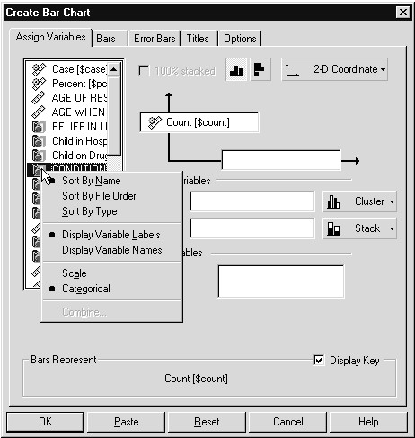
In addition to changing the measurement type for the selected variable, you can order the variables on the list in different ways (the default is alphabetical by variable labels, since the labels are displayed) and choose whether variable names or labels appear on the list.
By default, the scale (here vertical) axis will contain counts. Percents can be requested, and if we drag and drop a variable with scale measurement type into the vertical axis box, a list of applicable summary statistics (mean, median, standard deviation, etc.) will appear. The health (Condition of Health) variable will be placed along the horizontal axis, and we would like separate clusters based on hlth1 (Ill enough to go to doctor). Here we have several choices. If we place hlth1 in the Color box within the Legend area and Cluster is chosen, then the bars representing different hlth1 subgroups will be differentiated by color. If instead hlth1 is placed in the Style box and Cluster is chosen, then the bars representing different hlth1 subgroups will be differentiated by fill style (patterns) instead of color. If variables are placed in both Color and Style boxes and Cluster is chosen, then more complex subgroup clusters are formed. For example, if gender and region are placed in the Color and Style boxes, respectively, then each gender by region combination will be represented by a bar, identified by a color (corresponding to gender) and style (corresponding to region). Also, if a scale (measurement type) variable is placed in the Color box, then the color will be a function of the mean value of the measurement scale variable for each subgroup. Finally, a separate plot is created for each value of a variable placed in the Panel list box and the plots are displayed side by side. Thus, if gender is placed in the Panel list box, separate bar charts will be created for males and for females. Note also that making the appropriate choices beside the Color and Style list boxes (to the right) creates clustered or stacked bar charts. In this way a rich array of information can be represented within an Interactive graph. Our example will produce a stacked bar chart.
- Drag and Drop the Condition of Health [health] variable from the source list to the horizontal axis arrow box
- Drag and Drop the Ill enough to go to a doctor [hlth1] variable from the source list to the Style box

Figure 10.12 Completed Create Bar Chart Dialog Box (Interactive Graph)
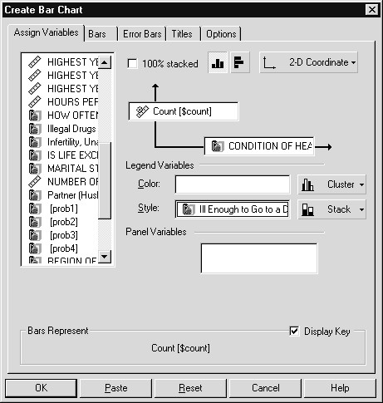
6) Click OK to create the graph
Figure 10.13 Stacked Bar Chart with Stack Groups Differing by Style

(Fill Pattern)
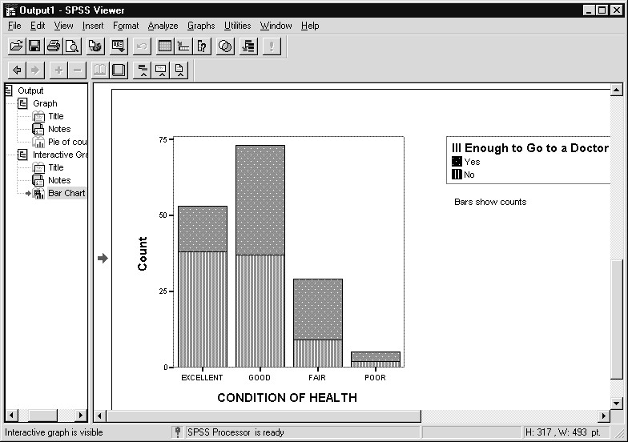
SPSS draws the chart and places it in the Viewer window. Different fill styles represent the different responses to the Ill enough to go to doctor (hlth1) question.
EDITING THE  INTERACTIVE GRAPH | Let’s edit this chart.  1) Double click anywhere on the chart

Figure 10.14 Interactive Chart Editor
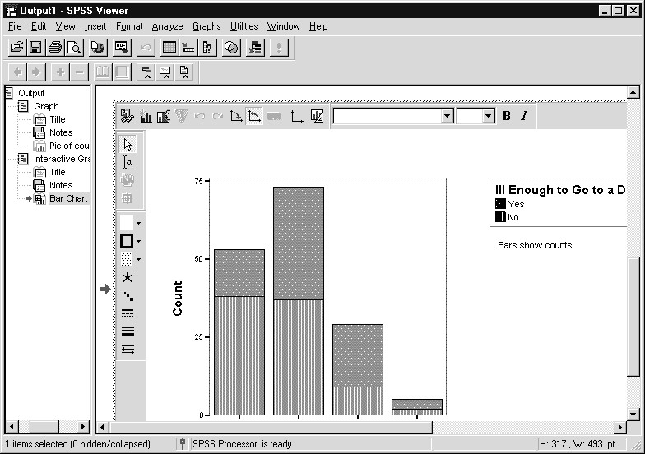
Unlike the SPSS standard chart editor, which opens a separate window, the SPSS Interactive chart editor edits the graph in place. The crosshatch border around the chart indicates that the editor window is active, as does the presence of the Format menu (the Insert menu also has some new choices). Movable tool bars contain commonly used features (for example: change the fill color of a chart object
the Chart Manager , add text , and insert an element . You can use the tools in the Interactive Chart Editor tool bars to make many changes to the graph. Let’s first change the colors of the bars. To change an element of a chart, you should first select it. Click once on the element to do this (after which it is surrounded by dashes to indicate the selection).
, display
First we will change the graph type from a stacked bar to a clustered bar chart.
- Click the Assign Variables... tool button
- Click the Stack button to the right of the Style box
(this opens the drop-down list), and then click the Cluster 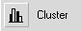 button from the drop-down list

Figure 10.15 Changing the Chart Type
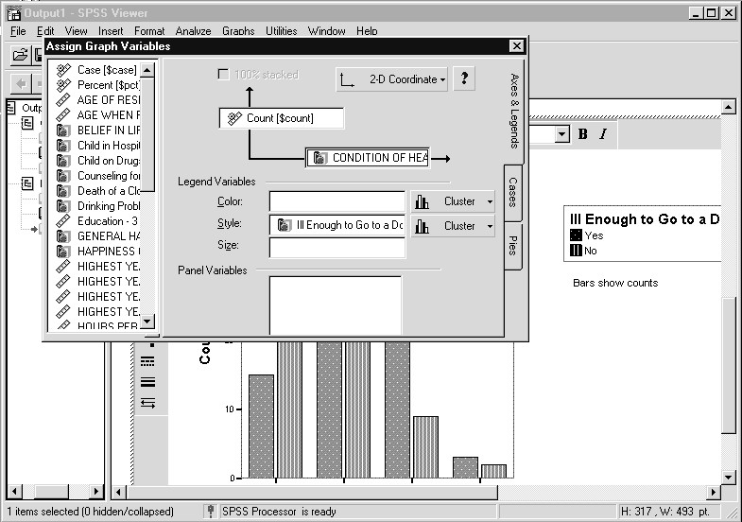
Note the graph changes immediately to a clustered bar chart, which makes it easy to explore different changes to your graph. Also, we can substitute different variables into the graph at this point.
3) Click the Close button in the Assign Graph Variables... dialog box
We can change the color of a single bar, a selected set of bars, or all bars corresponding to a legend category. If we want to change the bar color for the bars representing those who were not ill enough to go to the doctor, the most direct way is to select this category in the legend, then change the fill color.
- Click the Fill Pattern icon beside the No category in the Legend to select all “No” bars
- Click the arrow beside the Fill Color button , and then click any one of the available colors. You can also create your own colors by clicking on the Custom Colors button

Figure 10.16 Clustered Bar Chart with New Color for One HLTH1 Category
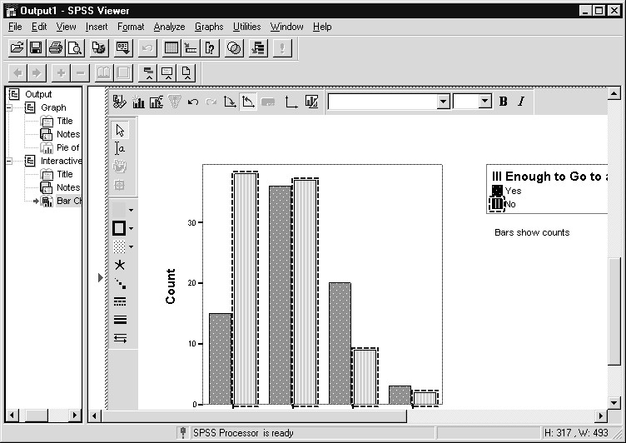
SPSS changes the color as shown in Figure 10.16. Any additional editing changes can be made at this point.
3) Note that the bars you selected remain marked. To deselect an element, click anywhere on the chart (within the crosshatched border) away from that feature
ADDING A NEW  VARIABLE TO AN  INTERACTIVE GRAPH | Interactive graphs allow you to modify the chart by actions that include adding and removing variables. For example, we could add a variable to create a third dimension to our chart. To demonstrate, we will replace the current scale axis, which contains counts, by the average age of the respondents. In this way we can view relations between age and health status as measured by the two health questions.
- Click the Assign Variables tool button
This dialog is similar to the Create Bar Chart dialog box we saw before, however it contains only features relevant to the assignment of variables.
- Drag and Drop Age of Respondent [age] from the source list box to the Vertical axis box

Figure 10.17 Assign Graph Variables Dialog Box
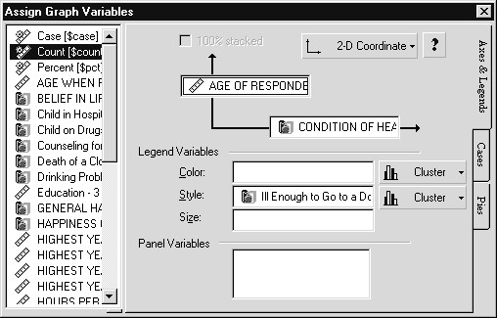
The graph changes immediately, but to better view it we close the Assign Graph Variables dialog.
3) Click the Close button in the Assign Graph Variables dialog

Figure 10.18 Bar Chart with Mean Age on Scale Axis
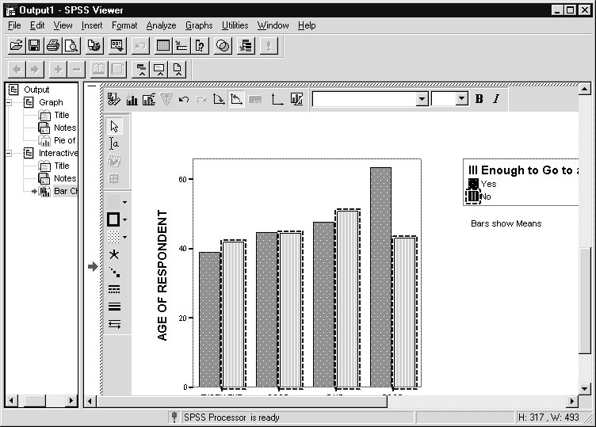
Not surprisingly we see that the mean age trends upward as health ratings decline. Instead of creating a new chart, as we would do with standard graphs, we can directly change variable assignment within an Interactive graph.
THE CHART MANAGER | When editing an Interactive graph you can invoke the Chart Manager, which provides quick access to the components that make up the chart.  Individual components can be selected, then edited, hidden or deleted. Also, if some component of the chart cannot be displayed, the Chart Manager may contain a warning message explaining the reason.
1) Click the Display Chart Manager tool

Figure 10.19 Chart Manager
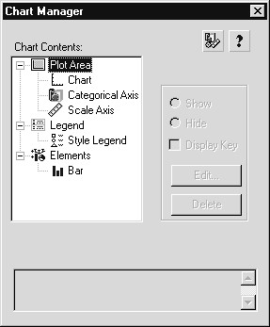
The Chart Manager shows this graph is composed of several components: a plot area containing the data region, a scale axis, and a single categorical axis (since it is a 2-D graph); the legend; and the chart elements (here only a single chart element (bar) is present). To edit a component (for example, the scale axis), click on the component to select it, then click the Edit pushbutton. The components can also be edited from the Format menu, or in many cases by double clicking (or selecting, then right-clicking) on the component in the chart. However, the Chart Manager provides an organized frame from which to work.
2) Click the Close button to close the Chart Manager
ADDING AN  ELEMENT TO AN  INTERACTIVE GRAPH | An Interactive graph can display multiple elements. For example, error bars can be added to a bar chart displaying means, or a regression line and robust smoother can be added to a scatterplot (cloud plot). For an added element to be visible, the assigned variables must be consistent with the element added (the Chart Manager warnings mentioned in the last section alert you to such problems). To demonstrate this feature we will add error bars to the graph.
- Click Insert Element tool
- Click Error Bar tool from the Insert Element drop-down list

Figure 10.20 Bar Chart with Error Bars
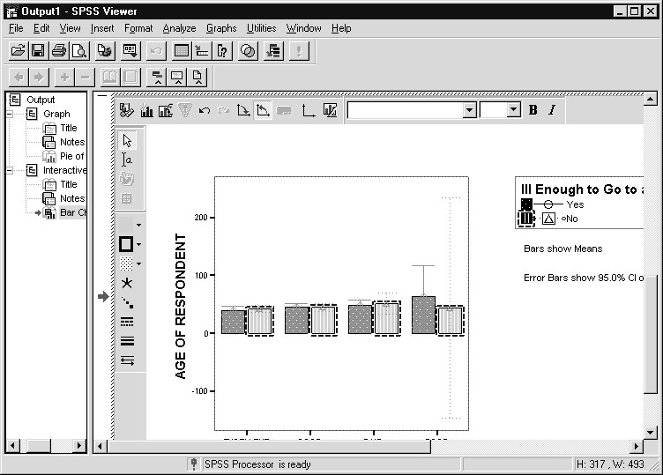
We see that error bars marking the 95% confidence band for each subgroup mean now appear in the graph. The graph has changed dramatically. This is because the subgroup composed of those reporting poor health and no doctor visits was quite small (two people: see Figure 10.13) and showed great variation in age (ages were 19 and 89), which resulted in an extremely wide confidence band for the mean. To speak meaningfully about this group, a larger sample would be needed.
Nonetheless, we have added a second element to the chart. To verify this:
- Click the Display Chart Manager tool
Figure 10.21 Chart Manager Displaying Bar and Error-Bar Elements
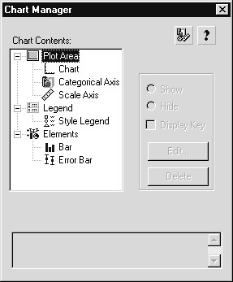
The graph now contains two elements: bars and error-bars. If we wished to edit or delete either element at this point, we need only to click on the element to select it, and then click the appropriate pushbutton.
CREATING A  SCATTERPLOT  (INTERACTIVE GRAPH) | The previous examples have shown how to display categorical data (at least one of the variables) in a bar chart. The next example shows how to display the values of scale (interval scale) variables with a scatterplot. In particular, we will examine the relationship between a respondent’s years of education and the number of hours he or she watches television each day, hypothesizing that as education level increases, the number of hours watching television decreases.
A scatterplot is a chart in which the axes display a range of continuous values. Normally, if there is a variable that can be classified as a predictor or independent variable, it is placed on the horizontal (x) axis. In this case, we will put years of education on the horizontal axis and number of viewing hours on the vertical axis. Scatterplots can be produced by standard or Interactive graphs; we will create an Interactive graph.
  - Click the Close button to close the Chart Manager, and click outside the crosshatch area to close the Chart Editor
  - Click Graphs...Interactive…Scatterplot from the main menu
  - Drag and drop Hours per day watching TV [tvhours] from the source list into the Vertical-axis arrow box
- Drag and drop Highest year of school completed [educ] from the source list into the Horizontal-axis arrow box

Figure 10.22 Completed Create Scatterplot Dialog Box (Interactive Graph)
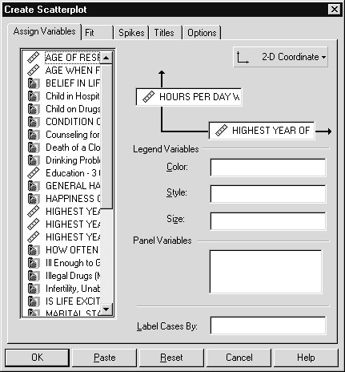
If we wish to distinguish subgroups in the scatterplot, categorical variables can be placed in the Color, Style or Size boxes within the Legend area. In this way the color, style or size of the symbols used in the plot will distinguish subgroups. If separate plots for different subgroups are desired, the variables forming these subgroups should be specified as
Panel variables. As before, Titles and Options tabs are available. Also, a Fit tab enables you to add a regression line or robust smoother as elements, and the Spikes tab will connect the points to some reference (the origin, centroid, horizontal axis, etc.).
5) Click OK to process the request

Figure 10.23 Scatterplot of Number of Hours Watching Television by Years of Education
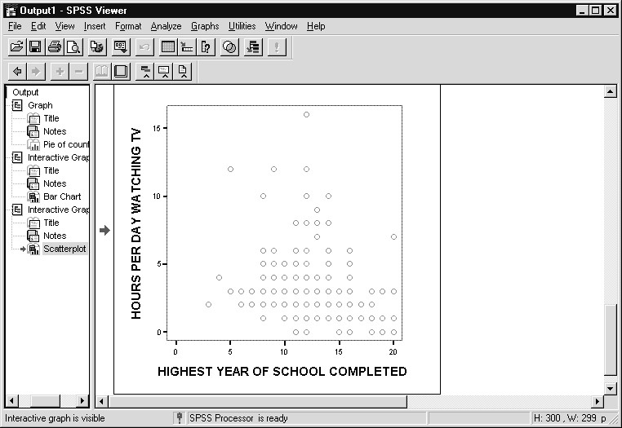
SPSS displays the scatterplot, as you can see in Figure 10.23. Although there is a suggestion of a negative relationship, the pattern is difficult to discern, in part because many individuals have the same values, but the density isn’t represented. A graphics technique called jittering adds a small random component to the data values in a plot, so multiple data points with the same values can be distinguished.
- Double click on the chart to open the Interactive Chart Editor window.
- Click the Display Chart Manager tool
- Click the Cloud element to select it, then click the Edit pushbutton
- Click the Jittering tab, and click the Jitter all scale variables checkbox
- Click to the right of the Percent scale pointer; alternatively, type 2.0 in the % text box

Figure 10.24 Requesting Jittering for a Scatterplot (Cloud Plot)
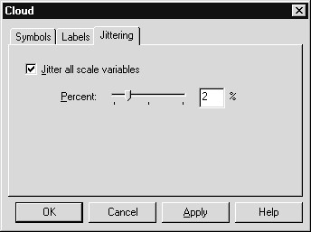
The Percent scale controls the magnitude of the random component added to the variables in the plot. You can try different values and compare the point separation.
6) Click OK to perform the jittering, and click the Close button to close the Chart Manager

Figure 10.25 Scatterplot after Jittering
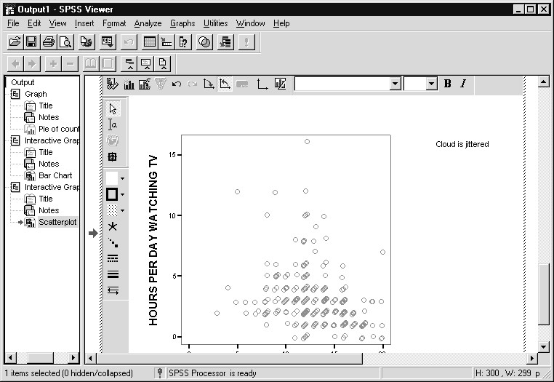
Jittering gives us a much better sense of the density of points in certain areas of the chart. The graph can be edited further (edit scales, add elements, insert titles or text), but we will stop at this point and export the chart.
7) Click outside the crosshatch border to close the Interactive Chart Editor
EXPORTING CHARTS | Now that we’ve created some charts, let’s try exporting the scatterplot to one of the available standard formats. Charts can be exported from the Viewer window.
- Click on the Scatterplot to select it
- Click on File...Export from the menu. The Export Output dialog box opens as shown in Figure 10.26
SPSS can export all the contents of the Viewer window, only charts, or everything but charts. In addition you can export all objects, all visible objects, or all selected objects (we want to export only the selected chart).
- Click Charts Only from the Export drop-down list

Figure 10.26 Export Chart Dialog Box
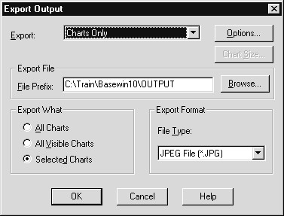
The default graph export format is a JPEG file (often used on the
Internet), although other choices are available (see File Type in the
Export Format area). The Options pushbutton allows you to change selected characteristics of the file type, and these will vary depending on the type. All the file types allow you to specify the size of the chart. We won’t change any options in this example. The File Prefix text box specifies the prefix for the chart file names. The file name for each exported chart is set by appending a sequence number to the prefix name (here OUTPUT). Thus if two charts were exported, they would be named OUTPUT0.jpg and OUTPUT1.jpg.
4) Click OK to export the char
The JPEG file has been saved and can now be used in other applications.
SAVING  CHARTS  Hints  SUMMARY | When you save the Viewer window, all the charts created in an SPSS session are saved, along with the other types of output. We domonstrated how to save the Viewer file in Chapter 8.  If you saved a Viewer file containing the three charts, you could bring them back into SPSS at any time for further editing, and can pass them to other applications via exporting or copying and pasting with the clipboard. In addition, the saved Viewer file could be examined using the SPSS SmartViewer or the SPSS SmartViewer Web Server.  You can incorporate a standard look in your charts using chart templates (for standard graphs) or ChartLooks (for Interactive graphs). The chart chapters of the SPSS Base 10.0 User’s Guide and the SPSS Interactive Graphics 10.0 manual discuss these features.  Since Interactive graphs allow variable substitution when editing, SPSS provides options to save the data with the charts to allow such editing later. The Options dialog (Edit..Options..Interactive) controls this feature (by default, data are not saved with charts in the Viewer file).  In this chapter you have learned how to create and edit three common chart types using both SPSS standard graphs and SPSS Interactive graphs, plus learned about exporting and saving charts.

Chapter 11  TOPICS | Useful Features  SPSS Syntax  SPSS Journal File  Copy and Paste Variable View Properties  Applying Dictionary Information  Dialog Box Recall  Data Codebook  Appendix: SPSS Options
INTRODUCTIONPSS for Windows has several features designed to make
S
convenient use of things you’ve done previously when working with new data files or performing new analyses. Each of the
features reviewed in this chapter supports this goal in a different way. SPSS syntax commands provide a way to rerun the same (or slightly modified) analyses in the future. The Variable View tab sheet allows you to enter a set of value labels (also missing values and other variable properties) once, then copy them to any other variables in the file. As such, they are very valuable to those needing to repeatedly run the same analyses, or who often deal with variables based on the same scale. SPSS has a feature that takes dictionary information (labels, missing values) from an SPSS data file and applies it to a new data file based on matching the variable names. The Recall Dialog tool button provides a list of recently accessed dialog boxes within SPSS for Windows, so you can quickly return to a dialog box used earlier. Finally, you can create a codebook as a reference document for an SPSS data file.
SPSS SYNTAX The SPSS for Windows dialog boxes make it very easy to request a wide variety of statistical analyses. However, some of you may need to run the same set of analyses repeatedly and do not wish to perform the mouse actions more than once. SPSS syntax commands permit you to rerun (or modify and run) analyses previously requested. You can instruct SPSS to create syntax commands from specific dialog boxes, or you can extract useful syntax commands from a historical file that SPSS automatically creates (by default), which contains all the commands from the current SPSS sessions.
The SPSS command language is based on syntax rules which are documented in the SPSS Base 10.0 Syntax Reference Guide (available on the CD-ROM containing the SPSS 10.0 program) for the Base system and in the second section of each of the manuals for optional modules. We introduce SPSS command syntax because it can be very useful for those who need to rerun analyses.
To demonstrate how you can have SPSS for Windows create command syntax, we will set up a frequency analysis, then create, examine, modify and run the syntax. If necessary, first open the General Social Survey data (either Gss91Small(.sav) or GSSCHP7(.sav)).
- Click File..Open..Data, then move to the c:\ Train\ Basewin10 folder and double click on Gss91Small
- Click Analyze..Descriptive Statistics..Frequencies
- Double click Subjective Class Identification [class] to move it to Variables list box
(alternatively, click class, then click right arrow)
- Click Charts pushbutton, then click Bar charts option button, finally click Continue

Figure 11.1 Frequencies Dialog Box
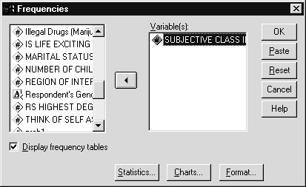
Clicking the OK pushbutton will result in a frequency table and bar chart of class placed in the Viewer window. Instead, we click the Paste button, which will paste the SPSS syntax command required to run this analysis into a newly opened syntax window. In practice, you would run the analysis first to make sure it produces what you want, then return to the dialog box and click the Paste button.
5) Click Paste pushbutton

Figure 11.2 Frequencies Command in Syntax Window
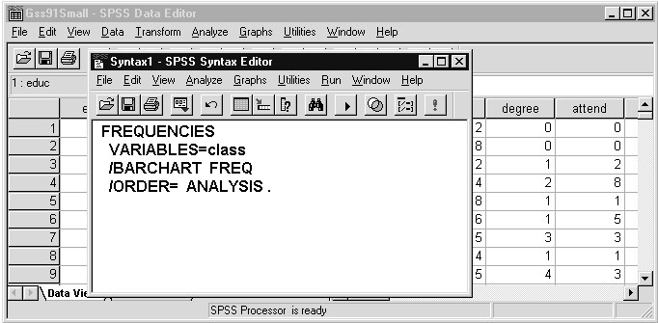
Notice the Frequencies command is followed by the subcommand
VARIABLES, which precedes the list of variables to be analyzed. The BARCHART subcommand requests that a bar chart be created. Any dialog box containing the Paste pushbutton can construct a syntax command that performs the work done by the dialog box. If we now moved to a different dialog box (for example Crosstabs) and clicked the Paste button, a second syntax command would be added to the Syntax window. In this way you can build a set of SPSS syntax commands to do a series of analyses.
If we were to click (or click and drag to select) anywhere on the
Frequencies command, then click the run tool , SPSS would run the
Frequencies command. If there are several commands that you wish to run, simply click and drag to select them, then click the run tool button. To demonstrate that you can change an SPSS syntax command, we will substitute the educ variable for class, then run the analysis.
6 ) Click and drag to select class, then type educ to replace class

Figure 11.3 Modified Frequencies Command
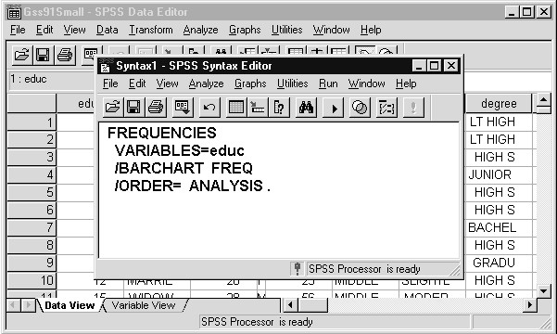
The Frequencies command will now run an analysis of highest year of school completed (educ).
- Click run tool (be sure insertion pointer touches the command)
- Click the open book icon beside Highest Year of School Completed item

Figure 11.4 Frequencies Output from Syntax
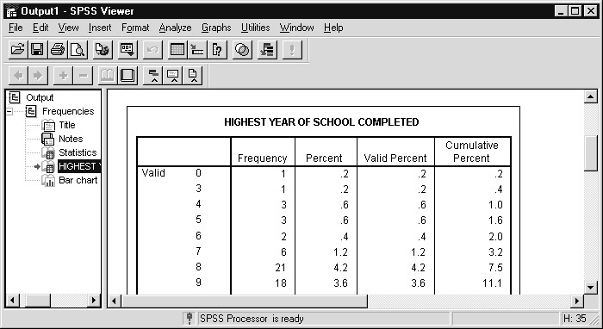
The frequency table and bar chart of education appear in the Viewer window. Note that the contents of a syntax window can be saved (as a text file) and later opened to rerun the commands.
SPSS JOURNAL Using the Paste pushbutton to construct syntax is helpful when you know FILE that you must run the same analysis in the future. But what can be done if you only later realize that you need to rerun an SPSS analysis? By default, SPSS for Windows automatically creates a command syntax record of the analyses you perform (all dialog box actions except those in the editor windows are recorded) and stores them in a text journal file. From within SPSS for Windows you can open this journal file, and then select and run commands to reproduce your previous work. You can also copy and paste syntax commands to a new syntax window.
The journal file is stored (by default) in the TEMP subdirectory beneath the directory containing windows (usually \ WINDOWS\ TEMP). You can control whether a journal file is recorded and where it is located through the Edit..Options menu choice (see Appendix to this chapter). We will examine the current journal file.
- Click File..Open..Syntax
- Select All files (*.*) from the Files of Type drop-down list
- Move to the \ TEMP folder (note: may be \ Windows\ Temp on SPSS training machines - click Edit..Options to verify)
- Click on spss.jnl in the folders window

Figure 11.5 Open File Dialog Box
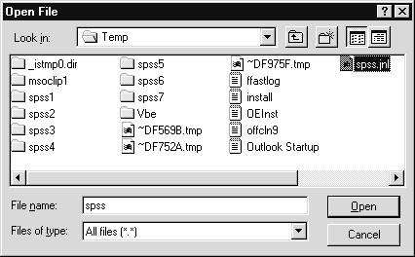
A syntax file is simply a text file containing SPSS syntax commands. The journal file can thus be considered a syntax file (Note: it also contains any warning or error messages issued by SPSS).
- Click Open to open the SPSS journal file
- Scroll to the bottom of the SPSS journal file

Figure 11.6 SPSS Journal File
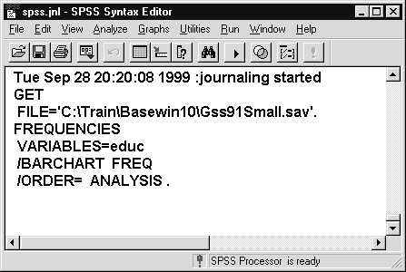
We see that the last command in the journal file is the Frequencies command we just ran. Before that is the GET command that retrieved the Gss91Small data file. Above that is a time and date stamp that SPSS adds to the journal when SPSS is run. This helps you locate previous work when the journal is set to append across SPSS sessions. If we scroll up in the window, we would see the syntax commands from all the analyses we ran in previous chapters. This is because journal recording, by default, is set to append (see appendix to this chapter). If journal recording were set to Overwrite, then the journal would contain syntax commands only from the current SPSS session. To rerun analyses, we need only click and drag to select the desired set of commands, then click
the run tool button . Thus the journal file provides a backup of your SPSS work and its commands can be rerun, or modified and then run, at any point in the future.
COPY AND  PASTE  VARIABLE VIEW PROPERTIES | Earlier in this course guide we supplied value labels for several variables from the 1991 General Social Survey. In survey work one often encounters a series of questions that take the same labels. For example, there may be one or more sets of rating questions on a scale of 1 (Strongly agree) to 5 (Strongly disagree). Rather than repeatedly typing the same set of value labels, the Copy and Paste feature in SPSS for Windows allows you to enter the labels once, then copy them to other variables in the SPSS data file. This provide a powerful method to increase your efficiency in SPSS. Copy and paste can be applied to variable and value labels, formats, missing values, measurement type and column alignment (in the Variable View sheet of the Data Editor).  To demonstrate, we will enter value labels for a set of health problem variables (see Appendix B for more details). Respondents were probed about whether or not their family had experienced any of a set of health problems in the previous year. Responses were coded as 1 (Yes) or 2 (No). There were additional missing-value codes, but here we will restrict ourselves to codes 1 and 2.  Since the Gss91Small(.sav) file already contains a complete set of labels, we will open a small (10-case) version of the General Social Survey file that contains no labels.
- Click the Goto Data icon , and click the Variable View
tab
- Click File..Open..Data, then double click on Nolabel (SPSS
Data file in the c:\ Train\ Basewin10 folder)
- Scroll down to the hlth1..hlth9 variables

Figure 11.7 Data File with No Value Labels (Variable View Sheet)
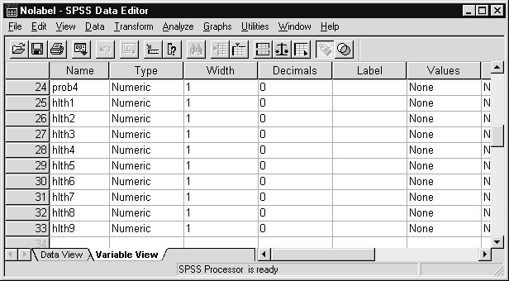
No value labels are currently present. We will enter value labels for one of these yes/no variables, then copy and paste the labels to the other variables. Note that the Variable View sheet of the Data Editor window must be the active window in order to perform this operation.
We proceed to enter the value labels
- Click in the cell under the Values column for the hlth1 variable, then click the button
- Click in Value text box and type 1
- Click in Value Label text box and type Yes
- Click Add pushbutton
- Click in Value text box and type 2
- Click in Value Label text box and type No
- Click Add pushbutton

Figure 11.8 Value Labels Entered for Hlth1 Variable
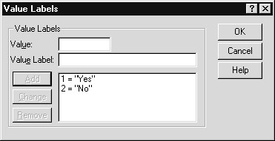
The usual rules for supplying value labels and modifying them apply.
11) Click OK

Figure 11.9 Value Labels Supplied for Hlth1
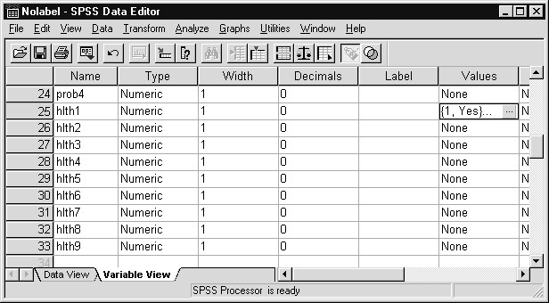
Now we must copy the value labels to the clipboard and paste them into the Values’ cells for the other health variables (hlth2 through hlth9). Since the Values cell for hlth1 is still selected, we can copy directly.
- Click Edit..Copy
- In the Values column, click and drag from the hlth2 cell to the hlth9 cell

Figure 11.10 Target Values Cells Selected
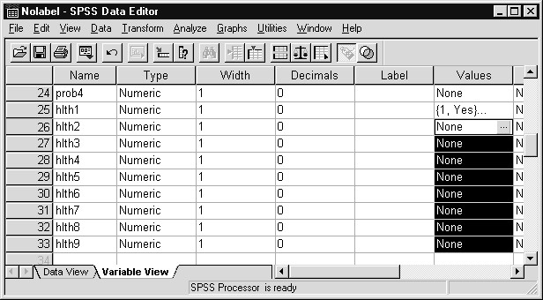
13) Click Edit..Paste

Figure 11.11 Value Labels Copied to Other Variables
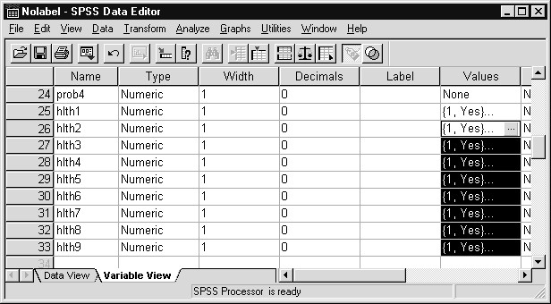
The value labels from hlth1 have been copied into the Values cells of the other health variables. In this way, variable properties (except for the variable name, which must be unique) can be specified once and then applied to other variables in the data file.
APPLYING  DICTIONARY INFORMATION | Another useful method of capitalizing on information already entered into SPSS for Windows involves applying labels, formats, measurement level, and missing values from a previously saved SPSS data file to the data file currently in the Data Editor. Basically this method searches for common variable names in the two files and, for these variables, copies the dictionary information (format, measurement level, missing values, variable and value labels) from the saved SPSS data file to the data in the Data Editor. This feature is valuable for those collecting the same data fields in different files (for example, each month’s data is stored in a separate file).  To demonstrate how to apply dictionary information from an SPSS data file, we will retrieve the Nolabel(.sav) data file and apply dictionary information from the Gss91Small(.sav) file.
- Click File..Open..Data
- Double click on Nolabel (in the Basewin10 folder) and click No when asked to save the original file’s contents

Figure 11.12 Survey File Without Labels
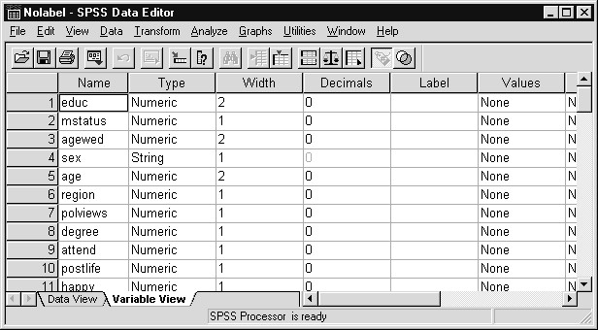
Most of the variable names match those of the Gss91Small. However, the name of the marital status variable is MSTATUS; recall it is named MARITAL in the Gss91Small file. Also, GENDER in the GSS file is named SEX in this file. When we apply the dictionary information from Gss91Small, it should not update MSTATUS or GENDER, since there are no matching variable names.
- Click File..Apply Data Dictionary
- Double-lick Gss91Small (in the c:\ Train\ Basewin10 folder) in the Apply Dictionary dialog
Dictionary information can only be applied from SPSS data files.

Figure 11.13 Modified Data Editor Window
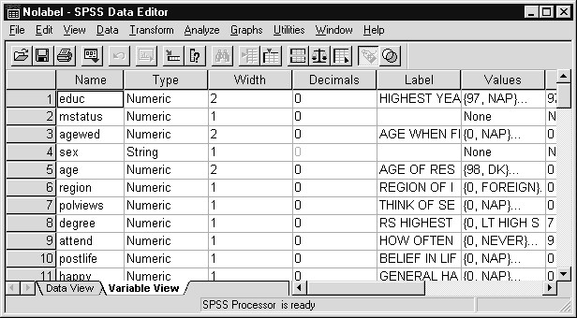
We see value labels appearing for many variables. Variable labels, measurement level, formats and missing-value declarations have also been copied for the variables whose names match those contained in Gss91Small. Notice that no value labels have been applied to MSTATUS and SEX because their names do not exist in Gss91Small. We can, of course, rename them (for example, click on MSTATUS in the Name column of the Variable View tab sheet and replace its name), then repeat the Apply Data Dictionary step.
DIALOG BOX RECALL | As an additional aid to ease of use within SPSS for Windows, the Dialog Box Recall tool button provides a list of the most recently accessed dialog boxes and enables you to return to any listed dialog box with a single mouse click. This is especially helpful to quickly return to a dialog box used earlier in the session and rerun an analysis, or make a modification to it and run. To demonstrate this feature:
1) Click Recall Dialog tool

Figure 11.14 List of Most Recently Accessed Dialog Boxes
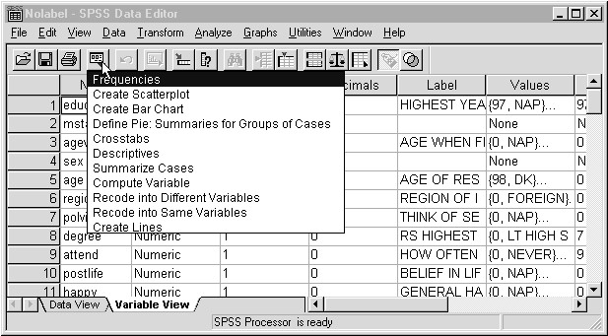
The dialog boxes should be familiar to you based on our work in the last few chapters. The dialog box most recently accessed was Frequencies, used early in this chapter. Below Frequencies we see several Graphs menu dialog boxes from Chapter 10 (Graphics). Below that is the Crosstabs dialog box from Chapter 8. Notice that Crosstabs is listed only once, although we ran several crosstab analyses. This illustrates that the Dialog Box Recall list is a list of the dialog boxes accessed and not a true record of every analysis run (the journal file provides this). Also, file access and editing dialog boxes are not listed. To open any dialog box on the list, you need only click on it.
2) Click Frequencies on Dialog Box Recall list

Figure 11.15 Frequencies Dialog Box
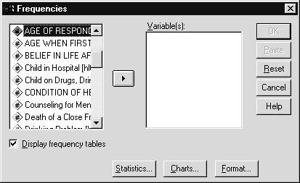
Notice that no variables appear in the Variable(s) list box, and if we clicked the Charts pushbutton we would find no charts selected. The reason why the specifications from our earlier use of this dialog box do not appear is because we opened a new data file (NOLABEL.SAV) since we last used the Frequencies dialog box. If we had been working with the original file (Gss91Small) all along, our most recent choices in the Frequencies dialog box would still be present. Since the data file has changed, SPSS brings up the default Frequencies dialog box. If no data were present in the Data Editor window, SPSS would prompt you to open a data file.
3) Click Cancel pushbutton to close the Frequencies dialog box
DATA It is often beneficial to have a paper-copy listing of all the variable
CODEBOOK definition information in an SPSS data file. This information is the portion of the SPSS data file referred to as the dictionary (as opposed to the data). SPSS data files can be conceptualized as having two parts, the dictionary and the data.
The listing of variable definition information is often called a codebook because it can be used as a reference aid when planning reports and analyses or even when trying to recall the variable names in a data file.
This information will include:
Variable Names
Variable Labels
Measurement Level
Print and Write Formats, including a data type and a number indicating the maximum width and the number
of decimal positions for a numeric variable
Value Labels
Missing Values
Do the following to generate such a listing in the Viewer window.
- Click Utilities..File Info from the main menu
- Scroll down in the Contents pane of the Viewer window until you reach Region

Figure 11.16 Codebook Information from SPSS Data File
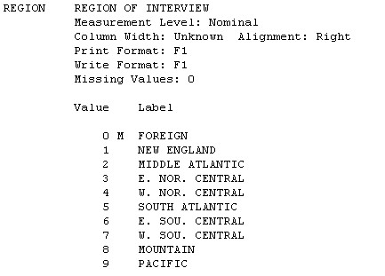
We see the dictionary information for the Region variable. SPSS places an “M” next to the values that have been defined as missing, as well as listing them above.
SUMMARY In this chapter we discussed several SPSS for Windows features that allow you to apply previous actions within SPSS to current and future situations. Syntax commands and the journal file enable you to rerun series of analyses, while copy and paste of variable properties and the Apply..Data..Dictionary option allow you maximum usage of variable definitions and labels. We also reviewed how to create a codebook from your SPSS data file.
APPENDIX: SPSS OPTIONS | SPSS for Windows is installed with default settings that determine the basic environment within which SPSS operates. These settings can be changed by you to suit your needs and style. For example, you can see variable lists displaying variable labels or variable names, and view them in alphabetic order or in the same order as the variables appear in the file. There are many features under your control. In this section we will mention two of the most commonly used ones. Most are covered in the
Intermediate Topics: SPSS for Windows 10.0 training course and all are discussed in the SPSS Base 10.0 User’s Guide.
1) Click Edit..Options

Figure 11.17 SPSS Options Dialog Box
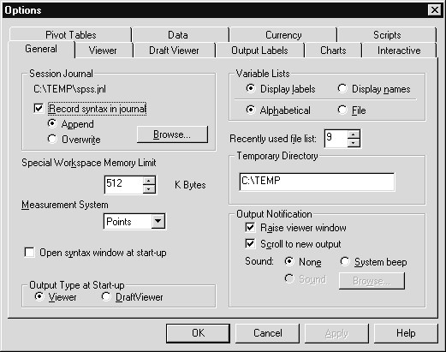
The sheets within the SPSS Options dialog box display the current settings and are used to change them as well. Notice the current location of the SPSS journal file appears in the upper left corner of the General tab sheet, and on this machine each SPSS session will be appended to the previously created journal file.
Any changes you make are retained by SPSS for future sessions. Also, please note that the Scripts tab is available to allow you to automate the manipulation of pivot tables.
In the upper right of the General options sheet are choices for the display of variable lists. By default, variable labels will appear with the variable name enclosed in square brackets [ ], but variable names alone can be chosen. For display order the default is file order. This might be preferred if data come from a spreadsheet and analysts like to retain the original column order when SPSS lists the variables in dialog boxes. Also, for survey data in which the variables are named Q1, Q2a, Q2b, Q3, etc., the order of the variables in the file (File order) is more convenient. Alphabetical order is preferred if the variable names (or labels) are recognizable, since it makes it easier to locate the variables by name (or label). To change either variable list option, simply click the appropriate option button, then click OK. The change will take effect the next time a data file is opened.
A second aspect often modified is the TableLook discussed in Chapter 9. Clicking on the Pivot Tables tab will lead you to formatting features that can be applied to pivot tables. You control such pivot table attributes as grid lines, fonts and colors.
This is a very brief look at the SPSS Options dialog box. Yet it serves to make the point that the Options dialog box gives you control over the SPSS environment. It is worth your time to investigate it further.

Appendix A  TOPICS | Multiple Response Variables  What Are Multiple Response Variables?  Defining a Multiple Response Set  Defining a Multiple Response Set: Dichotomous Items  Frequency Tables Using Multiple Response Variables  Crosstab Tables with Multiple Response Variables  Handling Nonresponses
INTRODUCTIONn this chapter we discuss a procedure within SPSS for Windows
I
designed to produce frequency and crosstab tables when several responses can be made (or recorded) to a single question. Other SPSS
procedures treat each variable as a separate entity; the Multiple Response procedure combines multiple variables measuring the same thing into a single table. We will show you how to set up such analyses and discuss the choices you have in requesting percentage summaries.
The Multiple Response procedure is part of the SPSS for Windows Base System. If you have the SPSS for Windows Tables option, it too can accept multiple response variables, but it provides much greater format control and supports far more complex summary table organization.
WHAT ARE  MULTIPLE  RESPONSE VARIABLES? | There are data collection situations in which several responses or measurements are recorded for a single question. For example, people might be asked to list every airline they have flown in the last six months, or to name every magazine to which they subscribe. In quality control applications all defects found in a sampled product might be recorded, or there might be a list of product characteristics, each one of which is checked if it is found to be within specification limits. When measuring customer satisfaction, you might ask those surveyed to tell you what they like and what they don’t like about your product or service. In this chapter we review the Multiple Response procedure in SPSS that produces summary frequency and crosstabulation tables composed of such multiple response variables.  There are questions of this type in the General Social Survey. Respondents were asked to name the most important problems they (and members of their household) had during the last twelve months. Up to four responses were recorded and stored in the variables prob1 to prob4. In this situation the survey designers expect each respondent to name, at most, a few of their most important problems. This is the rationale for recording the information in only four variables. Such common survey questions as “Tell me what you like (or dislike) about product X” are of this type. The coding scheme for the General Social Survey prob1 to prob4 variables appears below.  Problems Faced in Previous Year Coding (prob1,prob2,prob3,prob4):  Value Label  - Health  - Finances  - Lack of Basic Services  - Family  - Personal  - Legal  - Miscellaneous
For example, if I mentioned two problems, finances and legal difficulties, my data values would be prob1=2 (finances), prob2=6 (legal), prob3=sysmis(.), and prob4=sysmis(.). Under this coding scheme each variable can take any of the values, since a respondent could mention financial problems as their 1st, 2nd, 3rd or 4th problem. While we can run frequency tables on each of the four variables, we would like one table that combines all four variables. The Multiple Response procedure in SPSS for Windows can do just this.
A second way in which multiple response data can be collected is through a checklist type format. For surveys this means the respondent is presented with a list and is asked to check those that apply. This method of presentation is used when you want to insure that the respondent considers each of the possibilities (for example, a list of local radio stations, or magazines). However, if there are many response possibilities (all one-hundred-plus ice cream flavors at Baskin-Robbins) then this technique is not feasible. Variables coded this way are sometimes referred to as multiple dichotomy questions (since each item is checked or not). The General Social Survey has a set of questions of this type. They probe about specific health-related matters that might have occurred to the respondent (or those close to him/her). Here each specific matter was presented (for example, was someone ill enough to go to a doctor?) and the respondent answered yes or no. Responses to the nine different health matters were recorded in nine variables hlth1 to hlth9 and are presented below.

Health Problems Encountered in Previous Year
HLTH1 Ill Enough to Go to a Doctor
HLTH2 Counseling for Mental Problems
HLTH3 Infertility, Unable to Have a Baby
HLTH4 Drinking Problem
HLTH5 Illegal Drugs (Marijuana, Cocaine)
HLTH6 Partner (Husband, Wife) in Hospital
HLTH7 Child in Hospital
HLTH8 Child on Drugs, Drinking Problem
HLTH9 Death of a Close Friend
All variables are coded 1=yes, 2=no, 0=not applicable, 8=don’t know, and 9= no answer.
We will now use the Multiple Response procedure to produce summary tables based on these groups of related variables.
DEFINING A  MULTIPLE RESPONSE SET | The first step is to instruct SPSS that a set of variables represents responses to a single question of interest. We first reopen the Gss91Small  SPSS data file.
- Click File..Open..Data, move to the c:\ Train\ Basewin10 folder, and then double-click on Gss91Small
- Click Analyze..Multiple Response

Figure A.1 Multiple Response Menu
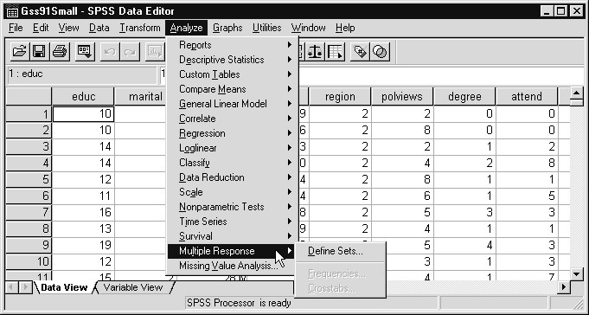
Notice that of the three choices on the Multiple Response menu, only one is active (Define Sets). The other two (Frequencies, Crosstabs), which produce the summary tables, will only become active after you define a set of variables that constitute the multiple response set.
3) Click Define Sets

Figure A.2 Define Multiple Response Sets Dialog Box
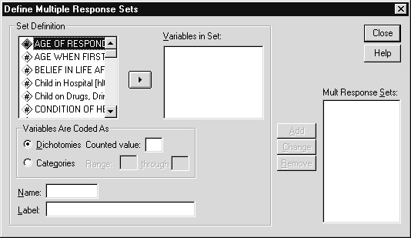
To define a multiple response set in SPSS we must supply three components: the list of variables that make up the set, the type of coding used, and a name. It is important to understand that SPSS does not create a new super-variable in the Data Editor to store the information from the set. Instead, when the set name is used within the Multiple Response procedure, SPSS substitutes the constituent variables. SPSS will not store the set definition in an SPSS data file if the file is saved after the set definitions are completed (although multiple response sets defined within the Tables option are retained).
We begin by defining a multiple response set for the group of four “Problems faced” variables.
- Click on prob1, then shift-click on prob4 in the Set
Definition list box to select prob1 to prob4
- Click the arrow to move prob1, prob2, prob3, prob4 into the Variables in Set list box
- Click the Categories option button in the Variables Are Coded As area.
We must now supply the range of data codes (from the prob variables) that we wish displayed in analyses. Recall the prob variables are coded 1 through 7. If we didn’t remember, we could have clicked with the right mouse button on any of the prob variables and obtained a variable information box that includes a drop-down list of value labels.
- Click in the text box to the right of Range: and type 1
- Click in the text box to the right of through and type 7
Finally we assign a name to the set and add an optional label. The multiple response set name is limited to 7 characters because, as we will see, SPSS adds a $ prefix to the set name in order to distinguish it from an ordinary variable name.
- Click in Name text box and type probs
- Click in Label text box and type Problems Faced in Last Year

Figure A.3 Supplying Multiple Response Set Information
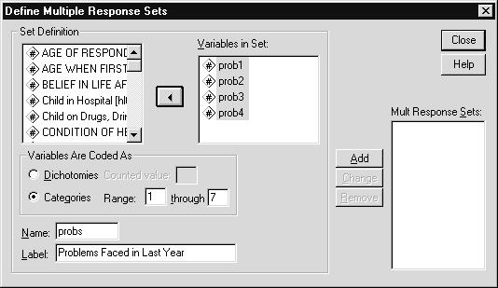
We have provided all the information necessary to define a multiple response set. If an error is discovered it can be corrected now, or the set definition can be changed later. To process the set:
11) Click the Add pushbutton

Figure A.4 Completed Multiple Response Set Definition
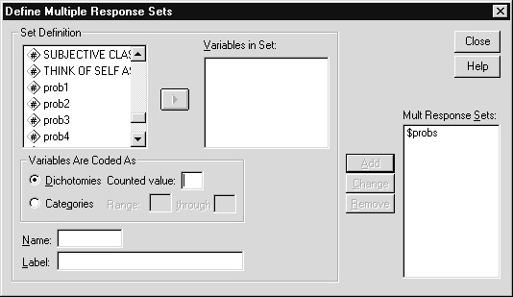
Notice that the set name $probs now appears in the Multiple Response Sets list box. As mentioned before, the $ prefix distinguishes the set name from an ordinary SPSS variable name (which cannot begin with a $). We could close this dialog box and proceed to analyses, but instead will define the second group of questions (health matters) as a multiple response set.
DEFINING A  MULTIPLE RESPONSE SET:  DICHOTOMOUS ITEMS | To define a group of related checklist type variables as a multiple response set, we follow the same steps as we did in the last section. The only difference will be our declaration that the variables are coded as dichotomies and then specifying the value that should be counted as a positive response (here 1-meaning yes).
- Move the following variables into the Variables in Set: list box
Ill Enough to go to the Doctor [hlth1]
Counseling for Mental Problems [hlth2]
Infertility, Unable to Have a Baby [hlth3]
Drinking Problem [hlth4]
Illegal Drugs (Marijuana, Cocaine) [hlth5]
Partner (Husband, Wife) in Hospital [hlth6]
Child in Hospital [hlth7]
Child on Drugs, Drinking Problem [hlth8]
Death of a Close Friend [hlth9]
- Click Dichotomies option button in the Variables Are Coded As area
- Click in the Counted Value text box and type 1
For these questions, a yes response was coded 1, which is what we wish to count. If we wanted to see the percent of those responding “No” in the summary tables, we would specify 2 as the Counted Value.
- Click in Name text box and type hlth
- Click in Label text box and type Health Problems in Last Year

Figure A.5 Completed Multiple Response Set for Dichotomous Variables
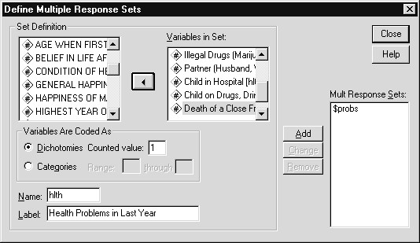
- Click Add pushbutton to add hlth to the Multiple Response
Sets list box
- Click Close pushbutton to process the multiple response sets
The multiple response set declarations will be in effect until you open a different data file or exit SPSS. They are stored in the Data Editor but are not retained in a saved SPSS data file. You can use the Paste pushbutton in the Multiple Response Frequencies or Crosstabs dialog boxes to create command syntax that can be used later. Note that multiple response sets defined using the SPSS Tables option are saved in an SPSS data file.
FREQUENCY  TABLES USING  MULTIPLE  RESPONSE VARIABLES | We will now run basic frequency analyses using the multiple response sets.  1) Click Analyze..Multiple Response

Figure A.6 Multiple Response Menu After Sets Are Defined
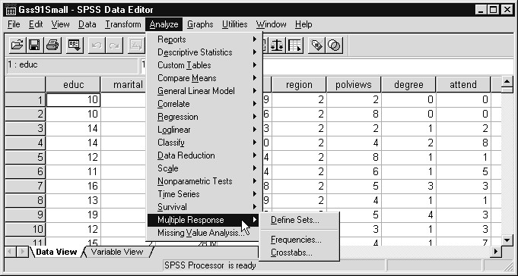
The Frequencies and Crosstabs menu choices are now active, since there are multiple response sets that can be analyzed.
- Click Frequencies
- Control-click on Problems Faced in Last Year [$probs] and Health Problems in Last Year [$hlth] to select them
- Click right arrow to move Problems Faced in Last Year
[$probs] and Health Problems in Last Year [$hlth] into Table(s) for: list box

Figure A.7 Multiple Response Frequencies Dialog Box
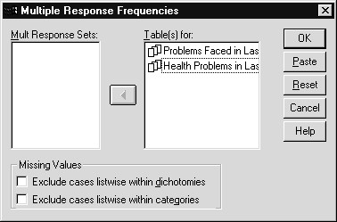
Notice that only the multiple response sets are available in the list box. The missing value options can be used to exclude cases that have one or more missing values for the variables in the response set. This option is typically used when every question should be answered. We will not invoke the option because any respondent with fewer than four important problems will have missing values for one or more of the prob variables.
- Click OK to run the analysis
- Click the Text Output item under Multiple Response in the
Outline pane of the Viewer window

Figure A.8 Multiple Response Frequency Table: Problems Faced by Respondent
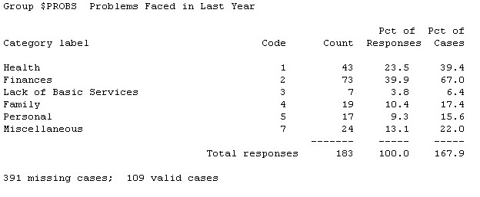
A single table appears based on responses to the four variables (prob1 to prob4). Note that in the current version of SPSS the table is formatted as text output and not a pivot table. The Count column indicates how many respondents mentioned each problem. Finances is the most commonly mentioned problem. The Pct of Responses column tells us what percentage of the total number of problems mentioned is contained in each category. The Pct of Cases is usually the percentage of interest, since it indicates what percentage of the respondents (who had at least one problem) had problems of each given type. Looking at the totals below the table we see there were 109 valid cases (or respondents who reported at least one problem). The sum of the Count column is 183 which, when compared to 109 respondents, indicates that some respondents mentioned multiple problems.
Notice also that there are 391 missing cases, that is, respondents who mentioned no problems. It is important to note that these individuals are excluded from the table and the percentage calculations. Thus if we look at the Pct of Cases column for the first problem (health) we see that 39.4 percent of those who mentioned some problem cited health problems. Thus no summary in this table tells us what percentage of the 500 respondents mentioned health problems. If you wish to see this percentage, we discuss how to obtain it in the section on Handling Nonresponses.
7) Scroll down in the Contents pane to the table of Health
Problems in Last Year

Figure A.9 Multiple Dichotomy Frequency Table: Health Problems
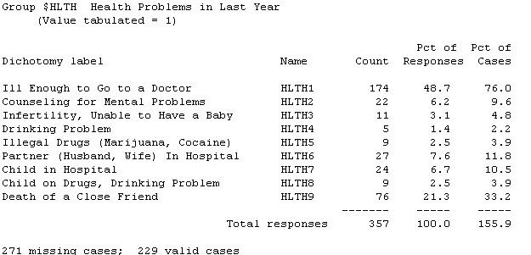
The most commonly cited health matter was illness that required a visit to the doctor. A total of 357 health matters were mentioned by 229 respondents (229 valid cases). The Pct of Responses column tells us what percentage of the total mentions of health matters was attributed to each specific issue. The Pct of Cases column displays the percentage of respondents (who mentioned at least one health matter) who mention each health matter. Once again, if a respondent experienced none of these health matters, he/she would not appear in the table. If one of the questions were “No health problems”, then inclusion of it would result in those experiencing no health problem appearing in the table and being included in percentage statistics.
CROSSTAB  TABLES WITH  MULTIPLE  RESPONSE VARIABLES | Multiple Response Sets can be part of crosstabulation tables involving other Multiple Response Sets or regular SPSS variables. We will produce a crosstab table relating problems faced in last year ($probs multiple response set) and self-reported social class (class).  1) Click Analyze..Multiple Response..Crosstabs
- Click Problems Faced in Last Year [$probs], then click arrow beside Row(s) list box
- Click Subjective Class Identification [class], then click arrow beside Column(s) list box
Notice that two question marks in parentheses appear after class in the Column(s) list box. The Multiple Response Crosstabs procedure requires that you use the Define Ranges pushbutton to specify the minimum and maximum values you want displayed for any ordinary SPSS variables used in the table. Also, notice that gender does not appear on the variable list of Multiple Response Crosstabs; it only accepts numeric variables, although you can use Transform..Autorecode to create a numeric form of gender.
- Click Define Ranges pushbutton
- Click in Minimum text box and type 1
- Click in Maximum text box and type 4

Figure A.10 Multiple Response Crosstabs Dialog Box with Range Subdialog Box
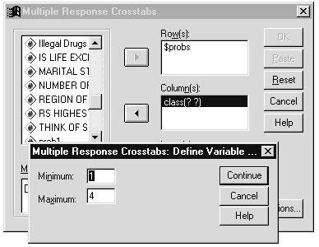
If we didn’t know the range of values that self-reported social class (class) takes, we need only click on class using the right mouse button in order to obtain dictionary information about the variable.
- Click Continue, then click Options pushbutton
- Click Column Checkbox in Cell Percentages area

Figure A.11 Multiple Response Crosstabs: Options Dialog Box
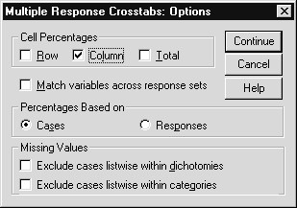
As we saw in the regular Crosstabs procedure, row, column and total table percentages can be obtained. Matching variables across response sets is a little-used option relevant when two multiple response sets are used in one table. More importantly, you must decide whether you want the percentages based on the number of cases (respondents) or on the number of responses. These correspond to the Pct of Cases and Pct of Responses columns in the Multiple Response Frequencies analysis covered earlier in this chapter. Note that only one of these percentage bases can be used in a multiple response crosstab table. The default is Cases, which is most often used because analysts want to state the percentage of respondents who make a specific choice. The Missing Values options are the same as in the Multiple Response Frequencies dialog box (discussed earlier).
- Click Continue to process the options
- Click OK to run the crosstab table
- Click the last Text Output item in the Outline pane.

Figure A.12 Multiple Response Crosstab Table
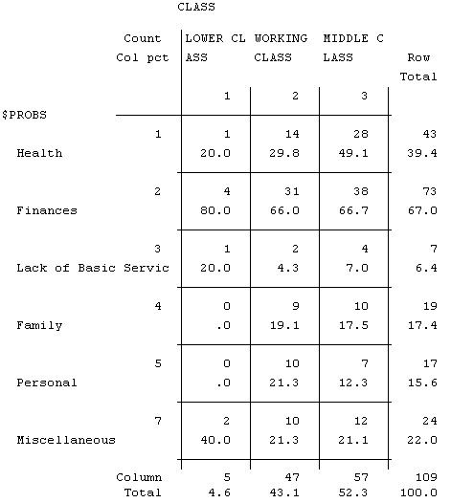
The crosstabulation table relates self-reported social class to problems faced in the last year. Recall that a respondent must have mentioned at least one problem to be included in the table. Looking at the first column (lower class) we see that one respondent of five, (Column total) or 20% mentioned Health problems. Notice there is no column for the upper class: no problems were reported for that group (we know from earlier chapters that this subgroup is very small). Given the small number of respondents in each class (see Column totals at the bottom of the table), we will not try to interpret the results. Nonetheless, we have demonstrated how you can create a single crosstab table in which one of the dimensions is based on a set of related variables.

HANDLING  NONRESPONSES  SUMMARY | For both types of multiple response sets (multiple response, multiple dichotomy), SPSS will exclude from summary tables those respondents who fail to give a positive answer to at least one of the variables in the set. Thus someone who did not report any problems (or health matters) would not appear in frequency or crosstab tables involving the $probs (or $hlth) multiple response set. The implication of this is that the base on which percents are calculated may not be the entire sample. This action is reasonable if you consider that percentages can be based on the total number of responses (for example, the total number of problems mentioned). For these percentages we should ignore those who do not respond.  This potential problem (exclusion of those who make no positive response) is avoided by allowing respondents to make a “none of the above” type choice and providing a code for it. In the $probs set, a respondent who reported no problems (those who had missing values on Prob1 through Prob4) could be assigned a new code (8) indicating “no problems” for the prob1 variable. SPSS would then include those with “no problems” in the base from which Pct of Cases is calculated. Similarly, for the $hlth set a new checklist question “no health matters” could be added, or you could use the Transform menu to create a new variable “None” coded 1 (Yes) if the respondent failed to give a yes (1) response, yet did respond to the hlth questions (one definition of "respond to the hlth questions" could be that the respondent answered yes (1) or no (2) to at least one of the hlth variables). (Hint: to do this, the Count transform can be run twice (click Transform..Count) in order to count the instances of 1s or 2s across the hlth variables for each respondent, and a Compute statement can set a new variable NONE to 1 or 0 based on the values of the count variables). The inclusion of this “None” variable in the set would force those not reporting any health matters to appear in the table and be included when case percentages are calculated. However, if you include such a “none” variable, be wary of using the Pct of Responses summary, since each “none” response is counted along with all the positive answers.  Ultimately you must decide the type of percentage summaries that provide meaningful answers to questions you have formulated. This section outlines the issues and describes the alternatives.  In this chapter we reviewed the Multiple Response procedure, which is used to create a single summary table of counts and percents, based on several variables that contain responses to one question.

Appendix B Coding of General Social Survey 1991 Questions
The General Social Survey is an interview study, so the respondents answer questions posed to them by an interviewer. As such, the General
Social Survey Codebook (General Social Surveys, 1972-1993: Cumulative Codebook, 1993) contains instructions to the interviewer, and not the questions as they would be worded in a self-administered survey. Below we present a collection of questions as they might appear as part of a mail survey, but it is important to stress that this is not how the General Social Survey is conducted. The purpose of this description is to provide you with an understanding of the content of the questions. The question itself appears, followed by information about its definition in SPSS.
The General Social Survey is administered to a noninstitutionalized US adult sample of about 1,500 individuals and is performed by the National Opinion Research Center (NORC) at the University of Chicago. The thirty-five or so data fields below represent a small subset of the questions asked in the General Social Survey. Also, the file used in the course is based on a random sample of 500 respondents taken from the full (about 1,500) sample.
Below each numbered question appears the SPSS variable name and the variable label. Next comes a list (if any) of the values declared missing. Finally the value labels appear beside the codes they label. The letter “M” next to a data value indicates the value has been declared missing for that variable.
- What is the highest grade in school that you finished and got creditfor?
EDUC HIGHEST YEAR OF SCHOOL COMPLETED
Missing Values: 97, 98, 99
Value Label
  - M NAP
  - M DK
  - M NA
- What is the highest educational degree you have received?
Less than high school High school Junior college Bachelor’s degree Graduate degree Don’t know
DEGREE RS HIGHEST DEGREE
Missing Values: 7, 8, 9
Value Label
  - LT HIGH SCHOOL
  - HIGH SCHOOL
  - JUNIOR COLLEGE
  - BACHELOR
  - GRADUATE
  - M NAP
  - M DK
  - M NA
3)Are you currently?
Married Widowed Divorced Separated
Never been married
MARITAL MARITAL STATUS
Missing Values: 9
Value Label
  - MARRIED
  - WIDOWED
  - DIVORCED
  - SEPARATED
  - NEVER MARRIED 9 M NA
4)If ever married, how old were you when you first married?
AGEWED AGE WHEN FIRST MARRIED
Missing Values: 0, 98, 99
Value Label
0 M NAP
  - M DK
  - M NA
- Gender?
Female Male
GENDER Respondent’s Gender
Missing Values: (a single blank)
Value Label
F Female M Male
- What was your age at your last birthday?
AGE AGE OF RESPONDENT
Missing Values: 0, 98, 99
Value Label
    - M DK
    - M NA
- Which region of the country do you live in?
New England Middle Atlantic East North Central
West North Central South Atlantic East South Central West South Central Mountain Pacific
REGION REGION OF INTERVIEW
Missing Values: 0
Value Label
    - M FOREIGN
    - NEW ENGLAND
    - MIDDLE ATLANTIC
    - E. NOR. CENTRAL
    - W. NOR. CENTRAL
    - SOUTH ATLANTIC
    - E. SOU. CENTRAL
    - W. SOU. CENTRAL
    - MOUNTAIN 9 PACIFIC
- Where would you place yourself on this scale of political views?
Extremely Liberal Liberal Slightly Liberal Moderate
Slightly Conservative Extremely Conservative Don’t Know
POLVIEWS THINK OF SELF AS LIBERAL OR CONSERVATIVE
Missing Values: 0, 8, 9
Value Label
    - M NAP
    - EXTREMELY LIBERAL
    - LIBERAL
    - SLIGHTLY LIBERAL
    - MODERATE
    - SLGHTLY CONSERVATIVE
    - CONSERVATIVE
    - EXTRMLY CONSERVATIVE
    - M DK
    - M NA
- How often do you attend religious services?
Never Less than once a year About once or twice a year
Several times a year 2-3 times a month Nearly every week Every week Several times a week Don’t know
ATTEND HOW OFTEN R ATTENDS RELIGIOUS SERVICES
Missing Values: 9
Value Label
    - NEVER
    - LT ONCE A YEAR
    - ONCE A YEAR
    - SEVRL TIMES A YR
    - ONCE A MONTH
    - 2-3X A MONTH
    - NRLY EVERY WEEK
    - EVERY WEEK
    - MORE THN ONCE WK 9 M DK,NA
- If you have a religious preference, do you believe there is a life afterdeath?
Yes No Undecided
POSTLIFE BELIEF IN LIFE AFTER DEATH
Missing Values: 0, 8, 9
Value Label
    - M NAP
    - YES
    - NO
    - M DK
    - M NA
- Taken all together, how would you say things are these days— wouldyou say that you are
Very happy Pretty happy Not too happy Don’t know
HAPPY GENERAL HAPPINESS
Missing Values: 0, 8, 9
Value Label
    - M NAP
    - VERY HAPPY
    - PRETTY HAPPY
    - NOT TOO HAPPY
    - M DK
    - M NA
- If you are currently married:
Taking things all together, how would you describe your marriage? Would you say that your marriage is
Very happy Pretty happy Not too happy Don’t know
HAPMAR HAPPINESS OF MARRIAGE
Missing Values: 0, 8, 9
Value Label
    - M NAP
    - VERY HAPPY
    - PRETTY HAPPY
    - NOT TOO HAPPY
    - M DK
    - M NA
- Would you say your own health, in general, is
Excellent Good Fair Poor
HEALTH CONDITION OF HEALTH
Missing Values: 0, 8, 9
Value Label
    - M NAP
    - EXCELLENT
    - GOOD
    - FAIR
    - POOR
    - M DK
    - M NA
- In general, do you find life?
Exciting Pretty routine Dull No Opinion
LIFE IS LIFE EXCITING OR DULL
Missing Values: 0, 8, 9
Value Label
    - M NAP
    - EXCITING
    - ROUTINE
    - DULL
    - M DK
    - M NA
- If married, what is the highest grade in school that your spousefinished and got credit for?
SPEDUC HIGHEST YEAR SCHOOL COMPLETED, SPOUSE
Missing Values: 97, 98, 99
Value Label
    - M NAP
    - M DK
    - M NA
- What is the highest grade in school that your mother finished and gotcredit for?
MAEDUC HIGHEST YEAR SCHOOL COMPLETED, MOTHER
Missing Values: 97, 98, 99
Value Label
    - M NAP
    - M DK
    - M NA
- What is the highest grade in school that your father finished and gotcredit for?
PAEDUC HIGHEST YEAR SCHOOL COMPLETED, FATHER
Missing Values: 97, 98, 99
Value Label
    - M NAP
    - M DK
    - M NA
- Of the following social classes, which would you say you belong in?
Lower Working Middle Upper No Class
Don’t know
CLASS SUBJECTIVE CLASS IDENTIFICATION
Missing Values: 0, 8, 9
Value Label
    - M NAP
    - LOWER CLASS
    - WORKING CLASS
    - MIDDLE CLASS
    - UPPER CLASS
    - NO CLASS
    - M DK
    - M NA
- How many children have you ever had?
None One Two Three Four Five Six Seven
Eight or more
CHILDS NUMBER OF CHILDREN
Missing Values: 9
Value Label
    - EIGHT OR MORE
    - M NA
- On the average day, about how many hours do you personally watchtelevision
_____ hours Don’t know
TVHOURS HOURS PER DAY WATCHING TV
Missing Values: -1, 98, 99
Value Label
-1 M NAP
    - M DK
    - M NA
21-24) What are the most important problems that you and members of your household have had during the last 12 months?___________________ _________________________________________________________________________________
_________________________________________________________________________________
PROB1
Value Label
    - Health
    - Finances
    - Lack of Basic Services
    - Family
    - Personal
    - Legal
    - Miscellaneous
PROB2 PROB2, PROB3 AND PROB4 used same value labels as
PROB3 PROB1
PROB4
27-35) Thinking about health-related matters, did any of the following happen to you since February/March 1990?
Ill enough to go to a doctor
Counseling for Mental Problems
Infertility, Unable to Have a Baby
Drinking Problem
Illegal Drugs (Marijuana, Cocaine)
Partner (Husband, Wife) In Hospital
Child in Hospital
Child on Drugs, Drinking Problem Death of a Close Friend
HLTH1 Ill Enough to Go to a Doctor
Missing Values: 0, 9
Value Label
- M NAP
- Yes
- No
- DK
- M NA
HLTH2 Counseling for Mental Problems (HLTH2 through HLTH9 use the
HLTH3 Infertility, Unable to Have a Baby same codes as HLTH1)
HLTH4 Drinking Problem
HLTH5 Illegal Drugs (Marijuana, Cocaine)
HLTH6 Partner (Husband, Wife) in Hospital
HLTH7 Child in Hospital
HLTH8 Child on Drugs, Drinking Problem
HLTH9 Death of a Close Friend

Appendix C  Multiple Dichotomy | Sample Questions  This appendix contains several sample survey questions which illustrate such characteristics as missing responses (don't know, not applicable), multiple dichotomy questions, and multiple response questions.  Which of the following magazines do you read regularly?
TimeU.S. News

Question
PeopleThe Economist
NewsweekNational Geographic
FortuneMoney
Multiple  Response  Question Missing Values | What do you like about your current job? ______________________  ________________________________________________________________  ________________________________________________________________ ________________________________________________________________  Coding Scheme  - Salary  - Benefits  - People I work with  - Flexible Hours  - Convenient Commute  - Opportunity for Advancement  - Interesting Work  - Child Care  - Other  (99) Nothing  If you have ever been married, at what age were you first married? ___
Never Married
Don't Know
When you called for service, were you given an estimate of how long it would take to resolve the problem?
Yes
No
Don't Remember
Sample Questions C - 1

Sample Questions C - 2

Appendix D  TOPICS | Adding Labels and Missing Value Codes in SPSS 9.0  Entering Variable Information in SPSS 9.0  Adding Variable Labels  Measurement Level  Entering Value Labels for a Variable  Treating Data Values as Missing Information  Other Differences
INTRODUCTIONn SPSS 10.0, variable and value labels, formats, measurement type
I
and missing values are entered through the Variable View tab sheet in the Data Editor window. In earlier versions of SPSS, these
operations were performed in the Define Variable dialog box (click Data..Define Variable from the Data Editor window). In these earlier versions the Data Editor contained a single sheet and not the two tab sheets (Data View, Variable View) that exist in SPSS 10.0.
This appendix is added for those using an earlier version of SPSS (pre SPSS 10.0). It assumes that you have already read through Chapter 5 of this course guide, which contains a description and discussion of the use of variable labels, value labels and missing values. Here, we simply describe how such information is entered in SPSS 9.0.

ENTERING  VARIABLE  INFORMATION IN SPSS 9.0 | Neither variable labels nor value labels are required to run statistical analyses with SPSS. However, these labels add identifying information to the SPSS output, which is especially useful if others are to view these results. The table below contains labeling information about the General Social Survey variables that were defined in Chapter 4. We will add a few of these labels to the SPSS data file. Note that some of the codes represent missing information (Don’t Know, No Answer). Later in the chapter we will discuss how to inform SPSS that these data codes signify missing data.  Table 5.1 Labeling Information for Several General Social Survey 1991
 | Variables  Question Description  Education Education in Years  Marital Status Respondent’s Marital Status |  | Data Codes  1= one year, etc.  98=Don’t Know  99=No Answer  1=Married  2=Widowed  3=Divorced  4=Separated  5=Never Married  9=No Answer  18= 18 years, etc. 0=Not Applicable  98=Don’t Know  99=No Answer  F=Female M=Male  21= 21 years, etc. 98=Don’t Know  99= No Answer  1=Very Happy  2=Pretty Happy  3=Not Too Happy  8=Don’t Know  9=No Answer
 | Age Wed  Gender  Age  Happiness | Age First Married  Respondent’s Gender  Age in Years  In General How Happy are You?
We will use the information in the Description column to provide variable labels, and that in the Data Codes’ column to supply value labels and missing values.
Note: We need not perform this step if the data from Chapter 4 still reside in the SPSS Data Editor window.
At the end of the last chapter we saved an SPSS data file containing responses to several questions from the General Social Survey of 1991. Reading an SPSS data file is very easy; you simply:
- Click File..Open from the main menu
If needed, move to the Basewin10 folder (within the c:\ Train folder).
- Click on the up-one-level tool until you reach to top level of the hard drive
- Double click on the Train folder in the Folder window
- Double click on the Basewin10 folder in the Folder window Check the Files of type specification; if necessary, change to SPSS.
- Click the Files of type drop-down arrow
- Select SPSS (.sav) on the Files of Type list (if necessary)
- Double-click Chapt4 in the Folders window to select it

Figure D.1 General Social Survey Data in Data Editor window
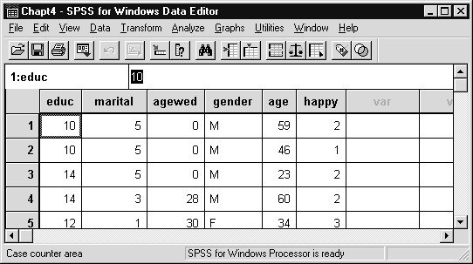
ADDING  VARIABLE LABELS | Note that in SPSS 9.0 the Data Editor contains a single sheet. As we have seen in earlier chapters within this guide, in SPSS 10.0 the Data  Editor contains two tab sheets: Data View sheet and Variable View sheet. Variable information entered in the Variable View sheet in SPSS 10.0 will be entered via the Define Variable dialog in SPSS 9.0, as wel will see below.
Now that the data are available in SPSS for Windows, we will add labels. We can proceed directly to statistical analyses, but as mentioned earlier, labels will aid output interpretation.
To demonstrate how to add variable labels, we will supply the label “Marital Status” for the variable marital. From within the Data Editor window:
- Click marital to select the variable
- Click Data..Define Variable
We could have reached the Define Variable dialog box directly by double clicking on marital in the Data Editor window.

Figure D.2 Define Variable Dialog box
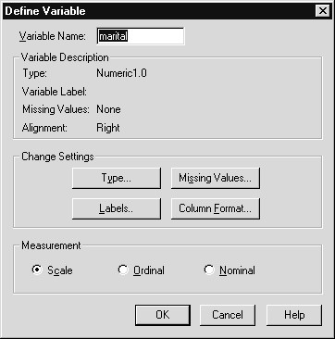
Notice that the contents of the Variable Name text box, here “marital,” are highlighted. We can change the variable name itself by typing in a new (up to 8 character) variable name. The Variable description area tells us that marital is a numeric variable with a numeric format one column wide (1) that will display to zero (.0) decimal places. There is no Variable Label; we will add one shortly. The Missing Values row records whether any data codes represent missing information for the marital variable; there are none. Finally, Alignment indicates how data values are displayed in the Data Editor window.
MEASUREMENT LEVEL | The measurement area permits you to supply the measurement type for the variable. Choices include scale (numeric interval and ratio scales, for example income in dollars), ordinal (a scale based on ordered categories, for example a 1 to 5 rating of degree of belief in an afterlife), and nominal (categorical). Choosing the appropriate measurement type is useful as a reminder when later running statistical analyses, and certain SPSS procedures (Interactive Graphs and SPSS AnswerTree) make use of this information. See Chapter 6 for more detail on level of measurement and choice of statistics.  Since marital status values represent separate categories (1 = married, 2 = widowed, etc.), we declare its measurement type as nominal.
- Click Nominal option button in the Measurement area
You can modify any of these aspects of the variable by choosing the appropriate pushbutton in the Change Settings area. To supply a variable label:
- Click Labels pushbutton in Change Settings area
We can now enter our variable label (most SPSS procedures support 256 character labels; those producing text output instead of pivot tables may only display 40-character labels) in the Variable Label text box.
- Type Marital Status in the Variable Label text box

Figure D.3 Define Labels Dialog Box
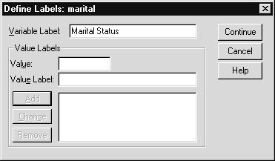
The label can be edited within the text box. Typically you would supply the desired variable and value labels for a variable at the same time, but we will treat them in separate sections of this chapter. To process the label:
5) Click Continue pushbutton

Figure D.4 Define Variable Dialog Box Showing Variable Label
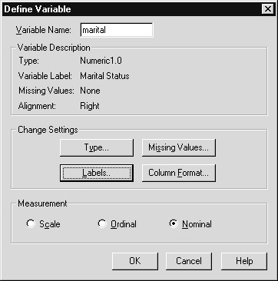
The variable label now appears in the Variable Label row of the Variable Description area. For a long label only the first part will be visible. Notice that the measurement type is now set to nominal.
6) Click OK pushbutton to store the label and measurement type
The variable label we just supplied will appear as part of the output for analyses involving the marital variable. We will see this later in the chapter.
ENTERING  VALUE LABELS FOR A VARIABLE | Recall that value labels are labels assigned to actual data values. We will demonstrate how to supply value labels for a numeric variable by entering labels for the five marital status codes (see Table 5.1 for the data values and labels). We could have provided these labels during the previous task while we had the Define Labels dialog box open. However, we will simply return to the Define Labels dialog box for the marital variable.
- Double click on marital in the Data Editor window
(alternatively, click on marital to select it, then click Data..Define Variable)
- Click Labels pushbutton
- Click in Value text box
- Type 1
- Click in Value Label text box (or press the Tab key)
- Type Married

Figure D.5 Adding a Value Label
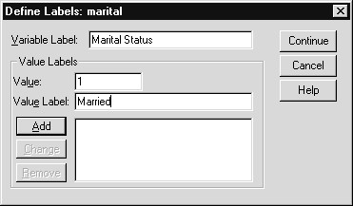
The value label “Married” will be associated with value 1 of the marital variable. At this point we can change either the value or label if corrections are necessary.
7) Click Add pushbutton to add the label to the list box

Figure D.6 Value Label Added to List
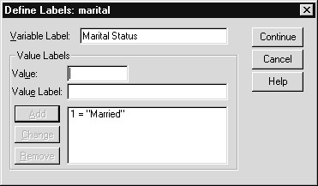
Once a label has been added to the list, we can move on to the next label. You can remove a label by clicking on it in the list box, then clicking the Remove pushbutton. Labels can be modified by clicking on the label in the list box (at which point its value and value label will appear in the appropriate text boxes), making the corrections, and clicking the Change pushbutton. We will continue to add the remaining value labels for marital.
- Click in Value text box and type 2
- Click in Value Label text box (or press Tab key) and type
Widowed
- Click Add pushbutton
- Click in Value text box and type 3
- Click in Value Label text box (or press Tab key) and type
Divorced
- Click Add pushbutton
- Click in Value text box and type 4
- Click in Value Label text box (or press Tab key) and type
Separated
- Click Add pushbutton
- Click in Value text box and type 5
- Click in Value Label text box (or press Tab key) and type
Never Married
- Click Add pushbutton

Figure D.7 Completed Define Labels Dialog Box
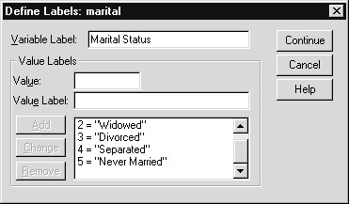
As we added the last label, a scroll bar appeared in the Value Labels list box. In this way, many value labels can be entered for a variable. You can use the Tab key to switch from the Value text box to the Value Label text box. Remember that since the Continue pushbutton is shaded, pressing the Enter key will invoke the Continue function and will not advance you to the next text box.
- Click Continue pushbutton to process the value labels
- Click OK pushbutton to store the labels
To quickly demonstrate that the MARITAL variable does contain labels, we will display the value labels in the Data Editor Window.
- Click the Display Value Labels tool button and place cursor above marital (alternatively, click View..Value Labels to check Value Labels)

Figure D.8 Data Editor Window with Value Labels Displayed
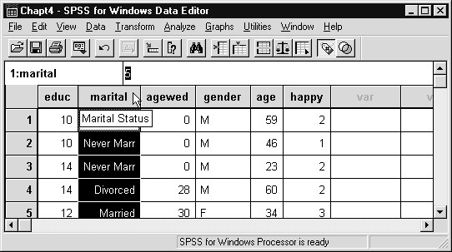
The variable and value labels for marital are now displayed in the Data Editor window. Similarly, these labels will appear in the output from statistical analyses that display the marital status categories.
23) Click the Display Value Labels tool button again to turn off display of Value Labels
Notice that after originally clicking the Display Value Labels tool button, it appeared depressed; after clicking it the second time (turning off the display) it again appears flush with other tool buttons.
TREATING DATA  VALUES AS  MISSING INFORMATION | For numeric variables, a blank data field or a data value that is not a valid number is automatically converted to a missing value by SPSS. This missing value, called system missing because the SPSS system  automatically makes it missing, is represented by a period (.) in the Data Editor window. In addition, system-missing values are excluded from statistical calculations within SPSS.
Surveys often let respondents choose “Don’t Know” or “None of the Above” as answers to questions. If codes for these responses are entered into the data file, you may want to exclude them from tables and statistical summaries. In engineering, physical and biological sciences, some automatic recording devices record a data value containing all 9s (for example, 999999) when the measurement fails for some reason. In all these instances SPSS provides a way to treat these data values as if they were missing. Also, for string variables, blank fields constitute valid values and must be declared as missing values if they are to be excluded from analyses. Up to three missing-value codes can be declared for each variable (and two of these can define a range of missing values). The reason for allowing three missing codes is to accommodate the most common reasons given for missing data in survey work: not applicable, don’t know, refuse to answer.
Missing values are defined in SPSS for Windows using the Define Variable dialog box, which can be reached by double clicking on the desired variable name in the Data Editor window, or by clicking on the variable name to select it, then clicking Data..Define Variable. To demonstrate how to declare missing values for a numeric variable, we will use the agewed (age when first married) variable. Referring to Table 5.1, agewed is recorded in years and there are three missing value codes. Zero (0) indicates the question is not applicable (the respondent has never been married), 98 represents a “Don’t Know” response (unlikely, but possible: perhaps it was several weddings back), and 99 indicates that no answer was recorded (refusal or not recorded). To declare these data values missing in SPSS we again start from the Data Editor window:
- Double-click on agewed
- Click Missing Values pushbutton

Figure D.9 Define Missing Values Dialog Box
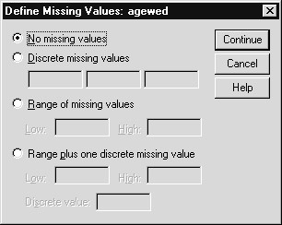
By default, the “No missing values” option button is selected. This does not imply that there are no missing values for agewed in the data, but rather that no data value has been designated as representing missing information. The second choice, “Discrete missing values” is the most commonly used choice. Here you can specify up to three distinct (discrete) missing value codes for the variable. The next option button, “Range of missing values”, allows you to give a range of values that will be treated by SPSS as missing. Finally, the “Range plus one discrete missing value” jointly declares that a range of values, plus one specific value, represent missing information. These choices result in considerable flexibility in defining missing values, especially when you consider that the values declared missing can be different for each variable.
- Click Discrete missing values option button
- Type 0 in the first text box below the Discrete missing values option button
- Click in 2nd text box (or press the Tab key) and type 98
- Click in 3rd text box (or press the Tab key) and type 99

Figure D.10 Completed Define Missing Values Dialog Box
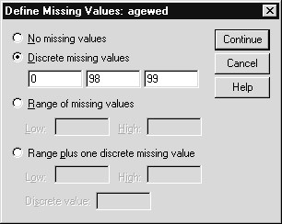
Any typing errors can be edited by clicking in the relevant text box and changing the data value. If you later want to turn missing value declaration off, return to this dialog box and click the “No missing values” option button.
7) Click Continue to process the missing values

Figure D.11 Missing Values Displayed in Define Variable Dialog Box
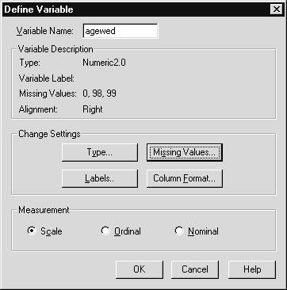
Notice that the list of declared missing values appears in the Variable Description section of the Define Variable dialog box. It would be useful to supply value labels for the missing value codes; how would someone reading the results know what a zero means for age first married? However, we will not enter such labels at this point.
8) Click OK to store the missing values
Now analyses involving agewed will exclude the missing values from statistical calculations. Some procedures, like Frequencies, which we will see later in this chapter, will tabulate how many occurrences of each missing code exist in the data.
Analyses will now reflect the the labels and missing values we supplied. If the data in the Data Editor is saved (File..Save As or File..Save) after changes are made in the Define Variable dialog, then these changes (dictionary changes) are saved with the data in the SPSS file (*.sav).
OTHER DIFFERENCES | There are other differences you will notice between SPSS 9.0 and SPSS 10.0 as presented in this course. To enter labels once and then apply them to many variables is done via a copy and paste operation in SPSS 10.0 (see Chapter 11), but SPSS 9.0 used the Template dialog (click Data..Template from the Data Editor window) to accomplish this. Also, to access files in SPSS 9.0 you would choose File..Open and use the Files of  Type drop-down menu to select a file type (for example, SPSS (*.sav). In SPSS 10.0, the file type appears as a File..Open submenu choice (for example, File..Open..Data). In addition, SPSS Server was first released with SPSS 10.0, so the File..Switch Server menu choice is not available in SPSS 9.0.

Hands-on Exercises
BACKGROUND  FOR BANK DATA  FILE  Data Location  Chapter 2 | The data file used for exercises contains demographic, salary and job information on the employees of a Midwestern bank around 1965. We are interested in understanding the employees in terms of demographics (gender, minority status, education) and employment measures (job position and beginning salary). In addition, we want to look at relations between demographics and beginning salary. Finally we want to represent our findings graphically. You are not expected to perform the definitive study on this data, but rather make a start in terms of describing these people and take a preliminary look at how the measures interrelate.  The data are stored as a fixed ASCII text file. In the course of performing the exercises you will read this data, supply labels and missing values, perform several statistical analyses, modify the data, and create several charts.  Some of the exercises are marked For those with extra time. If you have completed the regular exercises and wish to try some advanced variations, please avail yourself of them. It is not necessary to perform these advanced exercises in order to fulfill the goals of this course.  All data files are located in the directory c:\ Train\ Basewin10. They should be copied from the accompanying 3.5 floppy disk to this directory if you are not working at an SPSS training site.  Help and Output Navigation
This exercise does not involve the bank study per se, but explores the Help system within SPSS for Windows.
- Start SPSS for Windows by clicking Start..Programs..SPSS forWindows..SPSS 10.0 for Windows.
- Examine the SPSS Help system (using Help..Topics). Choose a topic or two of interest to you under Frequently asked Questions and review the information.
- Return to the Help Contents sheet (use Contents button). Choose theGallery of all Chart Types topic in the Graphical Analysis section. Return to the Help Contents sheet and investigate one other topic that is of interest to you. Exit the Help system by clicking the close box .
- For those with extra time: Investigate the Index sheet under the Help system which enables you to obtain immediate help on specific topics. Exit the Help system when finished.
Chapter 4  Chapter 5 | Entering and Reading Data  Here we want to read the data file (BWBANK.DAT stored in c:\ Train\ Basewin10 into SPSS for Windows and inspect the results in the Data Editor window.  - Use the Text Import Wizard (click Read Text Data...) under the File menu to open the file BwBank.dat. This is a fixed-column ASCII text file containing salary and job information on employees of a Midwestern bank from about 1965.  - Assign the names listed below to the variables using the Text Import Wizard Step 5 dialog box. All variables are numeric.  Variable Name Column Locations  id 1-4  salbeg 6-10 gender 12  jobtime 14-15 age 17-18 salnow 20-24 edlevel 26-27  workexp 29-33 (contains two decimal digits)  jobcat 35 minority 37  - Look at the first few cases in the Data Editor window. Confirm that all variables have numeric data values and that the values for such variables as age and edlevel (years of education) have realistic values.  - Save the data file under the name NEWBANK using the Save As choice on the File menu.  - For those with extra time: Do one of the following:  - A copy of the bank data strored as a table within an Access97  file named BwBank (.mdb). Read this file into SPSS. Note that an Access97 database driver must be installed on your machine and BwBank(.mdb) defined as a data source (see Chapter 4).  - A copy of the bank data stored as an Excel 97 spreadsheet file(with variable names in the first row) is contained in BwBank.xls. Read this file into SPSS.  Adding Labels and Missing Values
Here we wish to complete the definition of the bank data by adding variable and value labels, measurement levels, and defining missing value codes.
- Use the Variable View tab sheet in the Data Editor to add variable labels, value labels (where appropriate), measurement scale information, and missing values (where appropriate) for variables in the bank file. The labels and missing value codes are listed below. Note that not all variables have value labels and missing value codes.
Variable | Variable Label | Value | Missing
(Measurement Scale) |  | Labels | Value
id  (nominal) | Employee Code
salbeg  (scale) | Beginning Salary |  | 0
gender | Employee Gender | 0 Male | 9
(nominal) |  | 1 Female 9 Unknown
jobtime  (scale) | Months on the job |  | 0
age  (scale) | Employee Age |  | 0
salnow  (scale) | Current Salary |  | 0
edlevel (scale) | Educational Level (years) |  | 0
workexp  (scale) | Work Experience (years)
jobcat | Employment Category |  | 0
(nominal) | - Unknown  - Clerical
- Office Trainee
- Security Officer4 College Trainee
- Exempt Employee
- MBA Trainee
- Technical
minority | Minority Classification 9
(nominal) | - White  - Nonwhite  9 Unknown
- Run Frequencies on the labeled variables gender (employee gender) and jobcat (employment category).
- Save the file containing labels and missing values under the nameNEWBANK (same as before) using the Save As choice from the File menu.
For those with extra time: Add another case to the file to represent an employee of the bank in the mid-1960s. Save the file with this new case added.
Chapter 6  Chapter 7 | Examining Summary Data for Individual Variables  In this exercise we ask you to begin analyzing the bank data by producing some descriptive summaries on both the demographic and salary variables. These will provide summaries useful in describing the employees and serve as a check on the data values; for example, are the maximum and minimum values of education, age and current salary reasonable?  - Open the data file NEWBANK if you haven’t already done so.  - Run Frequencies on the variables jobcat (employment category),minority (minority classification), and gender (employee gender), requesting the mode, plus barcharts. Examine the bar charts to better understand the distributions of these variables. Which job category had the greatest number of employees, and which had the fewest?  - Run Frequencies for salbeg (beginning salary) and salnow (currentsalary), requesting summary statistics, and a histogram for each variable with a superimposed normal curve. Suppress the display of the frequency table. Do you think that salaries are normally distributed? If not, why?  - For those with extra time: Produce a frequency distribution of edlevel  (education level) showing the table in descending order of frequency (use the Format pushbutton). Modifying Data Values
In this section we will look at salary information in several different ways, which require some modification of the data. First we will group employees into several salary categories and see how many employees fall into each category. Next, we will study the difference between current and beginning salary across employees.
  - Open the data file NEWBANK(.sav) if you haven’t already done so.
  - Use Recode Into Different Variable under the Transform menu to create a new variable that groups salbeg (beginning salary) into 6 categories (call it salgrp). To decide which range of values to group together, you should look at the histogram or summary statistics from the exercise in Chapter 6. Alternatively, you can request Cut Points for 6 groups in the Percentile Values area under the Statistics pushbutton in the Frequencies dialog box to have SPSS provide endpoints for six approximately equal-sized groups. After the recode is complete, check your work by running frequencies of salgrp.
  - Use Compute under the Transform menu to create a new variable that contains the difference between current and beginning salary (salnow and salbeg).
  - Run Descriptives on this new variable to see summary information.Can you tell whether anyone has a current salary lower than their beginning salary? What was the largest salary change?
  - Save the modified data file as NEWBANK.
  - For those with extra time: Use the variables jobtime (months on the job) and workexp (work experience) to create a new variable that measures the total time (in months) each employee has been working. You need to change workexp from years to months to do this. Examine summary information on this new variable.
  - For those with even more extra time: Compute a new variable that divides the salary difference (see part 3 of this chapter’s exercises) by jobtime (months on the job). This will produce a salary difference adjusted for the number of months in the current job position. Run descriptive statistics on this new variable.

Chapter 8 Crosstabulation Tables
Here we explore the relationships among gender, minority status and salary category (created in exercises for Chapter 7) using crosstabulation tables. Specifically, are there higher proportions of women falling in the lower salary categories.
- Run a crosstabulation table of the variables gender (employee gender) and minority (minority classification) (click Analyze..Descriptive Statistics..Crosstabs)
- Create two crosstab tables of salgrp with each of the variables genderand minority. Display only column percentages. What is the relationship between salgrp and each of these variables?
- Produce a crosstab table of salgrp and gender with observed andexpected counts. Request the chi-square statistic to test for a relationship.
- Save the Contents of the Viewer window under the name Exer8 (Exer8.spo).
- For those with extra time: Examine the relationship between gender and jobcat (employment category). Request appropriate statistics to test whether the two variables are independent. What is the expected number of female security officers? Then try constructing a three-way crosstab table of gender, minority, and salgrp (hint: use salgrp as the row variable and minority as the layer variable). Does the relationship between gender and salary differ by minority status?
Chapter 9  Chapter 10 | Pivot Tables  We will modify the appearence of crosstab tables produced in the exercises for Chapter 8.  - Open the Exer8(.spo) Output Viewer file created in the last exercise.  - Edit the pivot table for the second crosstab in the Contents pane  (salgrp by gender with column percents). Transpose the Rows and Columns  - Modify the width of the first column (containing value labels) until itseems best to you.  - Change the title to one that you feel provides a better description of thetable.  - Apply several TableLooks to the table. Evaluate their strengths andweaknesses for the audience to whom you will be presenting your results.  - For those with extra time: Create a clustered bar chart from the column percentages in the crosstab table produce in the Chapter 8 (section 2) exercises.  Creating Charts
Here we produce presentation charts that display the results of what we discovered running frequency and crosstab analyses earlier.
- Create a pie chart showing the distribution of jobcat (employmentcategory) (use the Graphs..Pie menu to create a standard graph). Add a title to the chart and display both the counts and labels.
- Produce a simple bar chart using either standard or Interactive graphsthat displays the distribution of salary categories (salgrp).
- Create an Interactive graph that contains a clustered bar chartshowing the distribution of salgrp by gender. This displays the information appearing in the salgrp by gender crosstab table created in the exercises from Chapter 8.
- Change various aspects of the chart (orientation, fill color, fill pattern(style)). The quick method to begin is to double-click on the chart (which activates the Chart Editor).
- Create an Interactive graph that contains a scatterplot with beginningsalary on the horizontal axis and current salary on the vertical axis.
- Edit the scatterplot and add gender as a legend variable (you can useColor, Style or Size).
- Save the contents of the Viewer window in the current directory.
- For those with extra time: Create a scatterplot of beginning salary and current salary again, then ask for a regression line to be drawn through the points (add an element). Next, try changing the tickmarks or range of the axes (Axis under the Format menu, or from Chart Manager).
Chapter 11  Appendix A | Useful Features  These exercises do not directly advance the analysis of the bank data, but rather provide practice in features of SPSS that you will find useful.  - Open the NEWBANK(.sav) data file and create a pie chart based on jobposition. Open the SPSS.JNL file as a syntax window (click  File..Open..Syntax, then choose All Files (*.*) on the Files of Type: dropdown list). Review the commands (near the bottom of the file if the journal option was set to append). Locate the syntax command (Graph) that ran the pie chart, select it and run it. Now return to the syntax window, substitute the education variable for the job position variable and run the modified command.  - Click the Dialog Recall Box tool and review the SPSS for Windowsdialog boxes recently accessed. Click on one of the choices. Why are no variables selected for analysis (from the previous use of the dialog box)?  - For those with extra time: Open the copy of the General Social Survey  1991 stored in Access97 (GSS.mdb). (Hint: see Chapter 4 for details.)  Note it has no labels. Enter value labels for the variable HAPPY (1=Very Happy, 2=Pretty Happy, and 3=Not Too Happy). Copy these value labels and paste them into the variable HAPMAR (from the Variable View tab sheet of the Data Editor). Verify that the labels have been copied to these variables.  For those with extra time: Multiple Response Variables
Here we run additional analyses with multiple response variables, looking at the relation between reported problems and the marital status of the respondent using the General Social Survey data.
- Open the Gss91Small SPSS data file.
- Define a multiple response set called prob for the set of questionsasking about problems faced in the last year (see prob1, prob2, prob3 and prob4 in Appendix B).
- Run a Multiple Response Frequency table of problems faced. Of theproblems mentioned, which appeared least frequently?
- Create a Multiple Response Crosstab table of problems mentioned bymarital status (marital). Request column percentages based on cases. Which marital status groups were prone to what problems?

