Using the Telephone User Interface (TUI)
- Log in to your mailbox
- Press [1] [3] [1] to listen to unread fax messages
- Print your fax
  - To print to your default destination press [2][1]
  - To print to an alternative destination press [2][2]
    - Enter the telephone number of the fax number followed by the [#]

Using WebPhone Manager (WPM)
Note: WPM has context specific help. Click on the “Help” button located at the top right corner of each page for detailed information regarding the options for that page.
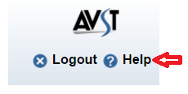

- To review Messages
  - Log into WPM at https://webvmail.vcu.edu/. The application will open to the Home page/Inbox Tab
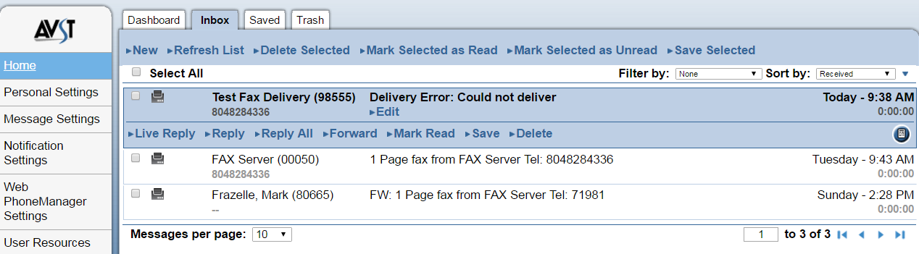

  - To download a fax click on the fax icon . Your fax will be downloaded as a .tif file.

    - To open the file either click on the file at the bottom of your window
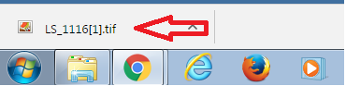

Or

    - go to your Download folder to open the file
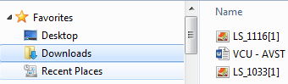

- Forward a fax message with or without comments

  - From the Inbox or Saved tab click “Forward”.

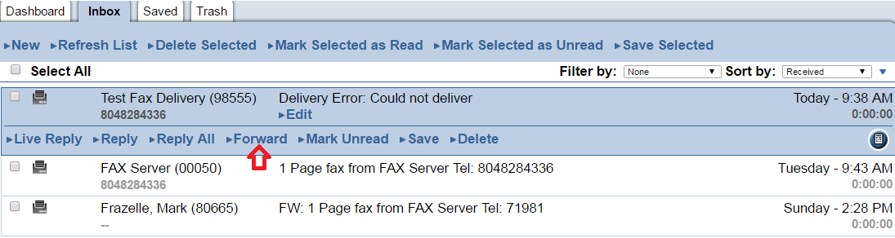
The Message Recording panel displays when you click New, Reply, or Forward in your Inbox, Saved, or Trash tabs. This panel allows you to record and send, forward, and reply to messages.
  - To forward your message without comments
    - Optionally, change the message priority by selecting one or more of the settings at the bottom of the screen under “Message Settings”
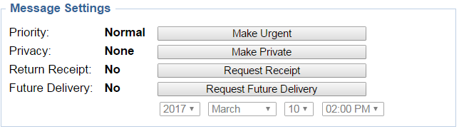

    - Click send
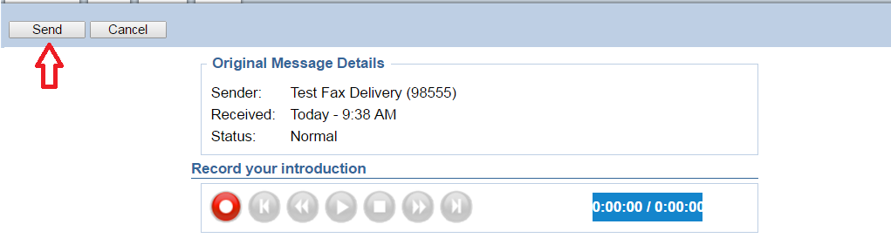

  - To forward with comments use the “Record your introduction” buttons to record your message.
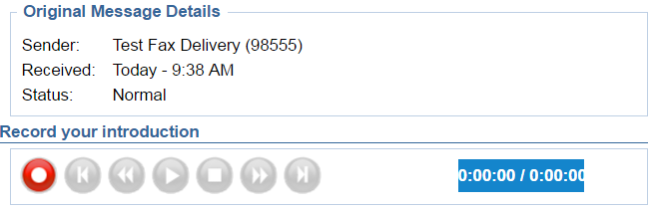
  - Click to begin recording. The voice mail system will call you on your VCU extension so you can record your message.
  - Lift your handset. When you hear the beep, record your message.
  - When you have finished recording click to stop, and then hang up.

If you are unsure if you successfully recorded your message you can view the Recording Counter. .

Other recording controls:

Click to return to the beginning of the recording.
Click to back up two seconds.
Click to playback the recording
Click to pause the playback.
Click to move forward two seconds.
Click to move to the end of the message.
  - Add one or more recipients
    - In the “Message Recipient” search field type the first few letters of the subscriber's first or last name.

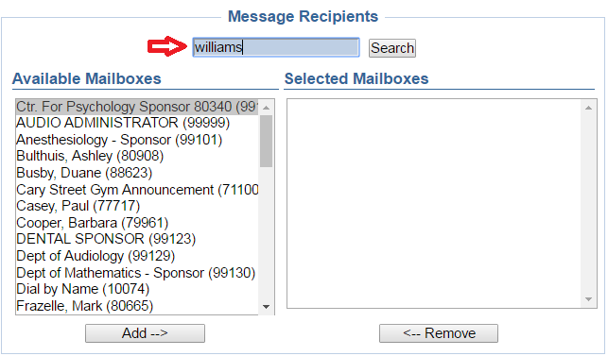
    - Click . The list of matching subscriber names displays in the Available Mailbox area.
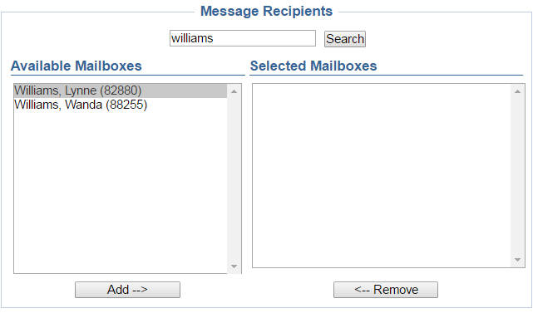

    - Highlight the desired name and click to move it from the “Available” window to the “Selected” window.

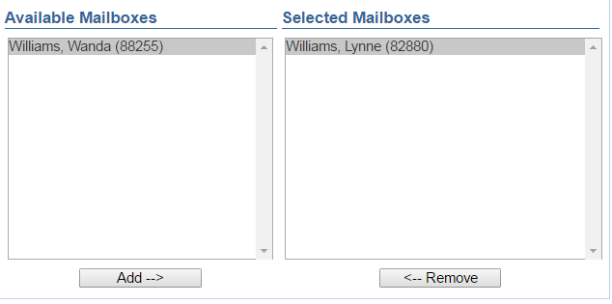

    - Optionally, change the message priority by selecting one or more of the settings at the bottom of the screen under “Message Settings”
    - Click send

